Bonfire and Halloween campaign 2025 – social media pack

Background
Each year, Greater Manchester undertakes a multi-agency approach to preventing, tackling and protecting against bonfire and firework injuries, anti-social behaviour (ASB) and criminal damage during the Halloween and bonfire period.
The campaign is led by Greater Manchester Fire and Rescue Service (GMFRS), in partnership with Greater Manchester Police (GMP), Greater Manchester Combined Authority (GMCA) and local councils.
For a number of years this campaign (previously known as Treacle/Safe4Autumn) has been effective in helping to tackle key issues such as ASB, deliberate fires and firework safety. Over the last four years, we have developed the Bang Out Of Order campaign element to reduce ASB over the Halloween and bonfire night period.
The headline outcomes for last year’s campaign were mixed. Most measures demonstrated reductions, whilst a couple increased. There were reductions in deliberate primary fires, hoax calls attended by GMFRS, attacks on firefighters and incidents of ASB. Hoax calls to the police and criminal damage offences were also reduced. However, there was an increase in deliberate secondary fires and firework related ASB.
This year’s campaign will continue to focus on reducing ASB during the Halloween and bonfire period – including deliberate primary and secondary fires, attacks on emergency services and hoax calls. There will also be messages to prevent firework related ASB.
The campaign also aims to reduce the number of fireworks and bonfire injuries by promoting fire safety advice and encouraging residents to attend organised events where possible.

Campaign materials:
- Posters.
- Social media graphics and MP4s.
- Artwork for advertising, including digital screens, YouTube, Snapchat and TikTok.
- Education resources – primary and secondary resources are available on StayWise.co.uk, covering bonfire, Halloween and firework safety messages and information about ASB.
- Creating some new staff videos and picture content.

Campaign assets are available to download from the GMFRS website (‘Toolkit, downloads and education resources’ page). Artwork for the printed materials is available for partners to print locally if they wish.
Partners are encouraged to:
- Share content from the digital toolkit as widely as possible across all social channels.
- Use the graphics from the digital toolkit across your digital signage network.
- When issuing press releases please link to https://www.manchesterfire.gov.uk/your-safety/campaigns/bangoutoforder/
We are issuing a press release at the start of the campaign. Throughout the campaign we will take an agile approach, staying alive to any opportunities which will gain media coverage for the campaign. This may include releases being issued to highlight topics or operational incidents throughout the campaign. Please let us know if you are planning local media/comms activity and include the key messages from this document where relevant.

Key messages:

Anti-social behaviour:
- Hoax calls can cost lives. If our crews are dealing with a hoax incident it takes crucial time away from real incidents where people’s lives may be in danger.
- Anti-social behaviour, illegal bonfires and misuse of fireworks have serious consequences and will not be tolerated this bonfire night.
- It's illegal to buy or use fireworks if you're under 18. Don’t start fires or set off illegal fireworks.
- To report an illegal bonfire contact your local council. If the fire is out of control call 999.
- Members of the public can dispose of unused fireworks safely, as part of our fireworks amnesty, by calling GMFRS on 0800 555 815.
- Free and confidential support is open to anyone affected by anti-social behaviour or crime this bonfire night. Call 0800 876 6155 or visit gmvictims.org.uk for more information.
- To make a report to police, you can use LiveChat or online reporting at https://www.gmp.police.uk/. You can also call 101. Always dial 999 in an emergency.
- Anonymously report deliberate fire-setting or attacks on firefighters to FireStoppers on 0800 169 5558 or firestoppersreport.co.uk.

Attacks on firefighters/emergency service workers:
- Abuse towards our firefighters/emergency service workers will not be tolerated. Assaulting emergency service workers is illegal and can result in a prison sentence if convicted.
- No one should be attacked for trying to keep you, your families and your friends safe. Respect our emergency service workers this bonfire night.
- Emergency service workers put their lives on the line every day to keep you safe and they have their own families to go home to at the end of their shift. Don’t make their jobs any harder.
- If a fire engine is damaged due to being attacked this bonfire night, it might not be available to respond to serious emergencies in your area.

General, including firework safety:
- Have a safe and enjoyable Halloween and bonfire night – please go to organised events. Find an event near you –.manchesterfire.gov.uk/your-safety/campaigns/bangoutoforder.
- Our advice is not to have fireworks and bonfires at home, but if you are going to celebrate at home, please stay safe by following the Firework Code and our bonfire guidance.
- Alcohol and fireworks do not mix and can lead to devastating injuries. Our advice is not to have fireworks at home, but if you are please do so safely and follow the Firework Code.
- Children’s Halloween costumes and other seasonal / themed costumes are currently classified as toys. You should check they are UKCA or CE marked to ensure they meet the required safety standards. Remember all garments have a risk of being flammable – you must keep them away from naked flames to prevent your child from sustaining devastating burns.
- If your child is planning to go out during the Halloween or bonfire period, make sure you know where they are, what they are doing and how to contact them.

Suggested social media posts – Facebook and X
Suggested post | Graphic and alt text
Last year police and firefighters dealt with 930 hoax calls over the bonfire night period.  If our emergency services are dealing with a hoax incident it takes crucial time away from real incidents where people’s lives may be in danger. 🚒  Making a hoax call could land you a heavy fine or 6 months in prison.  #BangOutOfOrder  #BonfireNight | 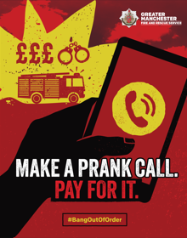  Illustration of hand holding a phone with a fire engine, pound signs and handcuffs in the background. Make a prank call. Pay for it. #BangOutOfOrder GMFRS logo
Last year there were 1,014 reports of anti-social behaviour involving fireworks over the bonfire night period.  Playing with fireworks is #BangOutOfOrder and can have serious consequences, including injuries to yourself or others.  Always follow the Firework Safety Code.  Find out more 👇  https://www.manchesterfire.gov.uk/your-safety/campaigns/bangoutoforder/ | 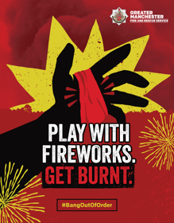  Illustration of hand with bandage. Play with fireworks. Get burnt. #BangOutOfOrder GMFRS logo
Last year @manchesterfire attended 1,198 fires started deliberately during the bonfire night period.  Anti-social behaviour is #BangOutOfOrder and has serious consequences.  If you deliberately start a fire or make a hoax call, you could receive a heavy fine or 6 months in prison. | 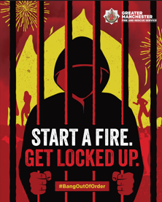  Illustration of person behind bars with fire in background. GMFRS logo. Start a fire. Get locked up. #BangOutOfOrder  OR  Illustration of hand holding a phone with a fire engine, pound signs and handcuffs in the background. Make a prank call. Pay for it. #BangOutOfOrder GMFRS logo
Don’t misuse fireworks or start fires.  And remember - it's illegal to buy or use fireworks if you're under 18.  #BangOutOfOrder  #BonfireNight | Illustration of hand with bandage. Play with fireworks. Get burnt. #BangOutOfOrder GMFRS logo
To report an illegal bonfire contact your local council. ☎  If the fire is out of control call 999. 🔥  Members of the public can dispose of unused fireworks safely, as part of the fireworks amnesty, by calling @manchesterfire on 0800 555 815. 🎆  #BangOutOfOrder #BonfireNight | Illustration of person behind bars with fire in background. GMFRS logo. Start a fire. Get locked up. #BangOutOfOrder
Anonymously report what you know about deliberate fire-setting or attacks on firefighters to FireStoppers on 0800 169 5558.  #BangOutOfOrder | 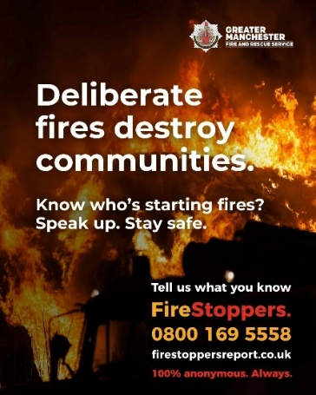  Fire burning behind silhouette of fire engine. Deliberate fires destroy communities. Know who’s starting fires? Speak up. Stay safe. Tell us what you know FireStoppers 0800 169 5558 firestoppersreport.co.uk 100% anonymous always. GMFRS logo
Free and confidential support is open to anyone affected by anti-social behaviour or crime this #Halloween and #BonfireNight period.  0800 876 6155  gmvictims.org.uk  #BangOutOfOrder | 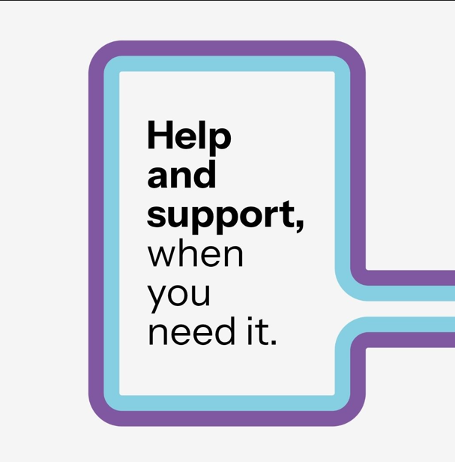  Text in a box, reads: Help and support, when you need it.
‍️To make a report to @gmpolice you can use LiveChat or online reporting at https://www.gmp.police.uk/  You can also call 101.  Always dial 999 in an emergency.  #BangOutOfOrder #BonfireNight | 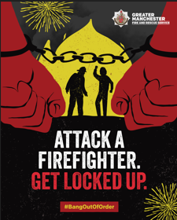  Illustration of person’s hands in handcuffs with silhouette of person in background attacking a firefighter. GMFRS logo. Attack a firefighter. Get locked up. #BangOutOfOrder  OR  Illustration of person behind bars with fire in background. GMFRS logo. Start a fire. Get locked up. #BangOutOfOrder
Last year firefighters were attacked at 17 incidents over the bonfire night period.  Abuse towards emergency service workers will not be tolerated.  Assaulting emergency service workers is #BangOutOfOrder and could get you locked up this #BonfireNight period. | Illustration of person’s hands in handcuffs with silhouette of person in background attacking a firefighter. GMFRS logo. Attack a firefighter. Get locked up. #BangOutOfOrder
No one should be attacked for trying to keep you, your family and your friends safe.  Respect our emergency service workers and don’t make their jobs any harder during this #Halloween and #BonfireNight period.  #BangOutOfOrder | Illustration of person’s hands in handcuffs with silhouette of person in background attacking a firefighter. GMFRS logo. Attack a firefighter. Get locked up. #BangOutOfOrder
Have a safe and enjoyable #Halloween and #BonfireNight.  Please go along to an official organised firework display if you can. If you’re celebrating at a private event, please stay safe by following safety advice from @manchesterfire and the Firework Code. 🎆  You can find out where organised bonfire, firework and Halloween events will be held in your area by visiting https://www.manchesterfire.gov.uk/your-safety/campaigns/bangoutoforder/ | 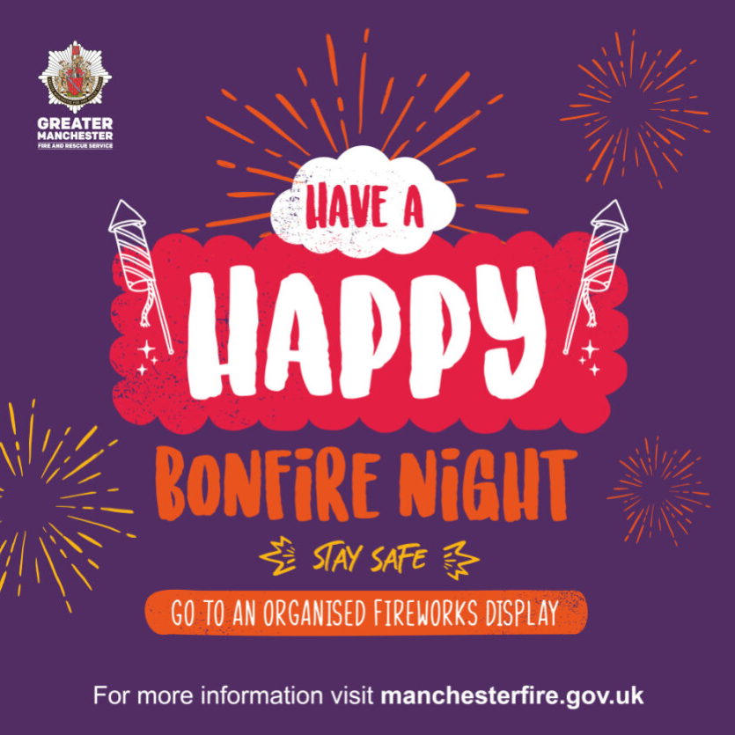  Cartoon image of fireworks. Text reads: Have a happy bonfire night. Stay safe. Go to an organised fireworks display. For more information visit manchesterfire.gov.uk
If your child is planning to go out during #Halloween or #BonfireNight, make sure you know where they are, what they are doing and how to contact them. | Cartoon image of fireworks. Text reads: Have a happy bonfire night. Stay safe. Go to an organised fireworks display. For more information visit manchesterfire.gov.uk
We want everyone to have a safe and happy #BonfireNight and encourage Greater Manchester residents to attend organised displays.  However, if you are going to celebrate at home, please stay safe by following the Firework Code and safety advice from @manchesterfire.  Visit https://www.manchesterfire.gov.uk/your-safety/campaigns/bangoutoforder/ | Cartoon image of fireworks. Text reads: Have a happy bonfire night. Stay safe. Go to an organised fireworks display. For more information visit manchesterfire.gov.uk  OR  Illustration of hand with bandage. Play with fireworks. Get burnt. #BangOutOfOrder GMFRS logo
Have a safe and enjoyable #Halloween and #BonfireNight.  Buying a Halloween costume? Check it’s UKCA or CE marked to ensure it meets the required safety standards. Remember all items of clothing have a risk of being flammable – always keep them away from naked flames. | Cartoon image of fireworks. Text reads: Have a happy bonfire night. Stay safe. Go to an organised fireworks display. For more information visit manchesterfire.gov.uk
Children’s themed costumes are currently classified as toys. Remember all garments have a risk of being flammable – you must keep them away from naked flames to prevent your child from sustaining devastating burns. | 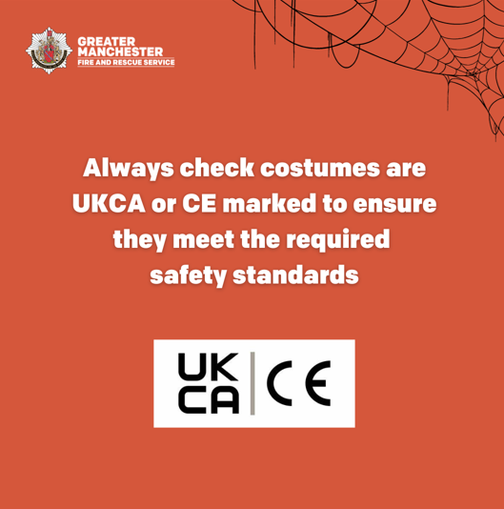  GMFRS logo and wording that says: ‘Always check costumes are UKCA or CE marked to ensure they meet the required safety standards.’ Underneath are the UKCA and CE logos
Always check your children’s costumes are UKCA or CE marked to ensure they meet the required safety standards. Children’s Halloween costumes and other themed costumes are currently classified as toys. | 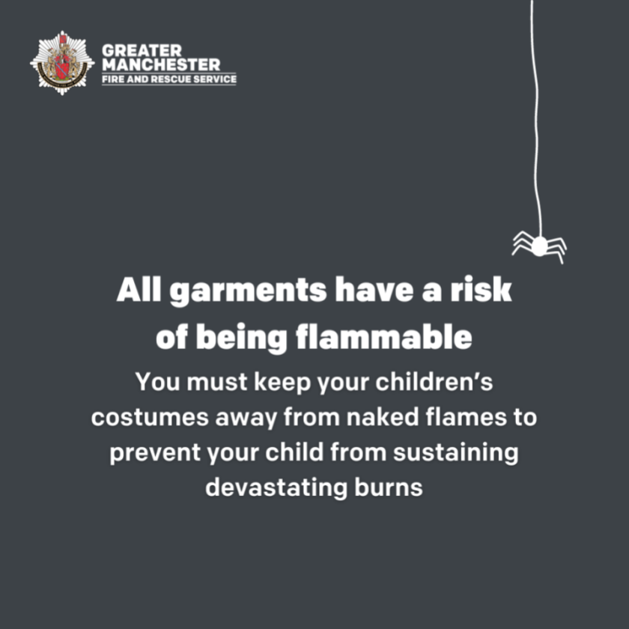  GMFRS logo and wording that says: ‘All garments have a risk of being flammable. You must keep your children’s costumes away from naked flames to prevent your child from sustaining devastating burns.’
Remember, all garments have a risk of being flammable – you must keep them away from naked flames to prevent your child from sustaining devastating burns. | 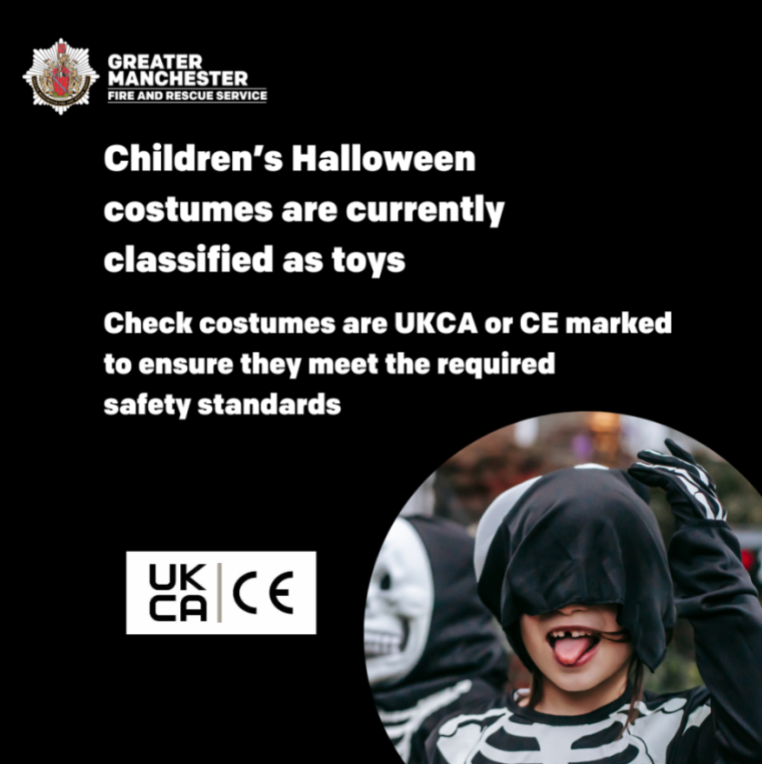  GMFRS logo and wording that says: ‘Children’s Halloween costumes are currently classified as toys. Check costumes are UKCA or CE marked to ensure they meet the required safety standards.” Then there is the UKCA and CE logos underneath. There is an image of a child in a skeleton Halloween costume.

Suggested social media posts – Instagram
Suggested post | Graphic and alt text / MP4
Last year police and firefighters dealt with 930 hoax calls over the bonfire night period.  If our emergency services are dealing with a hoax incident it takes crucial time away from real incidents where people’s lives may be in danger. 🚒  Making a hoax call could land you a heavy fine or 6 months in prison.  #BangOutOfOrder  #BonfireNight | MP4 file: Hoax calls
Last year there were 1,014 reports of anti-social behaviour involving fireworks over the bonfire night period.  Playing with fireworks is #BangOutOfOrder and can have serious consequences, including injuries to yourself or others.  Always follow the Firework Code. Find out more @manchesterfire | MP4 file: ASB Fireworks
Last year @manchesterfire attended 1,198 fires started deliberately during the bonfire night period.  Anti-social behaviour is #BangOutOfOrder and has serious consequences.  If you deliberately start a fire or make a hoax call, you could receive a heavy fine or 6 months in prison.  Read more about anti-social behaviour and the consequences 👇  @manchesterfire | MP4 file: Deliberate fires  OR  MP4 file: Hoax calls
Don’t misuse fireworks or start fires.  And remember - it's illegal to buy or use fireworks if you're under 18.  #BangOutOfOrder #BonfireNight | MP4 file: ASB Fireworks
To report an illegal bonfire contact your local council. ☎  If the fire is out of control call 999. 🔥  Members of the public can dispose of unused fireworks safely, as part of the fireworks amnesty, by calling @manchesterfire on 0800 555 815. 🎆  #BangOutOfOrder #BonfireNight | MP4 file: Deliberate fires
Anonymously report what you know about deliberate fire-setting or attacks on firefighters to FireStoppers on 0800 169 5558.  #BangOutOfOrder | Fire burning behind silhouette of fire engine. Deliberate fires destroy communities. Know who’s starting fires? Speak up. Stay safe. Tell us what you know FireStoppers 0800 169 5558 firestoppersreport.co.uk 100% anonymous always. GMFRS logo
Free and confidential support is open to anyone affected by anti-social behaviour or crime this #Halloween and #BonfireNight period.  0800 876 6155  #BangOutOfOrder | Text in a box, reads: Help and support, when you need it.
‍️To make a report to @gtrmanchesterpolice you can use LiveChat or online reporting.  You can also call 101.  Always dial 999 in an emergency.  #BangOutOfOrder #BonfireNight | MP4 file: Attacks on firefighters  OR  MP4 file: Deliberate fires
Last year firefighters were attacked at 17 incidents over the bonfire night period.  Abuse towards emergency service workers will not be tolerated.  Assaulting emergency service workers is #BangOutOfOrder and could get you locked up this #BonfireNight period. | MP4 file: Attacks on firefighters
No one should be attacked for trying to keep you, your family and your friends safe.  Respect our emergency service workers and don’t make their jobs any harder during this #Halloween and #BonfireNight period.  #BangOutOfOrder | MP4 file: Attacks on firefighters
Have a safe and enjoyable #Halloween and #BonfireNight.  🎆Please go along to an official organised firework display if you can. If you’re celebrating at a private event, please stay safe by following safety advice from @manchesterfire and the Firework Code. | 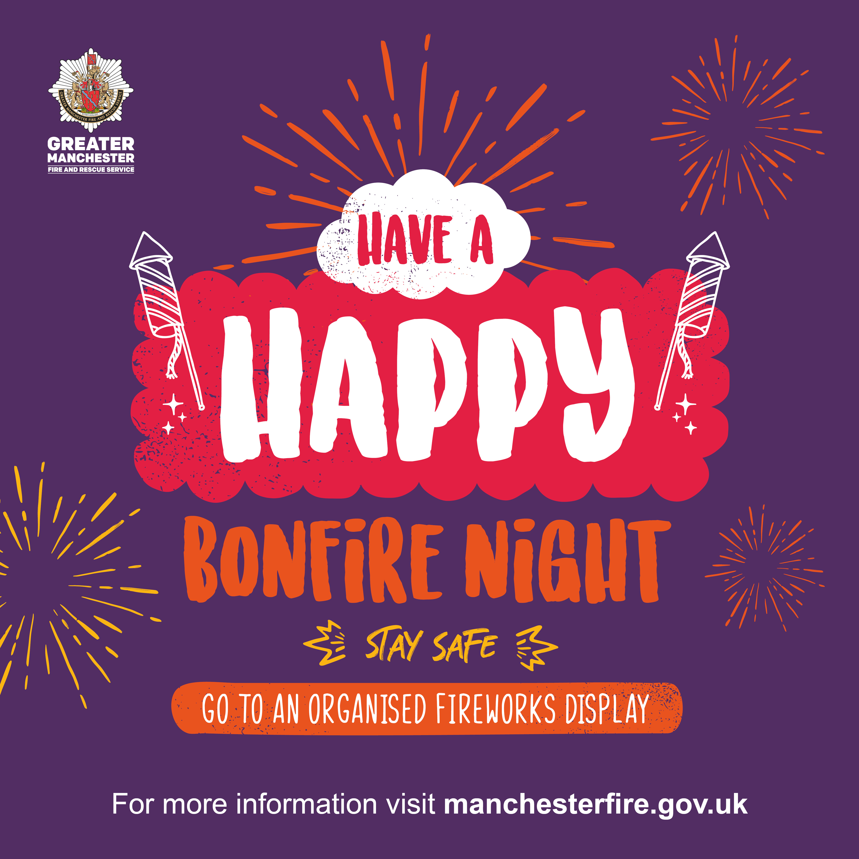  Cartoon image of fireworks. Text reads: Have a happy bonfire night. Stay safe. Go to an organised fireworks display. For more information visit manchesterfire.gov.uk
If your child is planning to go out during #Halloween or #BonfireNight, make sure you know where they are, what they are doing and how to contact them. | Cartoon image of fireworks. Text reads: Have a happy bonfire night. Stay safe. Go to an organised fireworks display. For more information visit manchesterfire.gov.uk
We want everyone to have a safe and happy #BonfireNight and encourage Greater Manchester residents to attend organised displays.  However, if you are going to celebrate at home, please stay safe by following the Firework Code and safety advice from @manchesterfire. | Cartoon image of fireworks. Text reads: Have a happy bonfire night. Stay safe. Go to an organised fireworks display. For more information visit manchesterfire.gov.uk  OR  MP4 file: ASB fireworks
Have a safe and enjoyable #Halloween and #BonfireNight.  Buying a Halloween costume? Check it’s UKCA or CE marked to ensure it meets the required safety standards. Remember all items of clothing have a risk of being flammable – always keep them away from naked flames.  You can find out where organised Halloween, bonfire and firework events will be held in your area by visiting @manchesterfire website. | Cartoon image of fireworks. Text reads: Have a happy bonfire night. Stay safe. Go to an organised fireworks display. For more information visit manchesterfire.gov.uk
Children’s themed costumes are currently classified as toys. Remember all garments have a risk of being flammable – you must keep them away from naked flames to prevent your child from sustaining devastating burns. | 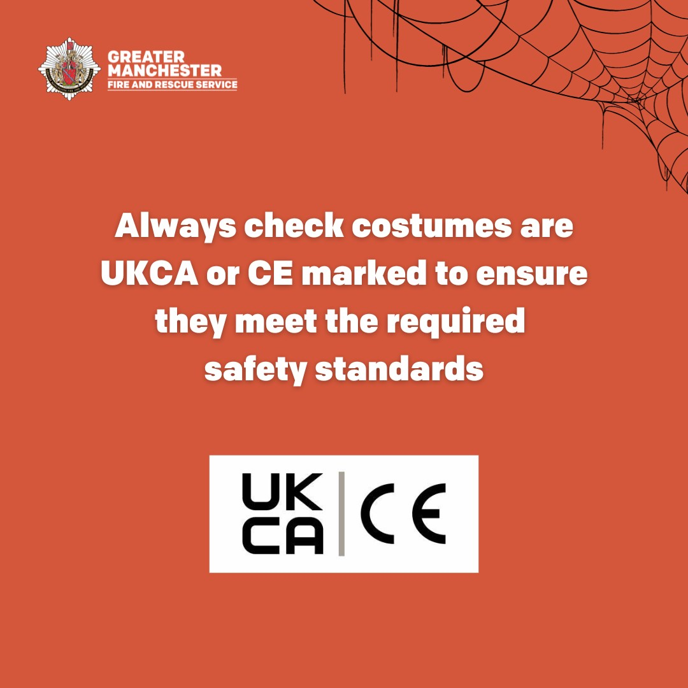  GMFRS logo and wording that says: ‘Always check costumes are UKCA or CE marked to ensure they meet the required safety standards.’ Underneath are the UKCA and CE logos
Always check your children’s costumes are UKCA or CE marked to ensure they meet the required safety standards. Children’s Halloween costumes and other themed costumes are currently classified as toys. | 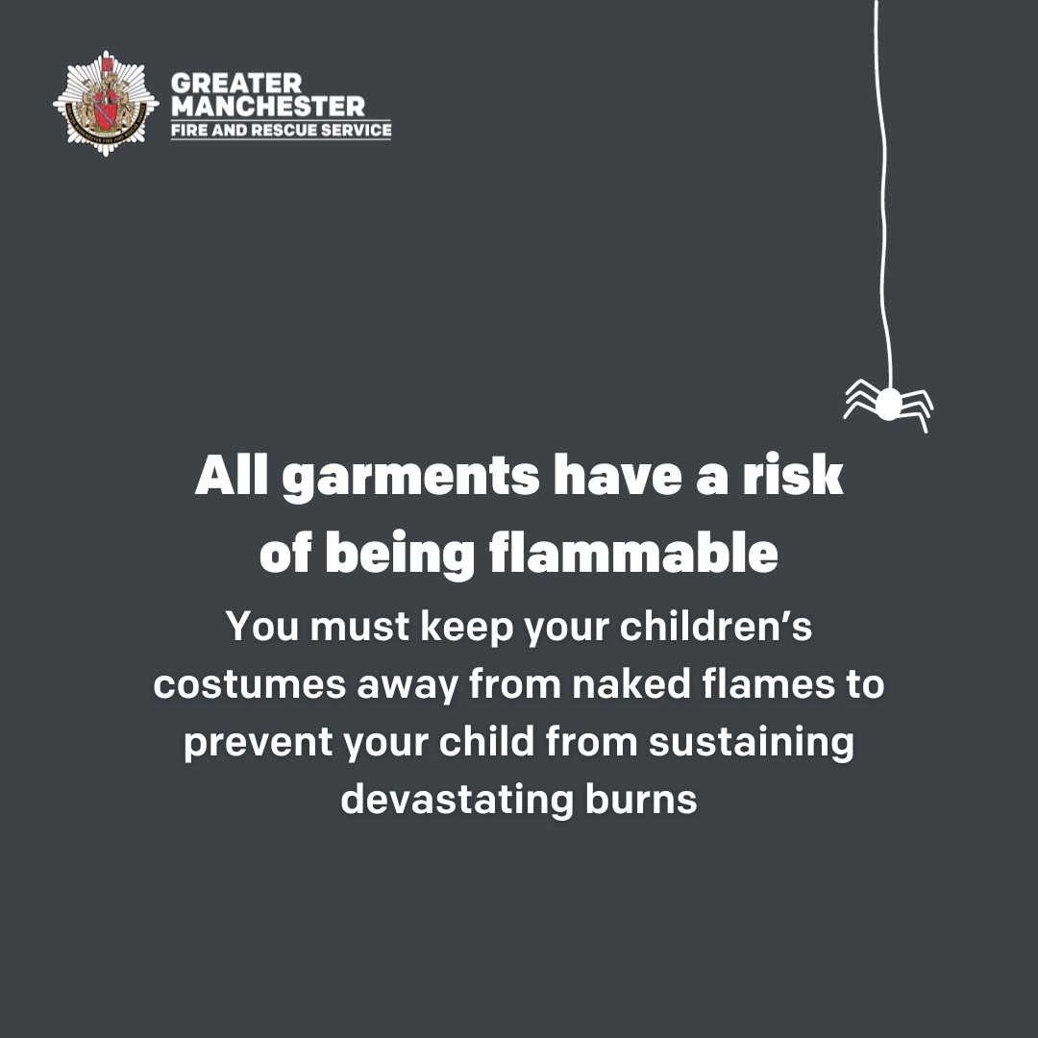  GMFRS logo and wording that says: ‘All garments have a risk of being flammable. You must keep your children’s costumes away from naked flames to prevent your child from sustaining devastating burns.’
Remember, all garments have a risk of being flammable – you must keep them away from naked flames to prevent your child from sustaining devastating burns. | 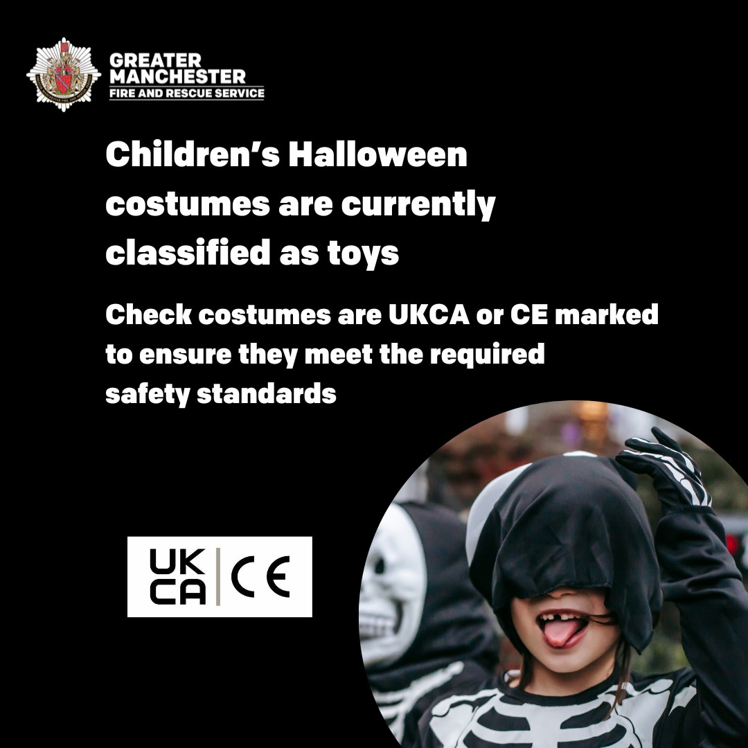  GMFRS logo and wording that says: ‘Children’s Halloween costumes are currently classified as toys. Check costumes are UKCA or CE marked to ensure they meet the required safety standards.” Then there is the UKCA and CE logos underneath. There is an image of a child in a skeleton Halloween costume.

