Station Resource Profiles
Service Excellence
June 2023

Contents
Introduction 4
Our Modelling Methodology 4
Community Risk Profile 5
Service Resources 6
Bolton Borough 9
Bury Borough 12
Manchester Borough 15
Oldham Borough 20
Rochdale Borough 23
Salford Borough 26
Stockport Borough 29
Tameside Borough 32
Trafford Borough 35
Wigan Borough 38
Appendix 1 – Special Appliance Glossary 43
Appendix 2 – Modelling methodology 46
Appendix 3 – Ward map of Greater Manchester 51

Document Details
If this document requires updating or editing, please contact the Author.
Document Version Control
Document Version | Date | Author
Version 1 | 01/12/2022 | Sarah Scoales / Clare Nolan
Version 2 | 15/03/2022 | Sarah Scoales / Clare Nolan
Version 3 | 05/06/2023 | Sarah Scoales / Clare Nolan

Approval Process
Details | Approver
Approval agency | SLT
Guidance Owner | Sarah Scoales
CDC Approval Owner | Clare Nolan

Consultation & Engagement
Involved | Consulted
- Sarah Scoales  - Clare Nolan  - Exec Board | - SLT  - Service Excellence Team

Introduction
This document presents a profile for the ten boroughs in Greater Manchester. Primarily this document is used to display results from the modelling undertaken as part of the Fire Cover Review.
The profile for each borough provides:
- A map of the 2022/23 risk model overlaid with current stations and resources
- An overview of resources currently in that borough and after any proposed changes
- Current performance and modelled performance after proposed changes at a station area and ward level. This is presented both for full 24 hour period and again for night time incidents.
- Current average response time and modelled average response time after proposed changes at a station area and ward level. This is presented both for full 24 hour period and again for night time incidents.

Our Modelling Methodology
Workload modelling is the main way we can assess the impact of making any changes to our response resources or the impact upon our resources due to changes in demand or other external factors.
It essentially helps us to answer, ‘what if?’ scenarios.
This process provides us with a range of options and the impact these will have on the Service’s performance, decisions can then be made regarding the most suitable options to consult upon. The modelling software in itself does not create or provide options or answers, rather is used to create data which can be used to determine potential options.
The methodology can be found in Appendix 2

Community Risk Profile
Greater Manchester is continually evolving with new housing, commercial and industrial developments and the resulting increase in both fire and road risk.
Most of our fire stations were built some years ago, and as a result some may no longer be in an ideal location. As the demographics and risk profile continues to evolve, we need to ensure where possible that we adapt to these changes.
It is important to be mindful of the risk profile of the area when considering the type, and locations of fire stations to ensure we continue to make best use of our resources to respond to emergencies and deliver fire prevention activities.
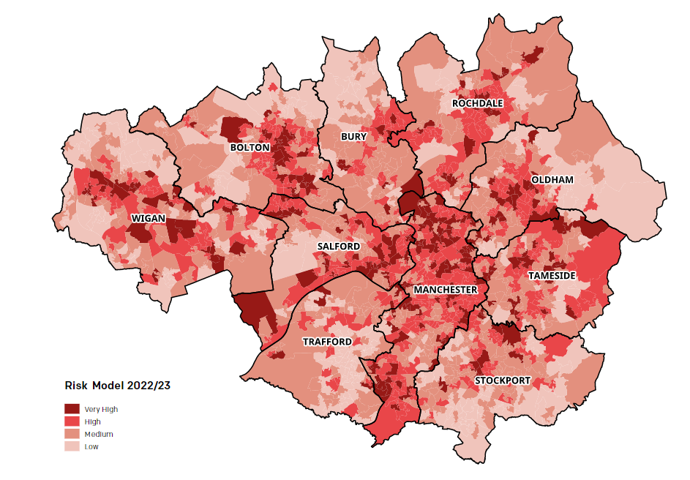
To enable us to create an accurate risk profile of our communities, we undertake an annual Strategic Assessment of Risk (SAoR) that helps us to consider the impact of external factors that may be a risk to our Service and how we need to respond. The SAoR underpins and supports our Fire Plan and Annual Delivery Plans by ensuring risk management drives decision-making to achieve our vision.

Service Resources
GMFRS provides a fire and rescue service from 41 strategically placed fire stations across Greater Manchester. The region is split into five area teams, which are illustrated on the map below.
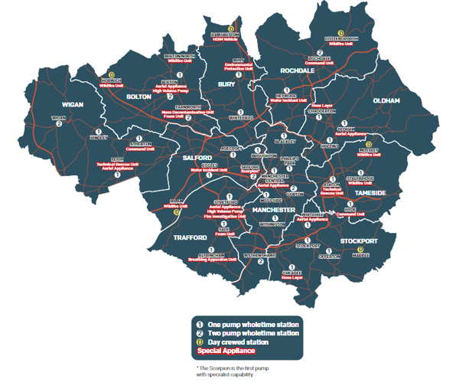

This section sets out the resources that are available in each borough.
Resource tables
STANDARD FIRE ENGINE
These vehicles are configured to carry up to 5 firefighters, have an on-board water tank, a water pump and associated hose equipment and deal with a vast array of emergency situations. The vehicles also carry road traffic collision rescue equipment, ladders, breaking in equipment, first aid equipment, and hazardous material protection suits.

DAY CREWED – STANDARD FIRE ENGINE
These vehicles are the same as the standard fire engines but are crewed differently.

TECHNICAL RESPONSE UNIT
These vehicles respond to more complex and sometimes unusual emergencies, such as complex road traffic collisions, water rescues, entrapment, terrorist threats, rescues from height, collapsed buildings, trench rescues and more.

SPECIAL APPLIANCE
These vehicles respond to a range of different emergencies requiring specialist capabilities. See Appendix A for full details.

Risk Maps
Each borough has its own risk map.
The maps display the risk level of each LSOA within the borough.
Very high risk (red)
High risk (orange)
Medium risk (yellow)
Low risk (blue)

The maps display the stations which are designated as flows:

One pump station
Two pump station
Day crewed one pump station
One pump and one TRU station

Ward Maps
A ward map of Greater Manchester is provided in Appendix 3 for reference.

Bolton Borough
Bolton Borough has four fire stations located at Bolton, Bolton North, Farnworth and a day-crewed station at Horwich. Across the stations there are a total of six fire engines. The map below shows the 2022-23 risk model and the location of the stations and roads for context. 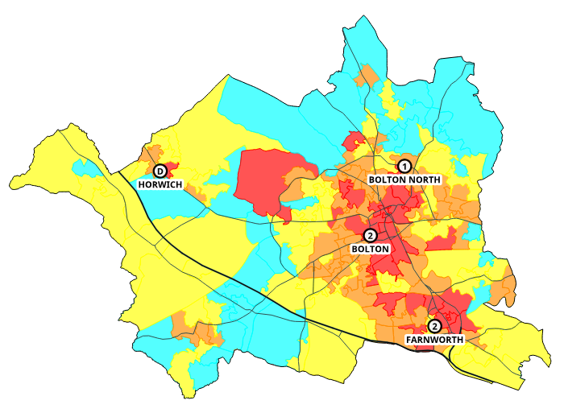
This table is an overview of the changes that may be made in the borough.
Station Area | Now | After Changes | Specials Details
Bolton |  |  | AA HVP
Bolton North |  |  | WU
Horwich |  |  | WU
Farnworth |  |  | MDU FU

The tables below report the actual performance by station area and ward for the past three years, then what the performance is likely to be given the changes proposed.
Performance is measured for each life risk incident and whether the first pump arrived within ten minutes (including call handling) and is given as a percentage that are in time. Average response time is measured for the first pump to arrive at all life risk incidents in that area and is given as a time.

Overall performance and average response time (all times of the day)
 |  | Performance |  |  | Average Response Time
Station Area |  | Actual | Option | Diff | Actual | Option | Diff
G50 | Bolton | 89.7% | 89.9% | 0.2% | 06:50 | 06:50 | 0
G51 | Bolton North | 89.2% | 89.2% | 0.0% | 07:07 | 07:07 | 0
G52 | Horwich | 67.4% | 67.4% | 0.0% | 08:52 | 08:52 | 0
G53 | Farnworth | 83.5% | 83.5% | 0.0% | 07:46 | 07:45 | -1
 | Bolton | 85.3% | 85.5% | 0.2% | 07:21 | 07:20 | -1

 | Performance |  |  | Average Response Time
Ward | Actual | Option | Diff | Actual | Option | Diff
Astley Bridge | 91.5% | 91.5% | 0.0% | 06:32 | 06:32 | 0
Bradshaw | 88.7% | 88.7% | 0.0% | 07:16 | 07:16 | 0
Breightmet | 86.2% | 86.2% | 0.0% | 08:13 | 08:09 | -3
Bromley Cross | 85.0% | 85.0% | 0.0% | 08:24 | 08:24 | 0
Crompton | 90.8% | 90.8% | 0.0% | 06:26 | 06:26 | 0
Farnworth | 87.0% | 87.0% | 0.0% | 06:40 | 06:39 | -1
Great Lever | 94.8% | 94.8% | 0.0% | 06:07 | 06:07 | 0
Halliwell | 92.9% | 92.9% | 0.0% | 06:16 | 06:15 | -1
Harper Green | 95.2% | 96.6% | 1.4% | 06:46 | 06:36 | -9
Heaton and Lostock | 81.3% | 83.7% | 2.4% | 08:21 | 08:19 | -1
Horwich and Blackrod | 64.1% | 64.1% | 0.0% | 08:20 | 08:20 | 0
Horwich North East | 85.0% | 85.0% | 0.0% | 08:26 | 08:26 | 0
Hulton | 83.1% | 83.1% | 0.0% | 08:06 | 08:06 | 0
Kearsley | 73.0% | 73.0% | 0.0% | 08:52 | 08:52 | 0
Little Lever and Darcy Lever | 81.8% | 81.8% | 0.0% | 08:21 | 08:21 | 0
Rumworth | 93.2% | 93.2% | 0.0% | 06:06 | 06:06 | 0
Smithills | 83.0% | 83.0% | 0.0% | 07:58 | 07:58 | 0
Tonge with the Haulgh | 95.4% | 95.4% | 0.0% | 06:10 | 06:11 | 1
Westhoughton North and Chew Moor | 54.1% | 54.1% | 0.0% | 10:00 | 10:00 | 0
Westhoughton South | 76.4% | 76.4% | 0.0% | 09:01 | 09:01 | 0
Bolton | 85.3% | 85.5% | 0.2% | 07:21 | 07:20 | -1

Incidents can also be analysed based upon when they occur. The tables below display performance and average response time at ‘night time’. In this case night time relates to the time that non-SDS crews respond from home (Monday – Friday 6:30pm – 8:30am, Saturday – Sunday 1pm – 8:30am). During this time a turnout delay is added onto each proposed mobilisation by NWFC to take into account that crews have to respond to the station first.

Performance and average response time (night time only)
 |  | Performance |  |  | Average Response Time
Station Area |  | Actual | Option | Diff | Actual | Option | Diff
G50 | Bolton | 90.7% | 90.7% | 0.0% | 06:47 | 06:47 | -1
G51 | Bolton North | 91.2% | 91.2% | 0.0% | 07:04 | 07:04 | 0
G52 | Horwich | 65.8% | 65.8% | 0.0% | 08:53 | 08:53 | 0
G53 | Farnworth | 85.6% | 85.6% | 0.0% | 07:40 | 07:39 | 0
 | Bolton | 86.3% | 86.3% | 0.0% | 07:19 | 07:18 | 0

 | Performance |  |  | Average Response Time
Ward | Actual | Option | Diff | Actual | Option | Diff
Astley Bridge | 90.2% | 90.2% | 0.0% | 06:42 | 06:42 | 0
Bradshaw | 90.2% | 90.2% | 0.0% | 07:10 | 07:10 | 0
Breightmet | 90.2% | 90.2% | 0.0% | 07:49 | 07:46 | -2
Bromley Cross | 90.5% | 90.5% | 0.0% | 08:06 | 08:06 | 0
Crompton | 90.1% | 90.1% | 0.0% | 06:32 | 06:32 | 0
Farnworth | 91.9% | 91.9% | 0.0% | 06:11 | 06:09 | -2
Great Lever | 96.4% | 96.4% | 0.0% | 06:02 | 06:02 | 0
Halliwell | 94.0% | 94.0% | 0.0% | 06:27 | 06:25 | -2
Harper Green | 94.5% | 94.5% | 0.0% | 06:41 | 06:41 | 0
Heaton and Lostock | 80.3% | 80.3% | 0.0% | 08:28 | 08:28 | 0
Horwich and Blackrod | 61.4% | 61.4% | 0.0% | 08:47 | 08:47 | 0
Horwich North East | 89.0% | 89.0% | 0.0% | 07:36 | 07:36 | 0
Hulton | 79.7% | 79.7% | 0.0% | 08:14 | 08:14 | 0
Kearsley | 72.7% | 72.7% | 0.0% | 09:15 | 09:15 | 0
Little Lever and Darcy Lever | 84.4% | 84.4% | 0.0% | 08:12 | 08:12 | 0
Rumworth | 93.5% | 93.5% | 0.0% | 05:54 | 05:54 | 0
Smithills | 88.1% | 88.1% | 0.0% | 07:43 | 07:43 | 0
Tonge with the Haulgh | 94.7% | 94.7% | 0.0% | 06:21 | 06:23 | 2
Westhoughton North and Chew Moor | 54.5% | 54.5% | 0.0% | 10:03 | 10:03 | 0
Westhoughton South | 75.0% | 75.0% | 0.0% | 09:04 | 09:04 | 0
Bolton | 86.3% | 86.3% | 0.0% | 07:19 | 07:18 | 0

Bury Borough
Bury Borough has three fire stations located at Bury, Whitefield and a day-crewed station at Ramsbottom. Across the stations there are a total of three fire engines. The map below shows the 2022-23 risk model and the location of the stations and roads for context.
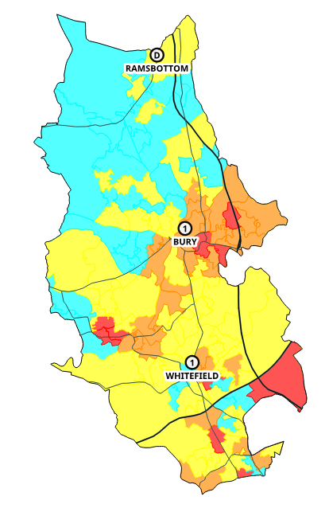
This table is an overview of the changes that may be made in the borough.
Station Area | Now | After Changes | Specials Details
Bury |  |  | EPU
Whitefield |  |  | P1 to be Scorpion (proposed)
Ramsbottom |  |  | HDIM
The tables below report the actual performance by station area and ward for the past three years, then what the performance is likely to be given the changes proposed.
Performance is measured for each life risk incident and whether the first pump arrived within ten minutes (including call handling) and is given as a percentage that are in time. Average response time is measured for the first pump to arrive at all life risk incidents in that area and is given as a time.

Overall performance and average response time (all times of the day)
 |  | Performance |  |  | Average Response Time
Station Area |  | Actual | Option | Diff | Actual | Option | Diff
G36 | Bury | 82.8% | 82.8% | 0.0% | 07:58 | 07:58 | 0
G37 | Whitehill | 84.3% | 84.7% | 0.4% | 07:51 | 07:52 | 0
G38 | Ramsbottom | 66.6% | 66.6% | 0.0% | 09:16 | 09:11 | -5
 | Bury | 83.5% | 83.7% | 0.3% | 07:55 | 07:54 | -1

 | Performance |  |  | Average Response Time
Ward | Actual | Option | Diff | Actual | Option | Diff
Besses | 89.3% | 89.3% | 0.0% | 07:20 | 07:18 | -2
Bury East | 84.2% | 85.3% | 1.1% | 07:42 | 07:39 | -3
Bury West | 83.9% | 83.9% | 0.0% | 07:39 | 07:39 | 0
Elton | 91.1% | 91.1% | 0.0% | 06:46 | 06:37 | -9
Holyrood | 83.1% | 88.5% | 5.4% | 08:00 | 07:42 | -18
Moorside | 81.3% | 81.3% | 0.0% | 07:56 | 07:56 | 0
North Manor | 67.4% | 67.4% | 0.0% | 09:06 | 08:57 | -10
Pilkington Park | 81.3% | 85.6% | 4.3% | 07:15 | 06:56 | -18
Radcliffe East | 82.1% | 82.1% | 0.0% | 08:18 | 08:18 | 0
Radcliffe North & Ainsworth | 79.0% | 79.0% | 0.0% | 09:34 | 09:34 | 0
Radcliffe West | 91.0% | 91.0% | 0.0% | 07:43 | 07:43 | 0
Ramsbottom | 73.8% | 73.8% | 0.0% | 08:49 | 08:49 | 0
Redvales | 77.5% | 75.4% | -2.2% | 08:10 | 08:19 | 9
Sedgley | 94.9% | 94.9% | 0.0% | 06:35 | 06:28 | -7
St Marys | 87.4% | 87.4% | 0.0% | 07:39 | 07:39 | 0
Tottington | 83.4% | 83.4% | 0.0% | 10:26 | 10:26 | 0
Unsworth | 76.4% | 74.7% | -1.8% | 08:04 | 08:21 | 16
Bury | 83.5% | 83.7% | 0.3% | 07:55 | 07:54 | -1

Incidents can also be analysed based upon when they occur. The tables below display performance and average response time at ‘night time’. In this case night time relates to the time that non-SDS crews respond from home (Monday – Friday 6:30pm – 8:30am, Saturday – Sunday 1pm – 8:30am). During this time a turnout delay is added onto each proposed mobilisation by NWFC to take into account that crews have to respond to the station first.

Performance and average response time (night time only)
 |  | Performance |  |  | Average Response Time
Station Area |  | Actual | Option | Diff | Actual | Option | Diff
G36 | Bury | 84.1% | 83.5% | -0.5% | 07:46 | 07:48 | 2
G37 | Whitehill | 86.5% | 85.9% | -0.6% | 07:54 | 07:57 | 3
G38 | Ramsbottom | 56.4% | 56.4% | 0.0% | 10:33 | 10:33 | 0
 | Bury | 84.2% | 83.7% | -0.5% | 07:59 | 08:01 | 2

 | Performance |  |  | Average Response Time
Ward | Actual | Option | Diff | Actual | Option | Diff
Besses | 88.4% | 88.4% | 0.0% | 07:34 | 07:34 | 0
Bury East | 81.7% | 81.7% | 0.0% | 07:53 | 07:53 | 0
Bury West | 89.7% | 89.7% | 0.0% | 07:00 | 07:00 | 0
Elton | 90.8% | 90.8% | 0.0% | 06:49 | 06:43 | -6
Holyrood | 85.3% | 85.3% | 0.0% | 07:54 | 07:54 | 0
Moorside | 86.4% | 86.4% | 0.0% | 07:36 | 07:36 | 0
North Manor | 63.1% | 63.1% | 0.0% | 09:30 | 09:30 | 0
Pilkington Park | 90.8% | 90.8% | 0.0% | 07:01 | 07:01 | 0
Radcliffe East | 87.0% | 87.0% | 0.0% | 08:24 | 08:24 | 0
Radcliffe North & Ainsworth | 79.7% | 79.7% | 0.0% | 10:01 | 10:01 | 0
Radcliffe West | 93.4% | 93.4% | 0.0% | 07:26 | 07:26 | 0
Ramsbottom | 63.1% | 63.1% | 0.0% | 10:25 | 10:25 | 0
Redvales | 79.3% | 76.0% | -3.2% | 08:07 | 08:20 | 14
Sedgley | 93.2% | 93.2% | 0.0% | 06:32 | 06:32 | 0
St Marys | 81.4% | 81.4% | 0.0% | 08:16 | 08:16 | 0
Tottington | 96.4% | 96.4% | 0.0% | 08:34 | 08:34 | 0
Unsworth | 84.6% | 81.5% | -3.1% | 07:36 | 07:49 | 13
Bury | 84.2% | 83.7% | -0.5% | 07:59 | 08:01 | 2

Manchester Borough
Manchester Borough has seven fire stations located at Moss Side, Withington, Wythenshawe, Manchester Central, Blackley, Phillips Park and Gorton. Across the stations there are a total of nine fire engines. The map below shows the 2022-23 risk model and the location of the stations and roads for context.
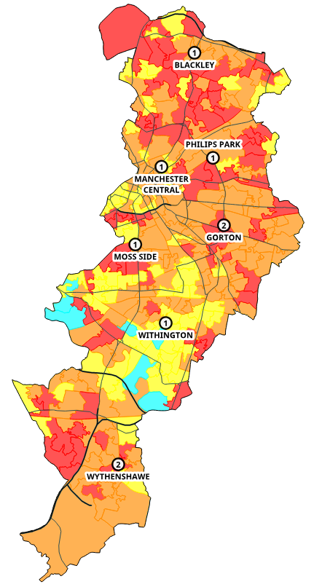
This table is an overview of the changes that may be made in the borough.
Station Area | Actual | After Changes | Specials Details
Moss Side
Withington
Wythenshawe
Manchester Central |  |  | AA
Blackley
Philips Park
Gorton

The tables below report the actual performance by station area and ward for the past three years, then what the performance is likely to be given the changes proposed.
Performance is measured for each life risk incident and whether the first pump arrived within ten minutes (including call handling) and is given as a percentage that are in time. Average response time is measured for the first pump to arrive at all life risk incidents in that area and is given as a time.

Overall performance and average response time (all times of the day)
 |  | Performance |  |  | Average Response Time
Station Area |  | Actual | Option | Diff | Actual | Option | Diff
G13 | Moss Side | 93.6% | 93.6% | 0.0% | 06:20 | 06:00 | -19
G14 | Withington | 90.9% | 91.4% | 0.6% | 07:12 | 07:10 | -2
G15 | Wythenshawe | 87.5% | 87.5% | 0.0% | 06:56 | 06:57 | 1
G16 | Manchester Central | 93.7% | 93.7% | 0.0% | 06:16 | 06:00 | -16
G17 | Blackley | 90.7% | 91.2% | 0.5% | 07:06 | 07:04 | -2
G18 | Philips Park | 92.5% | 92.9% | 0.3% | 06:55 | 06:49 | -6
G19 | Gorton | 94.5% | 94.2% | -0.2% | 06:43 | 06:43 | 0
 | Manchester | 92.1% | 92.2% | 0.1% | 06:46 | 06:40 | -6

 | Performance |  |  | Average Response Time
Ward | Actual | Option | Diff | Actual | Option | Diff
Ancoats & Beswick | 92.0% | 92.0% | 0.0% | 06:03 | 05:50 | -13
Ardwick | 95.7% | 95.7% | 0.0% | 06:24 | 06:16 | -8
Baguley | 89.0% | 89.0% | 0.0% | 07:10 | 07:11 | 1
Brooklands | 88.3% | 84.6% | -3.8% | 08:38 | 08:51 | 12
Burnage | 90.6% | 89.0% | -1.6% | 07:56 | 08:01 | 5
Charlestown | 91.1% | 91.1% | 0.0% | 07:02 | 07:02 | 0
Cheetham | 92.6% | 92.6% | 0.0% | 06:36 | 06:21 | -15
Chorlton | 96.4% | 96.4% | 0.0% | 07:27 | 07:16 | -11
Chorlton Park | 89.5% | 89.5% | 0.0% | 08:06 | 08:06 | 0
Clayton & Openshaw | 94.6% | 94.6% | 0.0% | 06:42 | 06:37 | -5
Crumpsall | 94.9% | 94.9% | 0.0% | 07:00 | 07:01 | 0
Deansgate | 93.6% | 93.6% | 0.0% | 06:05 | 05:57 | -8
Didsbury East | 90.3% | 92.7% | 2.4% | 07:24 | 07:21 | -3
Didsbury West | 92.6% | 92.6% | 0.0% | 06:33 | 06:33 | 0
Fallowfield | 88.4% | 88.4% | 0.0% | 07:33 | 07:27 | -5
Gorton & Abbey Hey | 92.9% | 92.9% | 0.0% | 06:49 | 06:49 | 0
Harpurhey | 94.9% | 95.7% | 0.8% | 06:23 | 06:15 | -7
Higher Blackley | 83.5% | 83.5% | 0.0% | 07:28 | 07:28 | 0
Hulme | 92.8% | 92.8% | 0.0% | 06:18 | 05:58 | -20
Levenshulme | 96.4% | 97.6% | 1.2% | 07:20 | 07:15 | -5
Longsight | 92.4% | 91.3% | -1.1% | 06:38 | 06:41 | 2
Miles Platting & Newton Heath | 93.1% | 93.7% | 0.7% | 06:37 | 06:29 | -8
Moss Side | 91.0% | 91.0% | 0.0% | 06:00 | 05:31 | -30
Moston | 90.8% | 90.8% | 0.0% | 07:26 | 07:24 | -2
Northenden | 87.7% | 87.7% | 0.0% | 07:13 | 07:15 | 2
Old Moat | 92.8% | 94.9% | 2.1% | 06:01 | 05:48 | -12
Piccadilly | 93.7% | 93.7% | 0.0% | 06:16 | 05:55 | -22
Rusholme | 95.0% | 95.0% | 0.0% | 06:43 | 06:40 | -3
Sharston | 84.3% | 84.3% | 0.0% | 06:25 | 06:25 | 0
Whalley Range | 96.4% | 96.4% | 0.0% | 06:19 | 06:06 | -13
Withington | 95.0% | 96.7% | 1.7% | 06:16 | 06:13 | -3
Woodhouse Park | 85.7% | 85.7% | 0.0% | 06:43 | 06:43 | 0
Manchester | 92.1% | 92.2% | 0.1% | 06:46 | 06:40 | -6

Incidents can also be analysed based upon when they occur. The tables below display performance and average response time at ‘night time’. In this case night time relates to the time that non-SDS crews respond from home (Monday – Friday 6:30pm – 8:30am, Saturday – Sunday 1pm – 8:30am). During this time a turnout delay is added onto each proposed mobilisation by NWFC to take into account that crews have to respond to the station first.

Performance and average response time (night time only)
 |  | Performance |  |  | Average Response Time
Station Area |  | Actual | Option | Diff | Actual | Option | Diff
G13 | Moss Side | 93.9% | 93.9% | 0.0% | 06:21 | 06:09 | -11
G14 | Withington | 92.1% | 91.6% | -0.5% | 07:00 | 07:01 | 1
G15 | Wythenshawe | 88.6% | 88.6% | 0.0% | 06:46 | 06:47 | 1
G16 | Manchester Central | 94.1% | 94.1% | 0.0% | 06:18 | 06:05 | -14
G17 | Blackley | 91.8% | 91.8% | 0.0% | 06:57 | 06:56 | 0
G18 | Philips Park | 93.9% | 93.9% | 0.0% | 06:51 | 06:48 | -3
G19 | Gorton | 94.7% | 94.3% | -0.4% | 06:42 | 06:42 | -1
 | Manchester | 92.8% | 92.4% | -0.3% | 06:43 | 06:39 | -3

 | Performance |  |  | Average Response Time
Ward | Actual | Option | Diff | Actual | Option | Diff
Ancoats & Beswick | 89.4% | 89.4% | 0.0% | 06:23 | 06:09 | -14
Ardwick | 95.1% | 95.1% | 0.0% | 06:18 | 06:11 | -7
Baguley | 92.3% | 92.3% | 0.0% | 06:55 | 06:57 | 2
Brooklands | 90.7% | 80.7% | -10.0% | 08:36 | 09:02 | 26
Burnage | 91.4% | 88.5% | -2.9% | 08:03 | 08:12 | 9
Charlestown | 92.4% | 92.4% | 0.0% | 07:07 | 07:07 | 0
Cheetham | 92.6% | 92.6% | 0.0% | 06:33 | 06:18 | -15
Chorlton | 96.4% | 96.4% | 0.0% | 07:13 | 07:05 | -8
Chorlton Park | 87.3% | 87.3% | 0.0% | 08:13 | 08:12 | -1
Clayton & Openshaw | 95.0% | 95.0% | 0.0% | 06:43 | 06:38 | -6
Crumpsall | 96.4% | 96.4% | 0.0% | 06:43 | 06:43 | 0
Deansgate | 94.2% | 94.2% | 0.0% | 06:05 | 06:00 | -4
Didsbury East | 90.0% | 90.0% | 0.0% | 07:28 | 07:25 | -3
Didsbury West | 96.4% | 96.4% | 0.0% | 05:54 | 05:54 | 0
Fallowfield | 84.4% | 84.4% | 0.0% | 07:40 | 07:44 | 4
Gorton & Abbey Hey | 91.7% | 91.7% | 0.0% | 06:55 | 06:55 | 0
Harpurhey | 95.1% | 95.1% | 0.0% | 06:19 | 06:18 | -1
Higher Blackley | 80.8% | 80.8% | 0.0% | 07:30 | 07:30 | 0
Hulme | 93.4% | 93.4% | 0.0% | 06:20 | 06:07 | -13
Levenshulme | 96.4% | 96.4% | 0.0% | 07:28 | 07:28 | 0
Longsight | 94.9% | 93.2% | -1.7% | 06:26 | 06:29 | 3
Miles Platting & Newton Heath | 94.5% | 94.5% | 0.0% | 06:35 | 06:31 | -4
Moss Side | 91.4% | 91.4% | 0.0% | 06:06 | 05:46 | -21
Moston | 91.8% | 91.8% | 0.0% | 07:16 | 07:16 | 0
Northenden | 88.9% | 88.9% | 0.0% | 07:11 | 07:15 | 4
Old Moat | 93.5% | 93.5% | 0.0% | 06:00 | 05:58 | -2
Piccadilly | 94.1% | 94.1% | 0.0% | 06:24 | 06:08 | -17
Rusholme | 94.3% | 94.3% | 0.0% | 06:38 | 06:38 | 1
Sharston | 87.1% | 87.1% | 0.0% | 06:07 | 06:07 | 0
Whalley Range | 96.4% | 96.4% | 0.0% | 06:12 | 06:12 | 0
Withington | 96.4% | 96.4% | 0.0% | 06:12 | 06:12 | 0
Woodhouse Park | 87.0% | 87.0% | 0.0% | 06:33 | 06:33 | 0
Manchester | 92.8% | 92.4% | -0.3% | 06:43 | 06:39 | -3

Oldham Borough
Oldham Borough has three fire stations located at Chadderton, Hollins and Oldham. Across the stations there are a total of three fire engines. The map below shows the 2022-23 risk model and the location of the stations and roads for context.
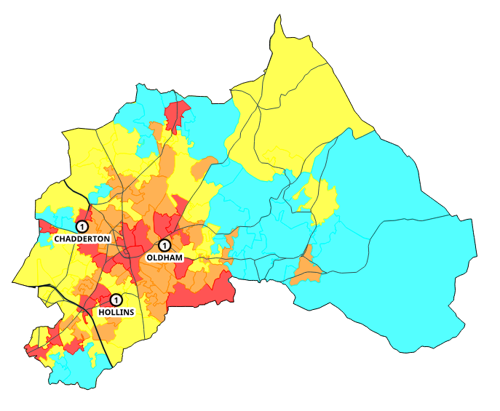
This table is an overview of the changes that may be made in the borough.
Station Area | Actual | After Changes | Specials Details
Oldham |  |  | AA
Hollins
Chadderton |  |  | HL

The tables below report the actual performance by station area and ward for the past three years, then what the performance is likely to be given the changes proposed.
Performance is measured for each life risk incident and whether the first pump arrived within ten minutes (including call handling) and is given as a percentage that are in time. Average response time is measured for the first pump to arrive at all life risk incidents in that area and is given as a time.

Overall performance and average response time (all times of the day)
 |  | Performance |  |  | Average Response Time
Station Area |  | Actual | Option | Diff | Actual | Option | Diff
G33 | Oldham | 87.7% | 87.4% | -0.3% | 07:13 | 07:13 | 1
G34 | Hollins | 89.5% | 89.8% | 0.4% | 06:56 | 06:55 | -1
G35 | Chadderton | 90.7% | 90.7% | 0.0% | 07:07 | 07:07 | 0
 | Oldham | 86.0% | 86.0% | 0.0% | 07:18 | 07:18 | 0

 | Performance |  |  | Average Response Time
Ward | Actual | Option | Diff | Actual | Option | Diff
Alexandra | 92.3% | 92.3% | 0.0% | 06:40 | 06:39 | -1
Chadderton Central | 90.1% | 90.1% | 0.0% | 06:45 | 06:42 | -3
Chadderton North | 91.3% | 91.3% | 0.0% | 06:33 | 06:43 | 10
Chadderton South | 90.2% | 87.8% | -2.4% | 06:55 | 06:53 | -2
Coldhurst | 92.4% | 93.6% | 1.2% | 06:47 | 06:41 | -5
Crompton | 91.4% | 91.4% | 0.0% | 08:58 | 08:58 | 0
Failsworth East | 84.9% | 84.9% | 0.0% | 07:50 | 07:50 | 0
Failsworth West | 91.5% | 91.5% | 0.0% | 08:13 | 08:14 | 2
Hollinwood | 87.6% | 87.6% | 0.0% | 06:00 | 05:59 | -1
Medlock Vale | 88.1% | 90.6% | 2.6% | 06:48 | 06:45 | -3
Royton North | 82.6% | 82.6% | 0.0% | 08:29 | 08:29 | 0
Royton South | 92.4% | 92.4% | 0.0% | 07:07 | 07:10 | 3
Saddleworth North | 33.6% | 33.6% | 0.0% | 11:44 | 11:44 | 0
Saddleworth South | 56.4% | 56.4% | 0.0% | 10:15 | 10:15 | 0
Saddleworth West and Lees | 96.4% | 96.4% | 0.0% | 06:50 | 06:50 | 0
Shaw | 75.4% | 72.3% | -3.0% | 09:30 | 09:26 | -4
St. James | 85.0% | 85.0% | 0.0% | 07:14 | 07:14 | 0
St. Marys | 86.3% | 86.3% | 0.0% | 06:36 | 06:36 | 0
Waterhead | 90.4% | 90.4% | 0.0% | 06:40 | 06:44 | 5
Werneth | 94.7% | 94.7% | 0.0% | 06:28 | 06:28 | 0
Oldham | 86.0% | 86.0% | 0.0% | 07:18 | 07:18 | 0

Incidents can also be analysed based upon when they occur. The tables below display performance and average response time at ‘night time’. In this case night time relates to the time that non-SDS crews respond from home (Monday – Friday 6:30pm – 8:30am, Saturday – Sunday 1pm – 8:30am). During this time a turnout delay is added onto each proposed mobilisation by NWFC to take into account that crews have to respond to the station first.

Performance and average response time (night time only)
 |  | Performance |  |  | Average Response Time
Station Area |  | Actual | Option | Diff | Actual | Option | Diff
G33 | Oldham | 90.1% | 90.1% | 0.0% | 07:03 | 07:02 | -1
G34 | Hollins | 91.1% | 91.1% | 0.0% | 06:50 | 06:50 | 0
G35 | Chadderton | 91.7% | 91.7% | 0.0% | 07:06 | 07:03 | -3
 | Oldham | 88.0% | 88.0% | 0.0% | 07:12 | 07:11 | -1

 | Performance |  |  | Average Response Time
Ward | Actual | Option | Diff | Actual | Option | Diff
Alexandra | 96.4% | 96.4% | 0.0% | 06:29 | 06:29 | 0
Chadderton Central | 94.2% | 94.2% | 0.0% | 06:15 | 06:11 | -4
Chadderton North | 85.9% | 85.9% | 0.0% | 07:40 | 07:40 | 0
Chadderton South | 88.1% | 83.1% | -5.0% | 06:50 | 06:55 | 5
Coldhurst | 93.1% | 95.2% | 2.1% | 06:36 | 06:27 | -9
Crompton | 96.4% | 96.4% | 0.0% | 08:44 | 08:44 | 0
Failsworth East | 85.0% | 85.0% | 0.0% | 08:01 | 08:01 | 0
Failsworth West | 96.4% | 96.4% | 0.0% | 07:57 | 08:03 | 6
Hollinwood | 89.7% | 89.7% | 0.0% | 06:02 | 06:01 | -1
Medlock Vale | 92.8% | 92.8% | 0.0% | 06:16 | 06:16 | 0
Royton North | 91.6% | 91.6% | 0.0% | 08:02 | 08:02 | 0
Royton South | 90.5% | 90.5% | 0.0% | 07:29 | 07:29 | 0
Saddleworth North | 36.4% | 36.4% | 0.0% | 11:31 | 11:31 | 0
Saddleworth South | 60.0% | 60.0% | 0.0% | 10:23 | 10:23 | 0
Saddleworth West and Lees | 96.4% | 96.4% | 0.0% | 06:48 | 06:48 | 0
Shaw | 81.6% | 81.6% | 0.0% | 07:23 | 07:23 | 0
St. James | 86.6% | 86.6% | 0.0% | 06:35 | 06:35 | 0
St. Marys | 85.3% | 85.3% | 0.0% | 08:29 | 08:19 | -9
Waterhead | 92.7% | 92.7% | 0.0% | 06:29 | 06:29 | 0
Werneth | 96.4% | 96.4% | 0.0% | 06:23 | 06:23 | 0
Oldham | 88.0% | 88.0% | 0.0% | 07:12 | 07:11 | -1

Rochdale Borough
Rochdale Borough has three fire stations located at Heywood, Rochdale and a day-crewed station at Littleborough. Across the stations there are a total of four fire engines. The map below shows the 2022-23 risk model and the location of the stations and roads for context.
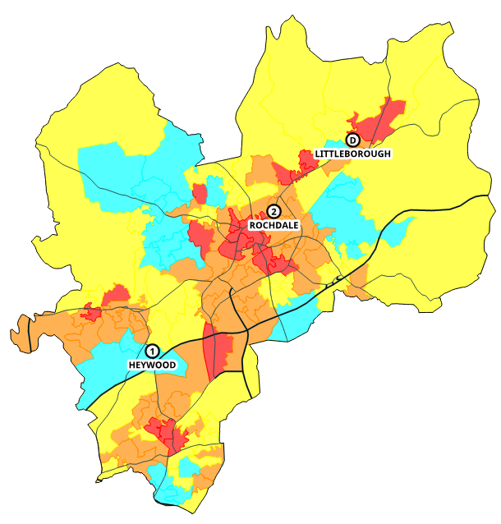

This table is an overview of the changes that may be made in the borough.
Station Area | Actual | After Changes | Specials
Rochdale |  |  | CU
Littleborough |  |  | WU
Heywood |  |  | WIU
The tables below report the actual performance by station area and ward for the past three years, then what the performance is likely to be given the changes proposed.
Performance is measured for each life risk incident and whether the first pump arrived within ten minutes (including call handling) and is given as a percentage that are in time. Average response time is measured for the first pump to arrive at all life risk incidents in that area and is given as a time.

Overall performance and average response time (all times of the day)
 |  | Performance |  |  | Average Response Time
Station Area |  | Actual | Option | Diff | Actual | Option | Diff
G30 | Rochdale | 83.7% | 83.3% | -0.3% | 07:43 | 07:44 | 1
G31 | Littleborough | 74.5% | 74.5% | 0.0% | 07:53 | 07:53 | 0
G32 | Heywood | 81.6% | 81.2% | -0.4% | 07:51 | 07:51 | 0
 | Rochdale | 83.1% | 82.9% | -0.3% | 07:45 | 07:46 | 1

 | Performance |  |  | Average Response Time
Ward | Actual | Option | Diff | Actual | Option | Diff
Balderstone & Kirkholt | 79.5% | 79.5% | 0.0% | 08:56 | 08:56 | 0
Bamford | 90.6% | 90.6% | 0.0% | 08:01 | 08:01 | 0
Castleton | 83.5% | 83.5% | 0.0% | 08:47 | 08:47 | 0
Central Rochdale | 90.6% | 89.5% | -1.0% | 05:45 | 05:50 | 5
East Middleton | 91.4% | 91.4% | 0.0% | 07:33 | 07:33 | 0
Healey | 89.7% | 89.7% | 0.0% | 07:39 | 07:39 | 0
Hopwood Hall | 80.8% | 80.8% | 0.0% | 07:32 | 07:28 | -4
Kingsway | 89.3% | 89.3% | 0.0% | 08:18 | 08:18 | 0
Littleborough Lakeside | 70.5% | 70.5% | 0.0% | 08:04 | 08:04 | 0
Milkstone & Deeplish | 86.4% | 86.4% | 0.0% | 07:21 | 07:21 | 0
Milnrow & Newhey | 50.8% | 48.9% | -1.9% | 10:48 | 10:52 | 3
Norden | 53.1% | 53.1% | 0.0% | 10:13 | 10:13 | 0
North Heywood | 76.7% | 76.7% | 0.0% | 07:43 | 07:43 | 0
North Middleton | 89.6% | 89.6% | 0.0% | 07:44 | 07:44 | 0
Smallbridge & Firgrove | 88.9% | 88.9% | 0.0% | 06:45 | 06:45 | 0
South Middleton | 91.3% | 91.3% | 0.0% | 07:08 | 07:08 | 0
Spotland & Falinge | 87.5% | 87.5% | 0.0% | 07:11 | 07:11 | 0
Wardle, Shore & West Littleborough | 90.3% | 90.3% | 0.0% | 06:52 | 06:52 | 0
West Heywood | 79.7% | 78.2% | -1.6% | 08:04 | 08:06 | 2
West Middleton | 89.6% | 89.6% | 0.0% | 07:45 | 07:45 | 0
Rochdale | 83.1% | 82.9% | -0.3% | 07:45 | 07:46 | 1

Incidents can also be analysed based upon when they occur. The tables below display performance and average response time at ‘night time’. In this case night time relates to the time that non-SDS crews respond from home (Monday – Friday 6:30pm – 8:30am, Saturday – Sunday 1pm – 8:30am). During this time a turnout delay is added onto each proposed mobilisation by NWFC to take into account that crews have to respond to the station first.

Performance and average response time (night time only)
 |  | Performance |  |  | Average Response Time
Station Area |  | Actual | Option | Diff | Actual | Option | Diff
G30 | Rochdale | 83.3% | 82.7% | -0.6% | 07:34 | 07:36 | 2
G31 | Littleborough | 59.6% | 59.6% | 0.0% | 09:29 | 09:29 | 0
G32 | Heywood | 84.1% | 84.1% | 0.0% | 07:33 | 07:33 | 0
 | Rochdale | 83.0% | 82.7% | -0.3% | 07:40 | 07:41 | 1

 | Performance |  |  | Average Response Time
Ward | Actual | Option | Diff | Actual | Option | Diff
Balderstone & Kirkholt | 74.8% | 74.8% | 0.0% | 09:12 | 09:12 | 0
Bamford | 93.5% | 93.5% | 0.0% | 07:38 | 07:38 | 0
Castleton | 83.9% | 83.9% | 0.0% | 08:43 | 08:43 | 0
Central Rochdale | 88.1% | 86.3% | -1.7% | 05:38 | 05:46 | 8
East Middleton | 96.4% | 96.4% | 0.0% | 07:19 | 07:19 | 0
Healey | 85.9% | 85.9% | 0.0% | 07:37 | 07:37 | 0
Hopwood Hall | 88.5% | 88.5% | 0.0% | 06:52 | 06:52 | 0
Kingsway | 87.5% | 87.5% | 0.0% | 07:57 | 07:57 | 0
Littleborough Lakeside | 42.6% | 42.6% | 0.0% | 10:38 | 10:38 | 0
Milkstone & Deeplish | 89.3% | 89.3% | 0.0% | 07:10 | 07:10 | 0
Milnrow & Newhey | 52.7% | 49.3% | -3.3% | 10:28 | 10:34 | 6
Norden | 48.4% | 48.4% | 0.0% | 10:08 | 10:08 | 0
North Heywood | 74.0% | 74.0% | 0.0% | 07:48 | 07:48 | 0
North Middleton | 92.1% | 92.1% | 0.0% | 07:29 | 07:29 | 0
Smallbridge & Firgrove | 91.1% | 91.1% | 0.0% | 06:23 | 06:23 | 0
South Middleton | 96.4% | 96.4% | 0.0% | 06:45 | 06:45 | 0
Spotland & Falinge | 89.3% | 89.3% | 0.0% | 06:42 | 06:42 | 0
Wardle, Shore & West Littleborough | 96.4% | 96.4% | 0.0% | 06:55 | 06:55 | 0
West Heywood | 83.9% | 83.9% | 0.0% | 07:39 | 07:39 | 0
West Middleton | 96.4% | 96.4% | 0.0% | 07:19 | 07:19 | 0
Rochdale | 83.0% | 82.7% | -0.3% | 07:40 | 07:41 | 1

Salford Borough
Salford Borough has five fire stations located at Agecroft, Broughton, Eccles, Salford and a day-crewed station in Irlam. Across the stations there are currently a total of six fire engines. The map below shows the 2022-23 risk model and the location of the stations and roads for context.
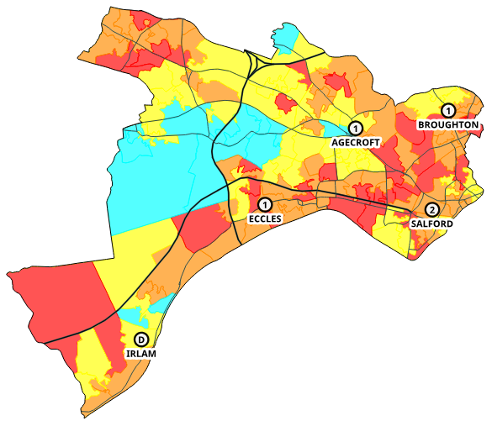
This table is an overview of the changes that may be made in the borough.
Station Area | Actual | After Changes | Specials Details
Salford |  |  | P1 is also Scorpion
Broughton
Agecroft
Eccles |  |  | WIU
Irlam |  |  | WU
The tables below report the actual performance by station area and ward for the past three years, then what the performance is likely to be given the changes proposed.
Performance is measured for each life risk incident and whether the first pump arrived within ten minutes (including call handling) and is given as a percentage that are in time. Average response time is measured for the first pump to arrive at all life risk incidents in that area and is given as a time.
Overall performance and average response time (all times of the day)
 |  | Performance |  |  |  |  |  | Average Response Time
Station Area |  | Actual |  | Option |  | Diff |  | Actual |  | Option |  | Diff
G58 | Salford Central | 93.2% |  | 93.6% |  | 0.4% |  | 06:10 |  | 06:09 |  | -1
G59 | Broughton | 93.4% |  | 93.4% |  | 0.0% |  | 06:32 |  | 06:30 |  | -2
G60 | Agecroft | 88.8% |  | 88.8% |  | 0.0% |  | 07:31 |  | 07:31 |  | 0
G61 | Eccles | 89.0% |  | 89.0% |  | 0.0% |  | 07:09 |  | 07:10 |  | 1
G62 | Irlam | 85.8% |  | 85.8% |  | 0.0% |  | 07:18 |  | 07:18 |  | 0
 | Salford | 90.2% |  | 90.2% |  | 0.0% |  | 07:00 |  | 07:00 |  | 0
 |  |  | Performance |  |  |  |  |  | Average Response Time
Ward |  |  | Actual |  | Option |  | Diff |  | Actual |  | Option |  |  | Diff
Barton & Winton |  |  | 92.6% |  | 92.6% |  | 0.0% |  | 06:03 |  | 06:03 |  |  | 0
Blackfriars & Trinity |  |  | 94.8% |  | 94.8% |  | 0.0% |  | 06:04 |  | 06:04 |  |  | 0
Boothstown & Ellenbrook |  |  | 83.6% |  | 83.6% |  | 0.0% |  | 09:32 |  | 09:32 |  |  | 0
Broughton |  |  | 96.4% |  | 96.4% |  | 0.0% |  | 05:51 |  | 05:48 |  |  | -3
Cadishead & Lower Irlam |  |  | 86.1% |  | 86.1% |  | 0.0% |  | 07:12 |  | 07:12 |  |  | 0
Claremont |  |  | 93.6% |  | 93.6% |  | 0.0% |  | 06:46 |  | 06:42 |  |  | -4
Eccles |  |  | 94.0% |  | 94.0% |  | 0.0% |  | 06:35 |  | 06:35 |  |  | 0
Higher Irlam & Peel Green |  |  | 86.5% |  | 86.5% |  | 0.0% |  | 07:12 |  | 07:12 |  |  | -1
Kersal & Broughton Park |  |  | 92.9% |  | 92.9% |  | 0.0% |  | 06:24 |  | 06:27 |  |  | 2
Little Hulton |  |  | 86.0% |  | 84.1% |  | -1.8% |  | 07:56 |  | 08:02 |  |  | 5
Ordsall |  |  | 94.9% |  | 96.7% |  | 1.8% |  | 05:19 |  | 05:14 |  |  | -5
Pendlebury & Clifton |  |  | 87.1% |  | 86.7% |  | -0.4% |  | 07:40 |  | 07:41 |  |  | 1
Pendleton & Charlestown |  |  | 93.6% |  | 94.7% |  | 1.1% |  | 06:27 |  | 06:22 |  |  | -5
Quays |  |  | 91.0% |  | 93.1% |  | 2.0% |  | 07:22 |  | 07:19 |  |  | -3
Swinton & Wardley |  |  | 88.6% |  | 88.6% |  | 0.0% |  | 08:08 |  | 08:08 |  |  | 0
Swinton Park |  |  | 93.5% |  | 93.5% |  | 0.0% |  | 06:49 |  | 07:00 |  |  | 12
Walkden North |  |  | 86.5% |  | 86.5% |  | 0.0% |  | 07:11 |  | 07:11 |  |  | 0
Walkden South |  |  | 79.0% |  | 79.0% |  | 0.0% |  | 08:08 |  | 08:08 |  |  | 0
Weaste & Seedley |  |  | 92.6% |  | 91.7% |  | -0.9% |  | 06:44 |  | 06:47 |  |  | 3
Worsley & Westwood Park |  |  | 81.8% |  | 81.8% |  | 0.0% |  | 08:16 |  | 08:16 |  |  | 0
Salford |  |  | 90.2% |  | 90.2% |  | 0.0% |  | 07:00 |  | 07:00 |  |  | 0

Incidents can also be analysed based upon when they occur. The tables below display performance and average response time at ‘night time’. In this case night time relates to the time that non-SDS crews respond from home (Monday – Friday 6:30pm – 8:30am, Saturday – Sunday 1pm – 8:30am). During this time a turnout delay is added onto each proposed mobilisation by NWFC to take into account that crews have to respond to the station first.

Performance and average response time (night time only)
 |  | Performance |  |  | Average Response Time
Station Area |  | Actual | Option | Diff | Actual | Option | Diff
G58 | Salford Central | 93.9% | 93.9% | 0.0% | 05:59 | 05:59 | 0
G59 | Broughton | 93.3% | 93.3% | 0.0% | 06:37 | 06:35 | -2
G60 | Agecroft | 91.2% | 91.2% | 0.0% | 07:28 | 07:29 | 1
G61 | Eccles | 89.8% | 89.8% | 0.0% | 07:07 | 07:07 | 0
G62 | Irlam | 87.3% | 87.3% | 0.0% | 07:15 | 07:15 | 0
 | Salford | 91.9% | 91.9% | 0.0% | 06:55 | 06:55 | 0

 | Performance |  |  | Average Response Time
Ward | Actual | Option | Diff | Actual | Option | Diff
Barton & Winton | 90.6% | 90.6% | 0.0% | 06:21 | 06:21 | 0
Blackfriars & Trinity | 94.3% | 94.3% | 0.0% | 06:12 | 06:13 | 1
Boothstown & Ellenbrook | 84.9% | 84.9% | 0.0% | 09:56 | 09:56 | 0
Broughton | 96.4% | 96.4% | 0.0% | 05:48 | 05:45 | -3
Cadishead & Lower Irlam | 90.7% | 90.7% | 0.0% | 06:58 | 06:58 | 0
Claremont | 96.4% | 96.4% | 0.0% | 06:41 | 06:32 | -9
Eccles | 94.4% | 94.4% | 0.0% | 06:31 | 06:31 | 0
Higher Irlam & Peel Green | 89.3% | 89.3% | 0.0% | 06:58 | 06:57 | -1
Kersal & Broughton Park | 93.0% | 93.0% | 0.0% | 06:43 | 06:43 | 0
Little Hulton | 88.5% | 88.5% | 0.0% | 07:36 | 07:36 | 0
Ordsall | 94.1% | 96.7% | 2.6% | 05:37 | 05:29 | -8
Pendlebury & Clifton | 90.0% | 89.3% | -0.7% | 07:31 | 07:33 | 2
Pendleton & Charlestown | 96.4% | 98.5% | 2.1% | 06:10 | 06:03 | -7
Quays | 93.6% | 93.6% | 0.0% | 06:23 | 06:23 | 0
Swinton & Wardley | 87.8% | 87.8% | 0.0% | 08:12 | 08:12 | 0
Swinton Park | 96.4% | 96.4% | 0.0% | 06:32 | 06:54 | 22
Walkden North | 88.3% | 88.3% | 0.0% | 07:07 | 07:07 | 0
Walkden South | 88.1% | 88.1% | 0.0% | 07:47 | 07:47 | 0
Weaste & Seedley | 92.9% | 91.4% | -1.5% | 06:48 | 06:53 | 5
Worsley & Westwood Park | 91.1% | 91.1% | 0.0% | 08:09 | 08:09 | 0
Salford | 91.9% | 91.9% | 0.0% | 06:55 | 06:55 | 0

Stockport Borough
Stockport Borough has five fire stations located at Cheadle, Whitehill, Stockport, Offerton and a day crewed station, Marple. Across the stations there are a total of five fire engines. The map below shows the 2022-23 risk model and the location of the stations and roads for context.
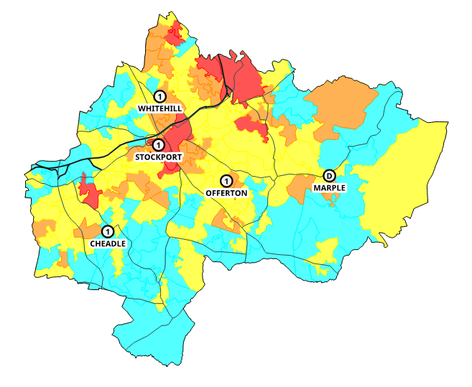
This table is an overview of the changes that may be made in the borough
Station Area | Actual | After Changes | Special
Whitehill |  |  | AA
Stockport
Cheadle |  |  | HL
Offerton
Marple
The tables below report the actual performance by station area and ward for the past three years, then what the performance is likely to be given the changes proposed.
Performance is measured for each life risk incident and whether the first pump arrived within ten minutes (including call handling) and is given as a percentage that are in time. Average response time is measured for the first pump to arrive at all life risk incidents in that area and is given as a time.
Overall performance and average response time (all times of the day)
 |  | Performance |  |  | Average Response Time
Station Area |  | Actual | Option | Diff | Actual | Option | Diff
G20 | Whitehill | 91.4% | 91.4% | 0.0% | 07:18 | 07:18 | 0
G21 | Stockport | 92.5% | 93.3% | 0.8% | 06:35 | 06:31 | -4
G22 | Cheadle | 82.4% | 82.4% | 0.0% | 07:30 | 07:31 | 1
G23 | Offerton | 91.8% | 82.4% | -9.5% | 06:41 | 08:07 | 86
G24 | Marple | 72.2% | 66.3% | -6.0% | 08:54 | 09:10 | 16
 | Stockport | 87.0% | 84.8% | -2.2% | 07:22 | 07:37 | 15

 | Performance |  |  | Average Response Time
Ward | Actual | Option | Diff | Actual | Option | Diff
Bramhall North | 67.8% | 67.8% | 0.0% | 09:05 | 09:17 | 12
Bramhall South and Woodford | 65.2% | 65.2% | 0.0% | 09:31 | 09:32 | 1
Bredbury and Woodley | 75.5% | 75.5% | 0.0% | 09:22 | 09:22 | 0
Bredbury Green and Romiley | 74.6% | 62.6% | -12.0% | 09:46 | 10:00 | 14
Brinnington and Central | 92.5% | 93.2% | 0.7% | 06:55 | 06:50 | -5
Cheadle and Gatley | 87.6% | 87.6% | 0.0% | 07:59 | 07:59 | 0
Cheadle Hulme North | 89.4% | 92.4% | 2.9% | 06:46 | 06:37 | -8
Cheadle Hulme South | 90.0% | 90.0% | 0.0% | 06:22 | 06:22 | 0
Davenport and Cale Green | 90.5% | 92.7% | 2.2% | 07:03 | 06:52 | -11
Edgeley and Cheadle Heath | 90.4% | 88.8% | -1.6% | 06:22 | 06:22 | 0
Hazel Grove | 92.1% | 66.0% | -26.2% | 07:22 | 09:06 | 104
Heald Green | 94.1% | 91.4% | -2.6% | 06:29 | 06:36 | 7
Heatons North | 96.4% | 96.4% | 0.0% | 06:58 | 06:54 | -4
Heatons South | 91.3% | 94.0% | 2.7% | 06:36 | 06:33 | -4
Manor | 93.6% | 93.6% | 0.0% | 06:37 | 06:59 | 23
Marple North | 67.8% | 67.8% | 0.0% | 08:35 | 08:35 | 0
Marple South and High Lane | 72.7% | 66.8% | -5.9% | 08:24 | 08:53 | 29
Offerton | 92.0% | 92.0% | 0.0% | 05:57 | 07:37 | 100
Reddish North | 96.4% | 96.4% | 0.0% | 07:15 | 07:15 | 0
Reddish South | 87.1% | 84.1% | -3.0% | 06:46 | 07:03 | 17
Stepping Hill | 92.0% | 85.9% | -6.1% | 06:40 | 08:21 | 101
Stockport | 87.0% | 84.8% | -2.2% | 07:22 | 07:37 | 15
Incidents can also be analysed based upon when they occur. The tables below display performance and average response time at ‘night time’. In this case night time relates to the time that non-SDS crews respond from home (Monday – Friday 6:30pm – 8:30am, Saturday – Sunday 1pm – 8:30am). During this time a turnout delay is added onto each proposed mobilisation by NWFC to take into account that crews have to respond to the station first.

Performance and average response time (night time only)
 |  | Performance |  |  | Average Response Time
Station Area |  | Actual | Option | Diff | Actual | Option | Diff
G20 | Whitehill | 90.8% | 90.8% | 0.0% | 07:19 | 07:20 | 1
G21 | Stockport | 94.0% | 94.7% | 0.7% | 06:29 | 06:23 | -6
G22 | Cheadle | 85.5% | 86.8% | 1.2% | 07:11 | 07:08 | -3
G23 | Offerton | 91.2% | 76.7% | -14.5% | 06:35 | 08:56 | 140
G24 | Marple | 68.5% | 58.2% | -10.3% | 09:27 | 09:54 | 27
 | Stockport | 87.3% | 84.2% | -3.1% | 07:19 | 07:41 | 22

 | Performance |  |  | Average Response Time
Ward | Actual | Option | Diff | Actual | Option | Diff
Bramhall North | 82.1% | 82.1% | 0.0% | 07:47 | 07:54 | 7
Bramhall South and Woodford | 60.7% | 60.7% | 0.0% | 09:46 | 09:48 | 2
Bredbury and Woodley | 78.5% | 78.5% | 0.0% | 09:08 | 09:08 | 0
Bredbury Green and Romiley | 77.0% | 52.0% | -25.0% | 09:48 | 10:22 | 34
Brinnington and Central | 93.0% | 94.0% | 1.0% | 06:49 | 06:42 | -7
Cheadle and Gatley | 86.7% | 86.7% | 0.0% | 07:42 | 07:42 | 0
Cheadle Hulme North | 96.4% | 99.4% | 4.0% | 05:57 | 05:43 | -14
Cheadle Hulme South | 90.2% | 90.2% | 0.0% | 06:13 | 06:13 | 0
Davenport and Cale Green | 90.2% | 93.5% | 3.3% | 07:11 | 06:54 | -17
Edgeley and Cheadle Heath | 90.7% | 87.7% | -3.0% | 06:01 | 05:56 | -5
Hazel Grove | 92.7% | 54.2% | -38.5% | 07:10 | 09:45 | 155
Heald Green | 96.4% | 96.4% | 0.0% | 06:32 | 06:32 | 0
Heatons North | 96.4% | 96.4% | 0.0% | 06:41 | 06:41 | 0
Heatons South | 96.4% | 96.4% | 0.0% | 06:18 | 06:21 | 2
Manor | 94.0% | 94.0% | 0.0% | 06:42 | 07:26 | 43
Marple North | 64.3% | 64.3% | 0.0% | 09:15 | 09:15 | 0
Marple South and High Lane | 62.0% | 54.9% | -7.1% | 09:18 | 09:58 | 40
Offerton | 92.1% | 92.1% | 0.0% | 05:48 | 08:38 | 170
Reddish North | 96.4% | 96.4% | 0.0% | 07:13 | 07:13 | 0
Reddish South | 81.0% | 81.0% | 0.0% | 07:24 | 07:32 | 9
Stepping Hill | 89.7% | 85.0% | -4.8% | 06:51 | 09:02 | 131
Stockport | 87.3% | 84.2% | -3.1% | 07:19 | 07:41 | 22

Tameside Borough
Tameside Borough has four fire stations located at Ashton, Stalybridge, Hyde and Mossley. Across the stations there are a total of four fire engines, and a Technical Response Unit as a ‘life risk fire engine’. Mossley is a day crewed station. The map below shows the 2022-23 risk model and the location of the stations and roads for context.
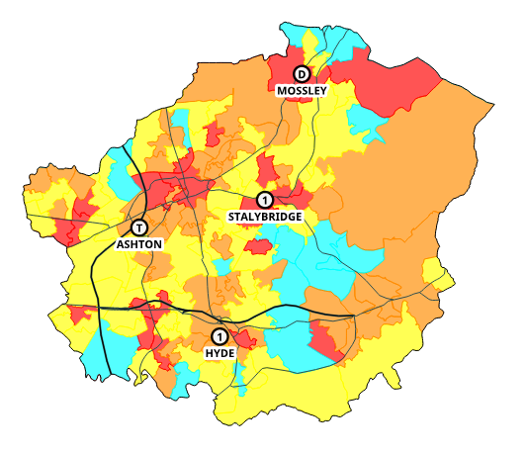
This table is an overview of the changes that may be made in the borough.
Station Area | Actual | After Changes | Specials Details
Ashton
Stalybridge |  |  | WU
Mossley |  |  | WU
Hyde |  |  | CU

The tables below report the actual performance by station area and ward for the past three years, then what the performance is likely to be given the changes proposed.
Performance is measured for each life risk incident and whether the first pump arrived within ten minutes (including call handling) and is given as a percentage that are in time. Average response time is measured for the first pump to arrive at all life risk incidents in that area and is given as a time.
Overall performance and average response time (all times of the day)
 |  | Performance |  |  | Average Response Time
Station Area |  | Actual | Option | Diff | Actual | Option | Diff
G39 | Ashton | 89.8% | 88.6% | -1.2% | 07:16 | 07:15 | -1
G40 | Stalybridge | 89.8% | 89.8% | 0.0% | 07:19 | 07:17 | -1
G41 | Mossley | 62.3% | 61.5% | -0.8% | 09:39 | 09:42 | 3
G42 | Hyde | 78.5% | 78.5% | 0.0% | 08:21 | 08:22 | 1
 | Tameside | 86.3% | 85.8% | -0.5% | 07:38 | 07:38 | 0

 | Performance |  |  | Average Response Time
Ward | Actual | Option | Diff | Actual | Option | Diff
Ashton Hurst | 89.1% | 89.1% | 0.0% | 08:34 | 08:33 | -1
Ashton St. Michaels | 93.6% | 93.6% | 0.0% | 06:55 | 06:52 | -3
Ashton Waterloo | 94.2% | 94.2% | 0.0% | 08:15 | 08:19 | 4
Audenshaw | 89.1% | 84.9% | -4.3% | 06:52 | 06:58 | 6
Denton North East | 96.4% | 96.4% | 0.0% | 06:58 | 06:55 | -4
Denton South | 86.1% | 86.1% | 0.0% | 07:38 | 07:38 | 0
Denton West | 87.5% | 87.5% | 0.0% | 08:11 | 08:11 | 0
Droylsden East | 88.7% | 88.7% | 0.0% | 07:45 | 07:34 | -11
Droylsden West | 86.1% | 80.4% | -5.7% | 08:22 | 08:31 | 9
Dukinfield | 94.9% | 93.2% | -1.7% | 07:17 | 07:20 | 3
Dukinfield Stalybridge | 93.5% | 97.0% | 3.6% | 06:37 | 06:27 | -10
Hyde Godley | 81.4% | 84.0% | 2.6% | 07:45 | 07:38 | -7
Hyde Newton | 82.4% | 80.4% | -2.0% | 07:53 | 07:58 | 5
Hyde Werneth | 80.8% | 80.8% | 0.0% | 07:06 | 07:20 | 14
Longdendale | 51.2% | 51.2% | 0.0% | 11:10 | 11:08 | -2
Mossley | 83.4% | 81.1% | -2.3% | 07:57 | 08:06 | 9
St. Peters | 90.5% | 91.3% | 0.9% | 06:49 | 06:49 | -1
Stalybridge North | 75.4% | 75.4% | 0.0% | 07:35 | 07:32 | -3
Stalybridge South | 82.6% | 82.6% | 0.0% | 07:39 | 07:34 | -6
Tameside | 86.3% | 85.8% | -0.5% | 07:38 | 07:38 | 0

Incidents can also be analysed based upon when they occur. The tables below display performance and average response time at ‘night time’. In this case night time relates to the time that non-SDS crews respond from home (Monday – Friday 6:30pm – 8:30am, Saturday – Sunday 1pm – 8:30am). During this time a turnout delay is added onto each proposed mobilisation by NWFC to take into account that crews have to respond to the station first.

Performance and average response time (night time only)
 |  | Performance |  |  | Average Response Time
Station Area |  | Actual | Option | Diff | Actual | Option | Diff
G39 | Ashton | 91.8% | 91.1% | -0.7% | 07:02 | 07:01 | -1
G40 | Stalybridge | 88.7% | 88.7% | 0.0% | 07:20 | 07:19 | -1
G41 | Mossley | 63.5% | 63.5% | 0.0% | 09:54 | 09:54 | 0
G42 | Hyde | 80.3% | 80.3% | 0.0% | 08:22 | 08:22 | 0
 | Tameside | 87.6% | 87.4% | -0.2% | 07:34 | 07:33 | -1

 | Performance |  |  | Average Response Time
Ward | Actual | Option | Diff | Actual | Option | Diff
Ashton Hurst | 90.8% | 90.8% | 0.0% | 08:47 | 08:47 | 0
Ashton St. Michaels | 94.1% | 94.1% | 0.0% | 06:47 | 06:47 | 0
Ashton Waterloo | 92.6% | 92.6% | 0.0% | 08:06 | 08:05 | -1
Audenshaw | 93.1% | 89.2% | -3.8% | 06:35 | 06:37 | 2
Denton North East | 96.4% | 96.4% | 0.0% | 06:34 | 06:34 | 0
Denton South | 79.7% | 79.7% | 0.0% | 07:55 | 07:55 | 0
Denton West | 92.4% | 92.4% | 0.0% | 07:49 | 07:49 | 0
Droylsden East | 86.4% | 86.4% | 0.0% | 07:59 | 07:49 | -10
Droylsden West | 92.4% | 92.4% | 0.0% | 07:55 | 07:51 | -5
Dukinfield | 96.4% | 93.7% | -2.7% | 07:09 | 07:12 | 3
Dukinfield Stalybridge | 96.4% | 99.8% | 4.6% | 06:15 | 05:55 | -20
Hyde Godley | 96.4% | 99.4% | 3.0% | 06:57 | 06:45 | -13
Hyde Newton | 82.6% | 79.0% | -3.6% | 08:06 | 08:15 | 9
Hyde Werneth | 74.7% | 74.7% | 0.0% | 07:39 | 07:39 | 0
Longdendale | 54.7% | 54.7% | 0.0% | 11:03 | 11:03 | 0
Mossley | 84.9% | 84.9% | 0.0% | 08:32 | 08:32 | 0
St. Peters | 91.3% | 91.3% | 0.0% | 06:33 | 06:35 | 2
Stalybridge North | 74.5% | 74.5% | 0.0% | 08:03 | 08:03 | 0
Stalybridge South | 80.6% | 80.6% | 0.0% | 07:42 | 07:42 | 0
Tameside | 87.6% | 87.4% | -0.2% | 07:34 | 07:33 | -1

Trafford Borough
Trafford Borough has three fire stations located at Altrincham, Sale and Stretford. Across the stations there are a total of three fire engines. The map below shows the 2022-23 risk model and the location of the stations and roads for context.
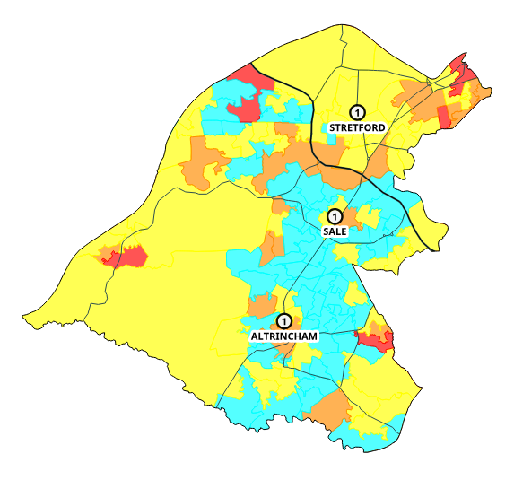
This table is an overview of the changes that may be made in the borough.
Station Area | Actual | After Changes | Specials
Stretford |  |  | HVP FI AA (proposed to be moved)
Sale |  |  | FU
Altrincham |  |  | BAU

The tables below report the actual performance by station area and ward for the past three years, then what the performance is likely to be given the changes proposed.
Performance is measured for each life risk incident and whether the first pump arrived within ten minutes (including call handling) and is given as a percentage that are in time. Average response time is measured for the first pump to arrive at all life risk incidents in that area and is given as a time.
Overall performance and average response time (all times of the day)
 |  | Performance |  |  | Average Response Time
Station Area |  | Actual | Option | Diff | Actual | Option | Diff
G10 | Stretford | 89.5% | 88.7% | -0.8% | 07:36 | 07:41 | 5
G11 | Sale | 82.8% | 79.9% | -3.0% | 07:45 | 08:55 | 70
G12 | Altrincham | 77.1% | 74.7% | -2.4% | 08:17 | 08:23 | 6
 | Trafford | 83.3% | 81.7% | -1.6% | 07:43 | 08:03 | 20

 | Performance |  |  | Average Response Time
Ward | Actual | Option | Diff | Actual | Option | Diff
Altrincham | 78.6% | 76.0% | -2.6% | 07:01 | 06:58 | -4
Ashton upon Mersey | 86.1% | 86.1% | 0.0% | 06:23 | 07:52 | 89
Bowdon | 59.3% | 55.9% | -3.3% | 10:05 | 10:21 | 16
Broadheath | 91.3% | 85.9% | -5.4% | 06:41 | 07:01 | 21
Brooklands | 90.0% | 90.0% | 0.0% | 07:11 | 08:36 | 85
Bucklow-St. Martins | 26.6% | 13.1% | -13.5% | 11:28 | 12:28 | 60
Clifford | 94.7% | 94.7% | 0.0% | 06:19 | 05:46 | -33
Davyhulme East | 84.9% | 84.9% | 0.0% | 07:54 | 08:01 | 7
Davyhulme West | 72.9% | 72.9% | 0.0% | 09:31 | 09:38 | 8
Flixton | 75.6% | 75.6% | 0.0% | 09:36 | 09:50 | 14
Gorse Hill | 93.8% | 92.3% | -1.5% | 06:46 | 06:54 | 8
Hale Barns | 73.5% | 73.5% | 0.0% | 09:08 | 09:08 | 0
Hale Central | 79.7% | 79.7% | 0.0% | 08:01 | 08:01 | 0
Longford | 91.3% | 91.3% | 0.0% | 06:53 | 06:50 | -2
Priory | 94.5% | 94.5% | 0.0% | 06:05 | 07:45 | 99
Sale Moor | 96.4% | 96.4% | 0.0% | 07:57 | 09:08 | 70
St. Marys | 83.9% | 87.1% | 3.2% | 07:44 | 08:11 | 28
Stretford | 94.6% | 94.6% | 0.0% | 06:47 | 06:52 | 6
Timperley | 91.1% | 84.9% | -6.3% | 06:59 | 07:10 | 10
Urmston | 89.6% | 86.6% | -2.9% | 08:07 | 08:11 | 5
Village | 92.7% | 88.4% | -4.3% | 07:47 | 07:54 | 8
Trafford | 83.3% | 81.7% | -1.6% | 07:43 | 08:03 | 20

Incidents can also be analysed based upon when they occur. The tables below display performance and average response time at ‘night time’. In this case night time relates to the time that non-SDS crews respond from home (Monday – Friday 6:30pm – 8:30am, Saturday – Sunday 1pm – 8:30am). During this time a turnout delay is added onto each proposed mobilisation by NWFC to take into account that crews have to respond to the station first.

Performance and average response time (night time only)
 |  | Performance |  |  | Average Response Time
Station Area |  | Actual | Option | Diff | Actual | Option | Diff
G10 | Stretford | 91.7% | 90.4% | -1.2% | 07:21 | 07:29 | 8
G11 | Sale | 85.8% | 80.2% | -5.6% | 07:32 | 09:22 | 110
G12 | Altrincham | 81.5% | 77.2% | -4.4% | 08:06 | 08:19 | 13
 | Trafford | 86.3% | 83.7% | -2.6% | 07:29 | 08:02 | 34

 | Performance |  |  | Average Response Time
Ward | Actual | Option | Diff | Actual | Option | Diff
Altrincham | 86.4% | 86.4% | 0.0% | 06:20 | 06:20 | 0
Ashton upon Mersey | 83.1% | 83.1% | 0.0% | 06:06 | 08:41 | 155
Bowdon | 55.2% | 49.3% | -5.9% | 09:54 | 10:23 | 29
Broadheath | 96.4% | 85.9% | -10.5% | 06:22 | 07:02 | 40
Brooklands | 96.4% | 96.4% | 0.0% | 06:55 | 09:18 | 143
Bucklow-St. Martins | 34.3% | 15.8% | -18.5% | 10:48 | 12:11 | 82
Clifford | 96.4% | 96.4% | 0.0% | 06:10 | 05:51 | -19
Davyhulme East | 87.8% | 87.8% | 0.0% | 07:51 | 07:58 | 7
Davyhulme West | 68.4% | 68.4% | 0.0% | 09:44 | 09:44 | 0
Flixton | 76.4% | 76.4% | 0.0% | 09:46 | 10:08 | 22
Gorse Hill | 94.4% | 92.1% | -2.2% | 06:34 | 06:46 | 12
Hale Barns | 86.9% | 86.9% | 0.0% | 08:36 | 08:36 | 0
Hale Central | 88.1% | 88.1% | 0.0% | 07:50 | 07:50 | 0
Longford | 91.8% | 91.8% | 0.0% | 06:48 | 06:45 | -3
Priory | 96.4% | 96.4% | 0.0% | 06:02 | 08:21 | 139
Sale Moor | 86.4% | 75.3% | -11.1% | 07:37 | 08:16 | 39
St. Marys | 96.4% | 93.4% | -3.0% | 08:21 | 10:42 | 141
Stretford | 93.4% | 93.4% | 0.0% | 06:49 | 06:57 | 9
Timperley | 86.4% | 75.3% | -11.1% | 07:00 | 07:18 | 18
Urmston | 96.4% | 92.1% | -4.3% | 07:25 | 07:32 | 7
Village | 96.4% | 89.3% | -7.1% | 08:01 | 08:14 | 13
Trafford | 86.3% | 83.7% | -2.6% | 07:29 | 08:02 | 34

Wigan Borough
Wigan Borough has four fire stations located at Atherton, Hindley, Leigh and Wigan. Across the stations there are a total of five fire engines and a Technical Rescue Unit ‘life risk pump’ at Leigh. The map below shows the 2022-23 risk model and the location of the stations and roads for context.
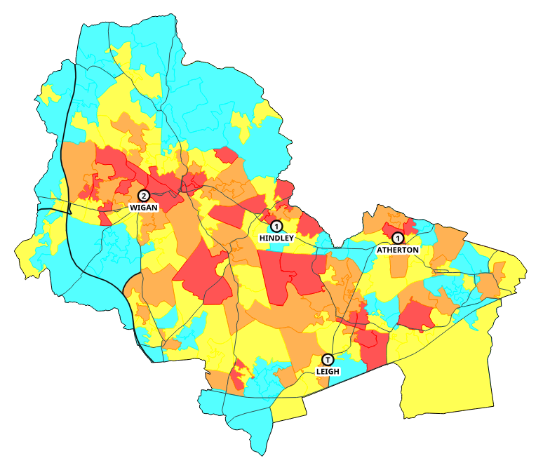
This table is an overview of the changes that may be made in the borough.
Station Area | Actual | After Changes | Specials
Wigan |  |  | P1 is proposed to become a Scorpion
Hindley
Atherton |  |  | CU
Leigh |  |  | AA (proposed to be removed)

The tables below report the actual performance by station area and ward for the past three years, then what the performance is likely to be given the changes proposed.
Performance is measured for each life risk incident and whether the first pump arrived within ten minutes (including call handling) and is given as a percentage that are in time. Average response time is measured for the first pump to arrive at all life risk incidents in that area and is given as a time.
Overall performance and average response time (all times of the day)
 |  | Performance |  |  | Average Response Time
Station Area |  | Actual | Option | Diff | Actual | Option | Diff
G54 | Wigan | 79.5% | 79.7% | 0.2% | 08:12 | 08:11 | -1
G55 | Hindley | 81.0% | 81.0% | 0.0% | 08:17 | 08:17 | 0
G56 | Atherton | 83.0% | 83.0% | 0.0% | 07:43 | 07:45 | 2
G57 | Leigh | 84.7% | 83.1% | -1.6% | 07:31 | 07:44 | 13
 | Wigan | 81.6% | 81.3% | -0.3% | 07:57 | 08:00 | 3

 | Performance |  |  | Average Response Time
Ward | Actual | Option | Diff | Actual | Option | Diff
Abram | 75.5% | 75.5% | 0.0% | 09:16 | 09:17 | 1
Ashton | 59.3% | 59.3% | 0.0% | 09:52 | 09:52 | 0
Aspull New Springs Whelley | 46.4% | 46.4% | 0.0% | 10:38 | 10:32 | -6
Astley Mosley Common | 62.4% | 62.4% | 0.0% | 10:07 | 10:07 | 0
Atherleigh | 91.8% | 91.8% | 0.0% | 06:30 | 06:29 | -1
Atherton | 92.7% | 91.3% | -1.4% | 06:09 | 06:15 | 6
Bryn | 67.0% | 67.0% | 0.0% | 10:05 | 10:05 | 0
Douglas | 94.0% | 94.0% | 0.0% | 05:50 | 05:50 | 0
Golborne and Lowton West | 58.6% | 53.6% | -5.0% | 09:33 | 09:57 | 24
Hindley | 92.5% | 92.5% | 0.0% | 06:13 | 06:13 | 0
Hindley Green | 90.3% | 90.3% | 0.0% | 07:03 | 07:03 | 0
Ince | 88.1% | 90.1% | 2.0% | 07:28 | 07:21 | -8
Leigh East | 93.6% | 93.6% | 0.0% | 07:35 | 07:44 | 9
Leigh South | 83.6% | 82.2% | -1.4% | 07:02 | 07:14 | 12
Leigh West | 91.2% | 90.0% | -1.2% | 07:00 | 07:08 | 8
Lowton East | 83.4% | 80.7% | -2.7% | 07:23 | 07:45 | 22
Orrell | 63.1% | 63.1% | 0.0% | 11:55 | 11:55 | 0
Pemberton | 82.8% | 82.8% | 0.0% | 08:06 | 08:06 | 0
Shevington with Lower Ground | 46.4% | 46.4% | 0.0% | 11:18 | 11:18 | 0
Standish with Langtree | 28.5% | 28.5% | 0.0% | 10:41 | 10:41 | 0
Tyldesley | 83.2% | 85.3% | 2.1% | 08:28 | 08:28 | 0
Wigan Central | 94.4% | 94.4% | 0.0% | 07:08 | 07:08 | 0
Wigan West | 94.5% | 94.5% | 0.0% | 07:16 | 07:16 | 0
Winstanley | 88.1% | 88.1% | 0.0% | 07:38 | 07:38 | 0
Worsley Mesnes | 90.3% | 90.3% | 0.0% | 06:57 | 06:59 | 2
Wigan | 81.6% | 81.3% | -0.3% | 07:57 | 08:00 | 3

Incidents can also be analysed based upon when they occur. The tables below display performance and average response time at ‘night time’. In this case night time relates to the time that non-SDS crews respond from home (Monday – Friday 6:30pm – 8:30am, Saturday – Sunday 1pm – 8:30am). During this time a turnout delay is added onto each proposed mobilisation by NWFC to take into account that crews have to respond to the station first.

Performance and average response time (night time only)
 |  | Performance |  |  | Average Response Time
Station Area |  | Actual | Option | Diff | Actual | Option | Diff
G54 | Wigan | 80.8% | 80.8% | 0.0% | 08:01 | 08:01 | 0
G55 | Hindley | 80.9% | 80.9% | 0.0% | 08:20 | 08:21 | 1
G56 | Atherton | 82.3% | 81.6% | -0.7% | 07:54 | 07:57 | 3
G57 | Leigh | 85.2% | 84.7% | -0.5% | 07:33 | 07:38 | 5
 | Wigan | 82.3% | 82.0% | -0.3% | 07:55 | 07:57 | 2

 | Performance |  |  | Average Response Time
Ward | Actual | Option | Diff | Actual | Option | Diff
Abram | 78.1% | 78.1% | 0.0% | 09:11 | 09:12 | 1
Ashton | 57.3% | 57.3% | 0.0% | 09:48 | 09:48 | 0
Aspull New Springs Whelley | 43.1% | 43.1% | 0.0% | 10:32 | 10:32 | 0
Astley Mosley Common | 63.1% | 63.1% | 0.0% | 10:26 | 10:26 | 0
Atherleigh | 88.4% | 88.4% | 0.0% | 06:54 | 06:53 | -1
Atherton | 90.4% | 88.2% | -2.2% | 06:25 | 06:35 | 10
Bryn | 72.4% | 72.4% | 0.0% | 09:49 | 09:49 | 0
Douglas | 94.4% | 94.4% | 0.0% | 05:41 | 05:41 | 0
Golborne and Lowton West | 64.4% | 64.4% | 0.0% | 09:18 | 09:23 | 4
Hindley | 92.0% | 92.0% | 0.0% | 06:25 | 06:25 | 0
Hindley Green | 85.9% | 85.9% | 0.0% | 08:00 | 08:00 | 0
Ince | 87.0% | 87.0% | 0.0% | 07:25 | 07:25 | 0
Leigh East | 93.8% | 93.8% | 0.0% | 07:37 | 07:40 | 3
Leigh South | 83.9% | 81.6% | -2.3% | 07:09 | 07:29 | 21
Leigh West | 90.1% | 90.1% | 0.0% | 07:12 | 07:12 | 0
Lowton East | 84.3% | 84.3% | 0.0% | 07:26 | 07:22 | -4
Orrell | 71.4% | 71.4% | 0.0% | 10:49 | 10:49 | 0
Pemberton | 80.8% | 80.8% | 0.0% | 08:08 | 08:08 | 0
Shevington with Lower Ground | 51.0% | 51.0% | 0.0% | 10:13 | 10:13 | 0
Standish with Langtree | 33.9% | 33.9% | 0.0% | 10:38 | 10:38 | 0
Tyldesley | 85.0% | 85.0% | 0.0% | 08:23 | 08:23 | 0
Wigan Central | 92.7% | 92.7% | 0.0% | 07:11 | 07:11 | 0
Wigan West | 92.6% | 92.6% | 0.0% | 07:39 | 07:39 | 0
Winstanley | 88.1% | 88.1% | 0.0% | 07:54 | 07:54 | 0
Worsley Mesnes | 90.5% | 90.5% | 0.0% | 06:44 | 06:44 | 0
Wigan | 82.3% | 82.0% | -0.3% | 07:55 | 07:57 | 2

Appendix 1 – Special Appliance Glossary
The below table provides a glossary of each of our special appliances:
Abbreviation | Special Appliance Type | Description
AA | Aerial Appliance | These vehicles have a range of uses at a variety of incidents, including tackling fires in high rise buildings, allowing firefighters to tackle a fire from above or act as a vantage point for firefighters using handheld jets. They can be used to assist in the recovery of casualties from hard-to-reach places or lower or raise casualties safely. With a ladder reach ranging between 32m and 42m, they are amongst the highest articulated ladder appliances in use by UK FRS.
BAU | Breathing Apparatus Unit | This specialist vehicle is available to be deployed at an incident where a large number of BA wearers are deployed or a large number of resources such as compressed air cylinders. The BA unit carries equipment to support the welfare of firefighters involved in BA wears.
CU | Command Unit | This vehicle would normally be used at large protracted incidents as a mobile incident command centre. This vehicle is equipped with Airwave and UHF radio transmission equipment that enables radio messages to be collated at the incident ground and relayed to the control room (NWFC).
EPU | Environmental Protection Unit | Designed to carry large quantities of specialised equipment to help mitigate damage to the environment from incidents such as flooding and chemical spillages etc.
FI | Fire Investigation Unit | This is a specialised unit used for investigating the cause and origin of fires. The team is comprised of highly trained and experienced firefighters who use forensic techniques and specialised equipment to gather evidence and determine the root cause of fires.
Abbreviation | Special Appliance Type | Description
FU | Foam Unit | These vehicles are designed to carry large quantities of foam to the scene of operations. Each vehicle carries 7x1000 litres of RF3 foam concentrate in intermediate bulk containers. They carry a number of foam making generators and foam making branch pipes.
HDIM | Hazardous Materials Detection, Identification and Monitoring | This vehicle was provided under the Government’s new dimensions programme and carries a large amount of specialised monitoring equipment. This equipment enables Hazmat Officers to make an effective assessment of suspected CBRN incidents.
HL | Hose Layer | These vehicles are equipped with 40x40m lengths of 100mm hose and can cover a distance of 1.6 kilometres. They are designed to deliver large quantities of water to the scene of operations.
HVP | High Volume Pump | These vehicles are capable of delivering large quantities of firefighting medium (usually water) to the scene of operations. They can be used to pump large quantities of floodwater away from affected areas. These vehicles carry 20x50m lengths of 150mm hose as well as a hydro-sub pumping unit.
HRET (Scorpion) | High Reach Extendable Turret (Scorpion) | This vehicle provides firefighters with a high degree of flexibility and precision in directing large volumes of water or other firefighting agents to extinguish fires, particularly in tall structures or buildings.
MDU | Mass Decontamination Unit | This vehicle is able to be deployed where a large number of members of the public are contaminated following exposure to a chemical substance. It is equipped with equipment and facilities to support the planned and structured decontamination procedure to support a large scale multi-agency response.
Abbreviation | Special Appliance Type | Description
WU | Wildfire Unit | This vehicle is equipped to respond to wildfires, which are typically outdoors on challenging terrain. Using specialised tools, equipment and techniques they tackle fires on grassland, scrubland and in forests.
WIU | Water Incident Unit | They carry an inflatable rescue boat with outboard motor, rescue paths; other items to assist in water rescue incidents.

Appendix 2 – Modelling methodology
This methodology forms part of the overall Community Risk Management methodology and outlines how response modelling is undertaken.

Workload modelling
Workload modelling is the main way we can assess the impact of making any changes to our response resources or the impact upon our resources due to changes in demand or other external factors.
It essentially helps us to answer ‘what if?’ scenarios such as:
- Moving a station
- Change shift patterns
- Change of crewing
- Closing a station
- Change in PDA
- Introducing new vehicle types
- Attending new types of incidents
- Change in road network

Figure 1 shows the basic process that is followed when undertaking workload modelling.

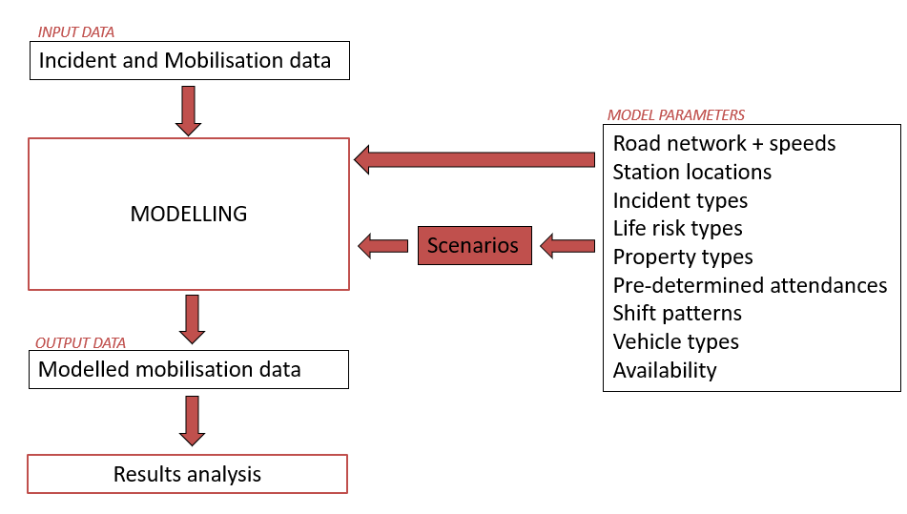
Figure 1: Workload modelling process

Input data
Historical incident and mobilisation data forms the basis of the input to workload modelling. Three years of data is typically used, although this can be more if required. This dataset usually comprises all incidents and pump mobilisations that have happened unless the scenario is very specific.
Also included in the input data are dummy incidents used to account for pumps being on training and dummy incidents which are placed over the border which account for over the border mobilisations. A typical model has roughly 100,000 incidents and 160,000 mobilisations.
Other dummy incidents can be included if required to account for increased demand or new incident types that we may be mobilised to.

Parameters
The parameters form part of the initial set up of a model.
Road network and speeds: This is the most important parameter in the model. The road network utilised is OS Highways. Using tracking data from our pumps, known as AVLS data, average speeds for each section of the road network is calculated.
Using this speed information, a pre-process is run whereby the modelling software calculates the travel time and distance between each station and each incident, and stores this in a database. This database is typically 4.5m records big.
Station locations, incident types, life risk types, property types, PDAs, vehicle types are all set up to mirror the prevailing real-life situation.

Scenarios
The scenarios are created within the modelling software by changing one or multiple parameters, for example changing the shift pattern from wholetime to day crewed or changing a PDA for a particular incident type.
For the purpose of this Fire Cover Review, all scenarios make changes to the shift types and pumps. To change a pump from wholetime to day-crewed an extra turnout delay is imposed on the proposed stations for the relevant time period i.e. the times crews would be responding from home, in line with real life. This delay is set to 3.5 minutes. This is to mirror the delay which is in place at NWFC when pumps are being mobilised in real life.
To change the number of pumps at a station, as in adding extra second pumps, these are simply added in as an additional resource to the model.
It is sensible to only make one change per model, to assess the individual impact of that change, then combine, rather than make multiple changes at once.

Modelling process
Using all the input data and parameters the model can now be run. This process mimics how mobilisations occur in real life. The software re-creates each incident at the same location and time it occurred in real life, then mobilises the correct number of quickest available resources (these could of course differ from the pumps that may have been mobilised in real life). The resources remain in attendance for the required period of time before being released and available for other incidents.
There are two ways in which the software can mobilise resources:
- Historical: it will mobilise the number of pumps that went to that historical incident at the times they went to the incident.
- PDAs: it will mobilise the required number of pumps based upon the incident type

Usually, the models are run using the historical method as this accounts for large incidents and make-ups etc. This means that if in real life we have had an incident that required 20 pumps, 20 will also be mobilised to it in the model.

Output and Results
The initial output of each model is simply a set of modelled mobilisations, with call signs and timestamps for each mobilisation. This is then analysed in comparison to other models and the historical input data.
The results are analysed in a very similar way to how actual response performance can be analysed.
All the results are related back to the historical performance for the same set of incidents/mobilisations, by applying the difference between the scenario model and base case model to the historical response performance.
Measures used to assess the models include:
- Performance vs 10 minute planning standard to life risk incidents
- Average response time to life risk incidents
- Lag time (difference between first and second, and second and third pump to arrive)
- Pump utilisation

Whilst generally only the performance of the first pump to life risk incidents is measured, the modelling still mobilises to all incidents from the three year period. Performance can also be measured for the 2nd and 3rd pump to arrive.
Importantly the models should be assessed at different geographies – whole of GM, borough, station area, ward and ideally LSOA. The impact at a smaller geography will always be stronger, positively or negatively, than the impact to response performance at a Greater Manchester level.

In real life GMFRS resources are mobilised dynamically, which means that station areas do not exist for the purpose of mobilising e.g. it is not the case that Oldham will always be sent first to an incident in Oldham, which resources are sent to an incident are those which will be able to respond the quickest at that particular time, regardless of their base. However, station area remains a useful geography to assess the impact of changes in the modelling results.

Modelling results in context
Whilst the modelling provides robust results relating to the likely impact that any changes will have upon response, it is important to consider these results within the wider context of the Service.
Therefore, for each scenario, the following impacts should be considered and compared, in conjunction with the modelling results.
- Impact upon response performance GM / borough / ward level
- Impact on finance
- Impact on crewing
- Impact on specials
- Impact on training
- Impact on prevention/protection delivery
- Potential future impact
- Other pros
- Other cons
- Decision
Response modelling is often an iterative process, therefore this whole section may be repeated multiple times if required.

Appendix 3 – Ward map of Greater Manchester
