Bonfire Campaign 2022 – social media pack

Background
Each year, Greater Manchester undertakes a multi-agency approach to preventing, tackling and protecting against bonfire and firework injuries, anti-social behaviour (ASB) and criminal damage during the Halloween and Bonfire period.
The campaign is a partnership between Greater Manchester Fire and Rescue Service (GMFRS), Greater Manchester Police (GMP), Greater Manchester Combined Authority (GMCA), local councils and Transport for Greater Manchester (TfGM).
For a number of years, this campaign (previously known as Treacle/Safe4Autumn) has been effective in helping to tackle key issues such as anti-social behaviour, deliberate fires and firework safety. Last year, we developed the Bang Out Of Order campaign artwork to reduce ASB, specifically deliberate fires, over the Halloween and Bonfire Night period.
The headline outcomes from last year’s campaign were mostly positive, with many measures demonstrating reductions compared with the previous year’s campaign. Both deliberate primary and secondary fires were reduced overall in the 2021 campaign, however there were increases in attacks on Firefighters and hoax calls attended by GMFRS.
Therefore, this year’s campaign will continue to focus on reducing ASB during the Halloween and Bonfire period – specifically attacks on emergency services, hoax calls, and deliberate primary and secondary fires.
The campaign also aims to reduce the number of fireworks and bonfire injuries by promoting fire safety advice and encouraging residents to attend organised events where possible.

Campaign materials
Campaign assets are available to download from the GMFRS website. The assets include:
- Posters – including the refreshed Bang Out Of Order artwork which focusses on the consequences of ASB and including relevant statistics from last year’s bonfire period to reduce the number of hoax calls and deliberate fires, and prevent attacks on emergency services. There are also posters and leaflets available to encourage people to go to organised displays.
- Social media graphics and gifs – As above.
- Education resources – primary and secondary school PowerPoint and lesson plans are available, covering bonfire, Halloween and firework safety messages and information about ASB. All three presentations have been filmed being delivered by our Prevention colleagues, which can be shown in schools.

Within this pack we have also provided key messages and suggested social media posts, for partners to use and localise as needed.
Partners are encouraged to:
- Share content from the digital toolkit as widely as possible across all social channels
- Use the graphics from the digital toolkit across your digital signage network
- When issuing press releases please link to https://www.manchesterfire.gov.uk/your-safety/campaigns/bangoutoforder/
We are issuing a press release to launch the campaign which includes figures on deliberate fires and hoax calls. Localised figures can also be provided to target the PR to local media as required. Throughout the campaign we will take an agile approach, staying alive to any opportunities which will gain media coverage for the campaign. This may include releases being issued to highlight topics or operational incidents throughout the campaign. Please let us know if you are planning local media/comms activity and include the key messages from this document where relevant.

Key messages:

Anti-social behaviour:
- Hoax calls can cost lives. If our crews are dealing with a hoax incident it takes crucial time away from real incidents where people’s lives may be in danger.
- Anti-social behaviour, illegal bonfires and misuse of fireworks have serious consequences and will not be tolerated this Bonfire Night.
- It's illegal to buy or use fireworks if you're under 18. Don’t start fires or set off illegal fireworks.
- To report illegal bonfires contact your local council. If the fire is out of control call 999.
- Members of the public can dispose of unused fireworks safely, as part of our fireworks amnesty, by calling GMFRS on 0800 555 815.
- Free and confidential support is open to anyone affected by anti-social behaviour or crime this Bonfire Night. Call 0161 200 1950 or visit www.gmvictims.org.uk for more information.
- To make a report to police, you can use LiveChat or online reporting at https://www.gmp.police.uk/ . You can also call 101. Always dial 999 in an emergency.

Attacks on Firefighters/emergency service workers:
- Abuse towards our Firefighters will not be tolerated. Assaulting emergency service workers is illegal and can result in a prison sentence if convicted.
- No one should be attacked for trying to keep you, your families, and your friends safe. Respect our emergency service workers this Bonfire Night.
- Emergency service workers put their lives on the line every day to keep you safe and they have their own families to go home to at the end of their shift. Don’t make their jobs any harder.
- If a fire engine is damaged due to being attacked this Bonfire Night, it might not be available to respond to serious emergencies in your area.

General, including firework safety:
- Have a safe and enjoyable Halloween and Bonfire Night – please go to organised events. Find an event near you – manchesterfire.gov.uk
- Our advice is not to have fireworks and bonfires at home, but it you are going to celebrate at home, please stay safe by following the Fireworks Code and our bonfire guidance
- Alcohol and fireworks do not mix and can lead to devastating injuries. Our advice is not to have fireworks at home, but if you are please do so safely and follow the Fireworks Code.
- Children’s Halloween costumes and other seasonal / themed costumes are currently classified as toys. You should check they are CE marked to ensure they meet the required safety standards. Remember all garments have a risk of being flammable – you must keep them away from naked flames to prevent your child from sustaining devastating burns.
- Buying Halloween costumes? Check they’re CE marked to ensure they meet the required safety standards. Remember all items of clothing have a risk of being flammable – always keep them away from naked flames.
- If your child is planning to go out during the Halloween or Bonfire period, make sure you know where they are, what they are doing and how to contact them.

Suggested social media posts
Suggested post | Graphic
🚒 If our emergency services are dealing with a hoax incident it takes crucial time away from real incidents where people’s lives may be in danger.  Making a hoax call could land you a heavy fine or 6 months in prison.  Find out more 👇  https://www.manchesterfire.gov.uk/your-safety/campaigns/bangoutoforder/  #BangOutOfOrder #BonfireNight | 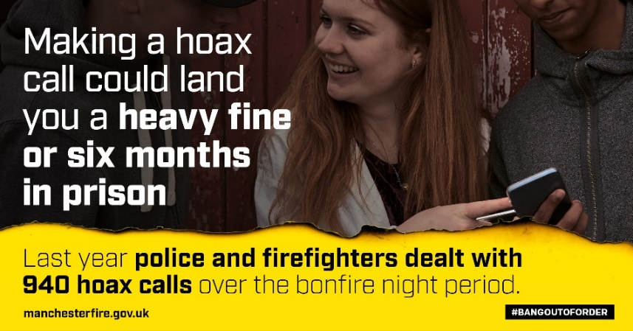
Anti-social behaviour, illegal bonfires and misuse of fireworks are #BangOutOfOrder and have serious consequences.  Find out more 👇  https://www.manchesterfire.gov.uk/your-safety/campaigns/bangoutoforder/ | 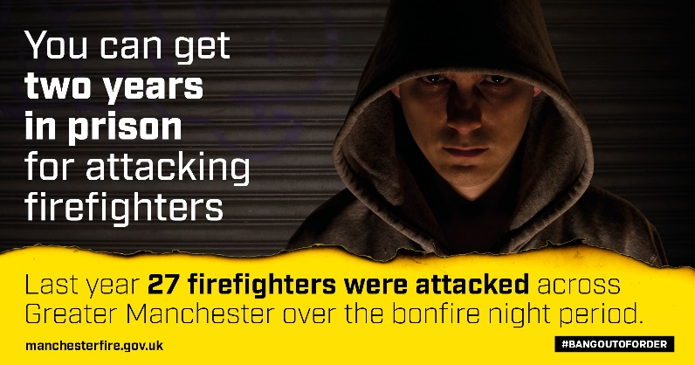 OR  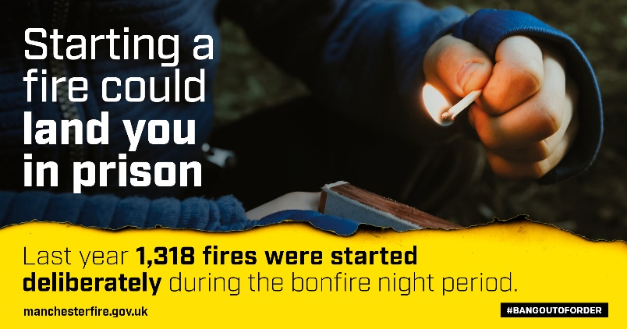
Don’t set off illegal fireworks or start fires.

And remember - it's illegal to buy or use fireworks if you're under 18.

Find out more 👇
https://www.manchesterfire.gov.uk/your-safety/campaigns/bangoutoforder/

#BangOutOfOrder #BonfireNight

*WARNING: THIS VIDEO CONTAINS INJURY IMAGES*  Rio was seriously injured by an exploded firework last year during the #BonfireNight period.  We’re sharing Rio’s experience to remind people to stay safe while celebrating.  More fireworks safety advice 👇  https://www.manchesterfire.gov.uk/your-safety/campaigns/bangoutoforder/ | GMFRS case study video – WeTransfer link to download: https://we.tl/t-aoVZ5QLVcg
To report illegal bonfires contact your local council.

If the fire is out of control call 999.

Members of the public can dispose of unused fireworks safely, as part of our fireworks amnesty, by calling @manchesterfire on 0800 555 815.

#BangOutOfOrder #BonfireNight

Free and confidential support is open to anyone affected by anti-social behaviour or crime this #BonfireNight period.  0161 200 1950  gmvictims.org.uk  #BangOutOfOrder | 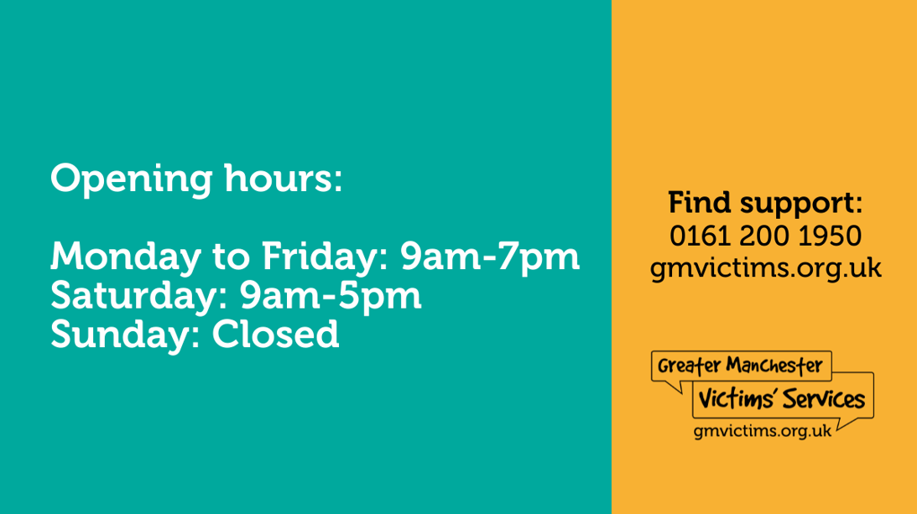
‍️To make a report to @gmpolice you can use LiveChat or online reporting at https://www.gmp.police.uk/  You can also call 101.  Always dial 999 in an emergency.  #BangOutOfOrder #BonfireNight | OR
Abuse towards our firefighters will not be tolerated.

Assaulting emergency service workers is #BangOutOfOrder and could get you locked up this #BonfireNight period.

Find out more 👇
https://www.manchesterfire.gov.uk/your-safety/campaigns/bangoutoforder/
No one should be attacked for trying to keep you, your families, and your friends safe.

Respect our emergency service workers and don’t make their jobs any harder during this #Halloween and #BonfireNight period.

Find out more 👇
https://www.manchesterfire.gov.uk/your-safety/campaigns/bangoutoforder/

#BangOutOfOrder
Have a safe and enjoyable #Halloween and #BonfireNight.  🎆Please go along to an official organised firework display if you can. If you’re celebrating at a private event, please stay safe by following our guidelines and the Fireworks Code.  Visit https://www.manchesterfire.gov.uk/your-safety/campaigns/bangoutoforder/ | 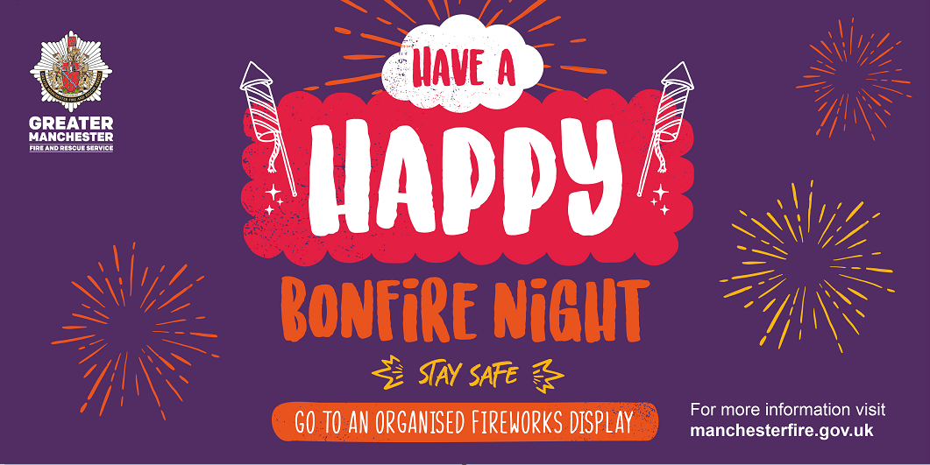
If your child is planning to go out during #Halloween or #BonfireNight, make sure you know where they are, what they are doing and how to contact them.

Find out more 👇
https://www.manchesterfire.gov.uk/your-safety/campaigns/bangoutoforder/

We want everyone to have a safe and happy #BonfireNight and encourage Greater Manchester residents to attend organised displays.

However, if you are going to celebrate at home, please stay safe by following the Fireworks Code and our bonfire safety advice.

Visit https://www.manchesterfire.gov.uk/your-safety/campaigns/bangoutoforder/

