Water Safety 2022 – Partner Communications Pack
Greater Manchester Fire and Rescue Service (GMFRS) is once again launching the water safety campaign, working with families who have lost ones through accidental drownings, to make people aware of the dangers of open water.
The campaign is aimed at young people, particularly teenage boys, who are historically more likely to take unnecessary risks by jumping into open water and swimming in different areas of Greater Manchester. There is also messaging aimed at adults who know a young person, asking them to speak to a young person they know about the dangers of open water and keeping safe.
The 2022 campaign will launch 17 June – when the weather will start to get warmer and ahead of Drowning Prevention Week (18 – 25 June). This campaign will also run alongside the Safe4Summer campaign which will share messages about keeping safe around water.
This year, the campaign messaging remains the same, with the key messages below:
- 165 people accidentally drowned in England in 2021. Don’t become a statistic, don’t go into the water.
- Never jump into open water. Cold Water Shock kills and you don’t know what’s lurking beneath the surface.
- Think about your family and friends before going in the water – they will miss you more than you think.
- If you encourage your mates to go in the water, it could be the last time you see them.
Twitter, Facebook and Instagram: @manchesterfire
Hashtags #DrowningPrevention #WaterSafety and #BeWaterAware used in social posts.
WeTransfer link to social media assets and videos: https://wetransfer.com/downloads/5d69d4351377ab49f69cea4d9b49bfff20220610101911/04895fdbd785a6adab1162b423b821e320220610102005/43f67c

Key activities
- Sharing messaging on social media – including videos from family and friends who have lost loved ones, recorded in 2020
- Paid social media advertising on Facebook during particularly warm spells of weather
- GMFRS press release on day of campaign launch
- Water safety banners installed at key locations (a follow on from previous years campaigns)
- Out of home advertising using the same artwork as the social media assets
- GMFRS school visits, giving presentations to students on water safety (alongside other prevention activity)
- Water safety webpage updated: https://www.manchesterfire.gov.uk/your-safety/campaigns/water-safety/
Campaign assets have been updated and are available in the zip file attached in the email sent to you. If you have any issues downloading any assets, please contact Jessica.Garriock@greatermanchester-ca.gov.uk
Partners are encouraged to share content from the digital toolkit as widely as possible across all social channels, as well as link through to our webpage: https://www.manchesterfire.gov.uk/your-safety/campaigns/water-safety/ when sharing any messaging.

Suggested social media posts
Copy | Image/Alt Text
General campaign messages
As part of the latest #watersafety campaign with @manchesterfire we are reminding people about the dangers of open water.  NEVER be tempted to go for a dip or encourage your friends to enter reservoirs, rivers, canals or ponds. Only swim at organised events.  #DrowningPrevention | If you encourage your mates to go in the water it could be the last time you see them. Cold water shock kills even the strongest swimmers.  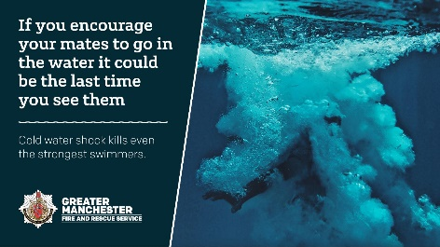
NEVER jump into open water and only swim at organised events. Cold Water Shock and under-water currents can kill, and you don’t know what’s lurking beneath the surface.  https://www.manchesterfire.gov.uk/your-safety/campaigns/water-safety/  #WaterSafety #DrowningPrevention #BeWaterAware | NEVER jump into open water. Cold water shock kills and you don’t know what’s lurking beneath the surface.  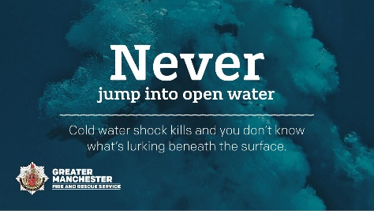
Did you know Cold Water Shock can kill even strong swimmers, and under-water currents can be deadly? Our message is clear: NEVER jump into open water and only swim at organised events.  https://www.manchesterfire.gov.uk/your-safety/campaigns/water-safety/  #WaterSafety #DrowningPrevention #BeWaterAware | If you encourage your mates to go in the water it could be the last time you see them. Cold water shock kills even the strongest swimmers.
Facebook/Insta  Do you know where your kids go, and what they get up to, when they’re out with their friends?  Please speak with them about the dangers of open water – it could save their life ❤️  Cold Water Shock and under-water currents can kill, and you never know what’s lurking beneath the surface.  https://www.manchesterfire.gov.uk/your-safety/campaigns/water-safety/  #WaterSafety #DrowningPrevention #BeWaterAware  Twitter  Do you know where your kids go, and what they get up to, when they’re out with their friends? Please speak with them about the dangers of open water – it could save their life  https://www.manchesterfire.gov.uk/your-safety/campaigns/water-safety/  #WaterSafety #DrowningPrevention #BeWaterAware | 165 people accidentally drowned in England in 2021. Don’t become a statistic, don’t go into the water.  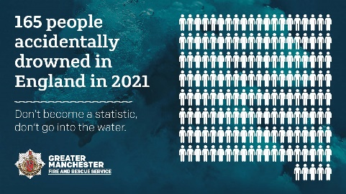
💔 Did you know that 165 people accidentally drowned in England in 2021?  Don’t become a statistic, don’t go into the water unless it’s part of an organised event.  https://www.manchesterfire.gov.uk/your-safety/campaigns/water-safety/  #WaterSafety #DrowningPrevention #BeWaterAware | 165 people accidentally drowned in England in 2021. Don’t become a statistic, don’t go into the water.
Family videos
Facebook/Insta  Family members who have lost loved ones continue to support the #WaterSafety campaign to protect young people like you.  They share their stories in memory of those who are no longer with us to prevent others experiencing the same heartache as them 💔  No matter how hot it is outside, please don’t ever be tempted to cool off by swimming in open water, or encourage your mates to jump into reservoirs, rivers, canals or ponds (or any other open water unless it’s part of an organised event).  #WaterSafety #DrowningPrevention #BeWaterAware  Twitter (thread)  Family members who have lost loved ones continue to support the #WaterSafety campaign to protect young people like you.  They share their stories in memory of those who are no longer with us to prevent others experiencing the same heartache as them 💔 1/  No matter how hot it is outside, please don’t ever be tempted to cool off by swimming in open water, or encourage your mates to jump into reservoirs, rivers, canals or ponds (or any other open water unless it’s part of an organised event).  #DrowningPrevention 2/ | YT clips
“It’s not worth your family going through the sort of pain that my family’s been through”.  Lauren’s brother Mark drowned in 2018. We’re sharing stories from those who have lost loved ones in accidental drownings, to remind people of the dangers of open water.  #DrowningPrevention | Lauren mp4 (Debdale Park, Manchester)
Chris lost his nephew Jack, to drowning. He’s sharing his story to prevent others going through what him and his family have.  “The water doesn’t care if you’re a strong swimmer or not, the water can be vicious, and it can change in an instant”.  #WaterSafety #DrowningPrevention | Chris mp4 (River Etherow, Tameside)
“It’s not worth it. Please listen when we tell you ‘don’t go in it’, it isn’t safe”.  Natalie shares her story of losing her son, Paul, so others don’t have to experience her heartache.  #WaterSafety #DrowningPrevention | Natalie mp4 (Greenbooth Reservoir, Rochdale)
“Losing him was the hardest thing, and life without him is harder “  💔 Jack Pullen drowned in July 2016 at age 16, in the River Etherow. His sister is helping raise awareness of the dangers of open water.  #WaterSafety #DrowningPrevention | Fallon mp4 (River Etherow, Tameside)
Ben and Jordan lost their friend, Paul, to drowning – they share their story to prevent others going through what they have.  Think about your friends and family before going in the water – they will miss you more than you think.  #WaterSafety #DrowningPrevention | Ben and Jordan mp4 (Greenbooth Reservoir, Rochdale)
“So many children, teens, and adults don’t make it home after 20 minutes of swimming”  Dylan Ramsay drowned in 2011 in a quarry near Chorley, Lancashire. Dylan’s mum Beckie spoke to us about her heartache  https://www.youtube.com/watch?v=Rx2O1_OMJC4  #WaterSafety #DrowningPrevention | Dylan youtube video  https://www.youtube.com/watch?v=Rx2O1_OMJC4
Warm weather proactive messaging
Looks like it will stay warm a bit longer, so why not have a chat with your kids, or other young people you know, about the dangers of open water? It could save their life ❤️  👉 https://www.manchesterfire.gov.uk/your-safety/campaigns/water-safety/  #WaterSafety #DrowningPrevention #BeWaterAware | 165 people accidentally drowned in England in 2021. Don’t become a statistic, don’t go into the water.
Enjoying the warmer weather?  Please don’t be tempted to cool off by going into open water, or encourage your friends to swim or jump into reservoirs, rivers, canals or ponds Only swim at organised events.  https://www.manchesterfire.gov.uk/your-safety/campaigns/water-safety/  #WaterSafety #DrowningPrevention | If you encourage your mates to go in the water it could be the last time you see them. Cold water shock kills even the strongest swimmers.
☀ It’s warm in Greater Manchester, so what better time to remind people about our #WaterSafety campaign  Do you know a young person? Chat with them today about the dangers of open water  https://www.manchesterfire.gov.uk/your-safety/campaigns/water-safety/  #DrowningPrevention #BeWaterAware | 165 people accidentally drowned in England in 2021. Don’t become a statistic, don’t go into the water.
Facebook/Insta  Quick question for you before you head out to enjoy the weather…  Did you know even strong swimmers can drown?  Please, please, please don’t ever be tempted to cool off by swimming in open water, or encourage your mates to jump into reservoirs, rivers, canals or ponds (or any other open water unless it’s part of an organised event)  https://www.manchesterfire.gov.uk/your-safety/campaigns/water-safety/  #WaterSafety #DrowningPrevention #BeWaterAware  Twitter  Did you know even strong swimmers can drown?  Please don’t ever be tempted to cool off by swimming in open water, or encourage your mates to jump into reservoirs, rivers, canals or ponds (or any other open water unless it’s part of an organised event)  #DrowningPrevention | 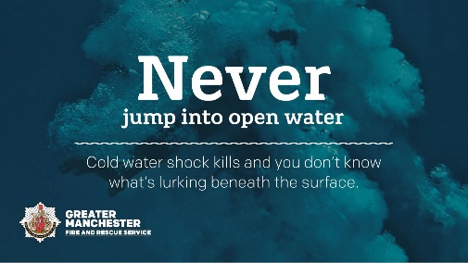  NEVER jump into open water. Cold water shock kills and you don’t know what’s lurking beneath the surface.

