Image | Copy
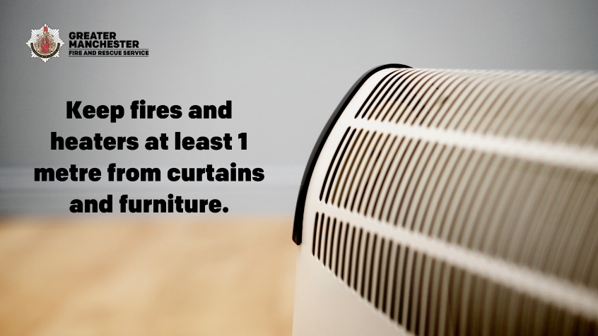 | Keep fires and heaters at least 1 metre from curtains and furniture.  Put your heater on a level surface, well away from anything that could knock it over. This winter, #StayWarmSafely  More info https://www.manchesterfire.gov.uk/your-safety/campaigns/stay-warm-safely-this-winter/
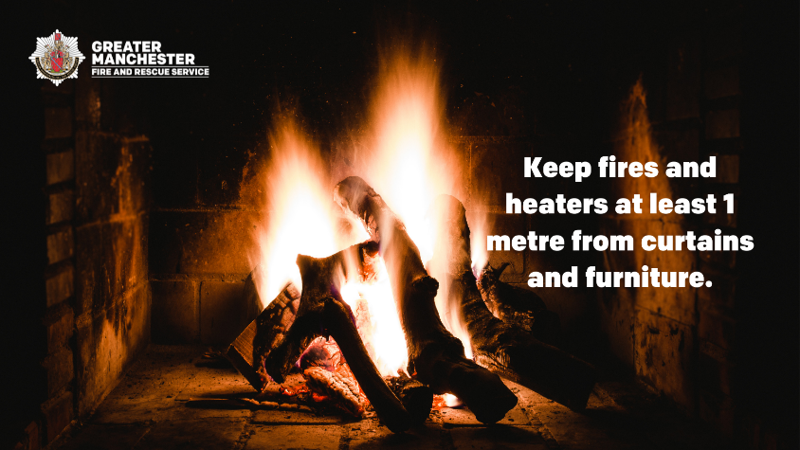 | Keep fires and heaters at least 1 metre from curtains and furniture, and always switch fires and heaters off, or put them out, before bed or leaving your home. This winter, #StayWarmSafely  More info https://www.manchesterfire.gov.uk/your-safety/campaigns/stay-warm-safely-this-winter/
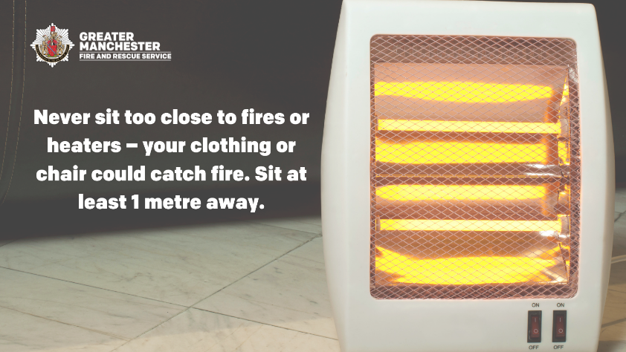 | Never sit too close to fires or heaters – your clothing or chair could catch fire. Always sit at least 1 metre away.  Use a fireguard, particularly if you have an open fire or children or pets at home.  More info https://www.manchesterfire.gov.uk/your-safety/campaigns/stay-warm-safely-this-winter/ #StayWarmSafely
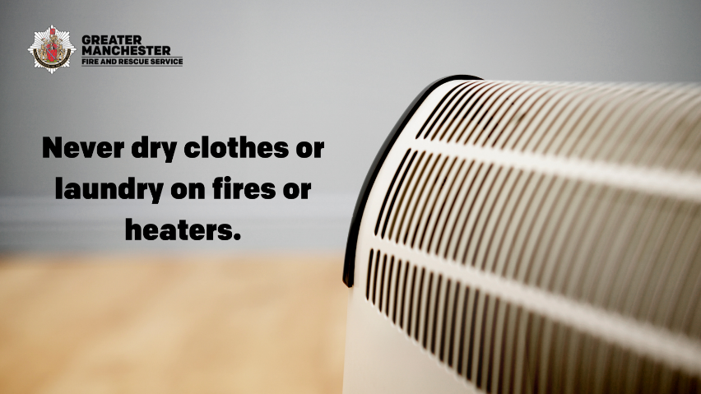 | Stay warm safely this winter, never dry clothes or laundry on fires or heaters, and never leave your heater unattended whilst in use or while you are asleep #StayWarmSafely  Find out more about safe heating this winter https://www.manchesterfire.gov.uk/your-safety/campaigns/stay-warm-safely-this-winter/
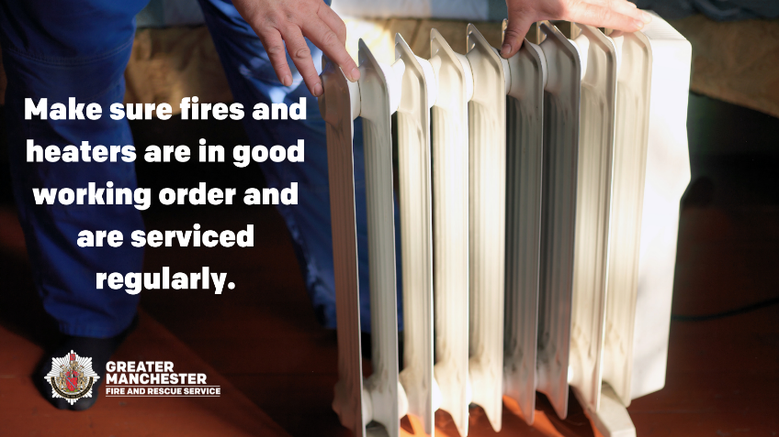 | Make sure any fires and heaters are in good working order and are serviced regularly.  Don’t take risks with old heaters, if it’s electrical and getting older, get it tested by a qualified electrician or buy a new one #StayWarmSafely  Find out more https://www.manchesterfire.gov.uk/your-safety/campaigns/stay-warm-safely-this-winter/
Make sure any fires and heaters are in good working order and are serviced regularly. Check they are clean before use.

Check that your heater isn't on a recall list https://productrecall.campaign.gov.uk/

Find out more https://www.manchesterfire.gov.uk/your-safety/campaigns/stay-warm-safely-this-winter/ #StayWarmSafely

