Bonfire Campaign 2021 – Partner Communications Pack
Each year, Greater Manchester undertakes a multi-agency approach to preventing, tackling and protecting against bonfire and firework injuries, anti-social behaviour (ASB) and criminal damage during the Halloween and Bonfire period.
The campaign is a partnership between Greater Manchester Fire and Rescue Service (GMFRS), Greater Manchester Police (GMP), Greater Manchester Combined Authority (GMCA), local councils and Transport for Greater Manchester (TfGM).
This year, the campaign focusses on reducing anti-social behaviour during the Halloween and Bonfire period – specifically attacks on emergency services and deliberate primary and secondary fires.
The campaign also aims to reduce the number of fireworks and bonfire injuries by promoting fire safety advice and encouraging residents to attend organised events where possible.
The 2021 campaign will launch on October 15 – the date fireworks legally go on sale in the UK.
A number of campaign assets have been created, which can be shared by all partners between 15 October and 10 November.
Campaign assets are available to download on this wetransfer link – https://we.tl/t-BUb3Idn4Dn - and will also be available to download from the GMFRS website. The assets include:
- Posters – including the new Bang Out Of Order artwork which focusses on anti-social behaviour and attacks on emergency services. There are also posters and leaflets available to encourage people to go to organised displays.
- Social media graphics and gifs – As above.
- Education resources – primary and secondary school PowerPoint and lesson plans have been created, covering bonfire, Halloween and firework safety messages and information about ASB. All three presentations have been filmed being delivered by our Prevention colleagues, which can be shown in schools.
Within this pack we have also provided key messages and suggested social media posts, for partners to use and localise as needed.
These focus on anti-social behaviour (hoax calls, attacks on emergency services, and deliberate nuisance fires) and also specific safety messaging in relation to fireworks and bonfire safety.
In addition, there will be messaging specific to Trick or Treating, which aligns with the current Greater Manchester Covid’s Not Gone campaign. We will share a further update once this is ready.
We are issuing a press release to launch the campaign which includes figures on deliberate fires and hoax calls. Localised figures can also be provided to target the PR to local media as required. Throughout the campaign we will take an agile approach, staying alive to any opportunities which will gain media coverage for the campaign. This may include releases being issued to highlight topics or operational incidents throughout the campaign. Please let us know if you are planning local media/comms activity and include the key messages from this document where relevant.
Partners are encouraged to:
- Share content from the digital toolkit as widely as possible across all social channels
- Use the graphics from the digital toolkit across your digital signage network
- When issuing press releases please link to https://www.manchesterfire.gov.uk/your-safety/campaigns/bangoutoforder/

Key messages:

Anti-social behaviour:
- Anti-social behaviour, illegal bonfires and misuse of fireworks have serious consequences and will not be tolerated this #BonfireNight.
- Setting fire to rubbish can be dangerous. You don’t know what’s hidden underneath.
- Hoax calls can cost lives. If our crews are dealing with a hoax incident it takes crucial time away from real incidents where people’s lives may be in danger.
- It's illegal to buy or use fireworks if you're under 18. Don’t start fires or set off illegal fireworks.
- To report illegal bonfires contact your local council. If the fire is out of control call 999.
- Members of the public can dispose of unused fireworks safely, as part of our fireworks amnesty, by calling GMFRS on 0800 555 815.
- If your child is planning to go out during the #Halloween or #Bonfire period, make sure you know where they are and how to contact them
- Free and confidential support is open to anyone affected by anti-social behaviour or crime this Bonfire Night. Call 0161 200 1950 or visit www.gmvictims.org.uk for more information.
- To make a report to police, you can use LiveChat or online reporting at https://www.gmp.police.uk/ . You can also call 101. Always dial 999 in an emergency.

Attacks on firefighters/emergency services:
- Abuse towards our firefighters will not be tolerated. Assaulting emergency service workers is illegal and can result in a prison sentence if convicted.
- No one should be attacked for trying to keep you, your families, and your friends safe. Respect our firefighters this Bonfire Night.
- Emergency service workers put their lives on the line every day to keep you safe and they have their own families to go home to at the end of their shift. Don’t make their jobs any harder.
- If a fire engine is damaged due to being attacked this Bonfire Night, it might not be available to respond to serious emergencies in your area.

General, including firework safety:
- Have a safe and enjoyable #Halloween and #BonfireNight – please go to organised events. Find an event near you – manchesterfire.gov.uk
- Looking to celebrate #BonfireNight with friends and family? Find an organised event near you by visiting manchesterfire.gov.uk
- Our advice is not to have fireworks and bonfires at home, but if you are going to celebrate at home, please stay safe by following the Fireworks Code
- Alcohol and fireworks do not mix and can lead to devastating injuries. Our advice is not to have fireworks at home, but if you are please do so safely and follow the fireworks code.
- Children’s #Halloween costumes and other seasonal / themed costumes are currently classified as toys. You should check they are CE marked to ensure they meet the required safety standards. Remember all garments have a risk of being flammable – you must keep them away from naked flames to prevent your child from sustaining devastating burns.
- Buying #Halloween costumes? Check they’re CE marked to ensure they meet the required safety standards. Remember all items of clothing have a risk of being flammable – always keep them away from naked flames.

Suggested social media posts
Suggested post | Graphic
Setting fires, throwing fireworks and making hoax calls are #BangOutOfOrder and will not be tolerated this Halloween and #BonfireNight in Greater Manchester.  Find out more  manchesterfire.gov.uk | 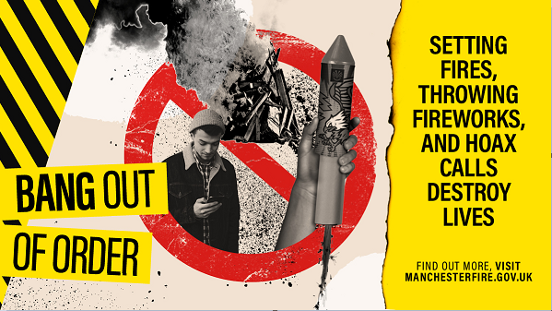
It's illegal to buy or use fireworks if you're under 18.
Don’t start fires or set off illegal fireworks.
#BangOutOfOrder #BonfireNight

Hoax calls can cost lives.
If our emergency services are dealing with a hoax incident it takes crucial time away from real incidents where people’s lives may be in danger.
Find out more
manchesterfire.gov.uk
#BangOutOfOrder #BonfireNight

To report illegal bonfires contact your local council.
If the fire is out of control call 999.
Members of the public can dispose of unused fireworks safely, as part of our fireworks amnesty, by calling @manchesterfire on 0800 555 815.
#BangOutOfOrder #BonfireNight

Free and confidential support is open to anyone affected by anti-social behaviour or crime this #BonfireNight.  0161 200 1950  gmvictims.org.uk  #BangOutOfOrder #BonfireNight | 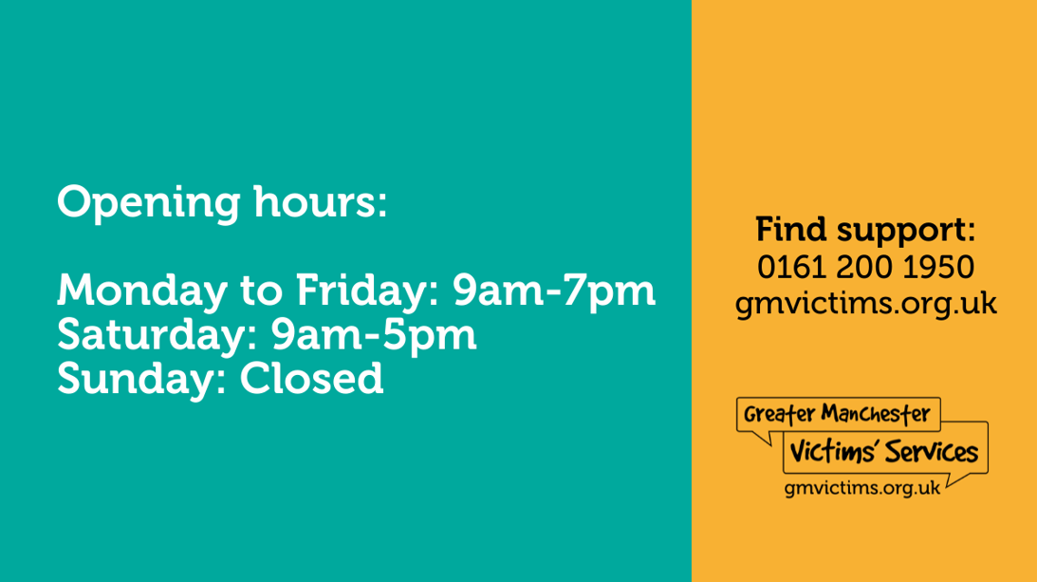
‍️To make a report to @gmpolice you can use LiveChat or online reporting at https://www.gmp.police.uk/ .
You can also call 101.
Always dial 999 in an emergency.
#BangOutOfOrder #BonfireNight

Abuse towards our firefighters will not be tolerated. Assaulting emergency service workers is #BangOutOfOrder and could get you locked up this #Halloween and #BonfireNight  Find out more  manchesterfire.gov.uk | 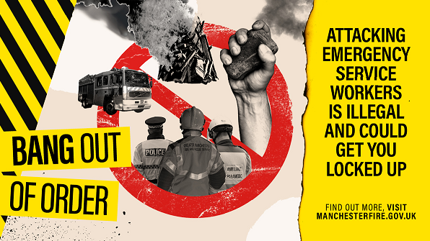
No one should be attacked for trying to keep you, your families, and your friends safe.
Respect our emergency services this #Halloween and Bonfire season.
#BonfireNight #BangOutOfOrder
Have a safe and enjoyable #Halloween and #BonfireNight.  Officially organised firework displays are taking place again this year across Greater Manchester, so please go along to one near you.  Visit manchesterfire.gov.uk  #BonfireNight | 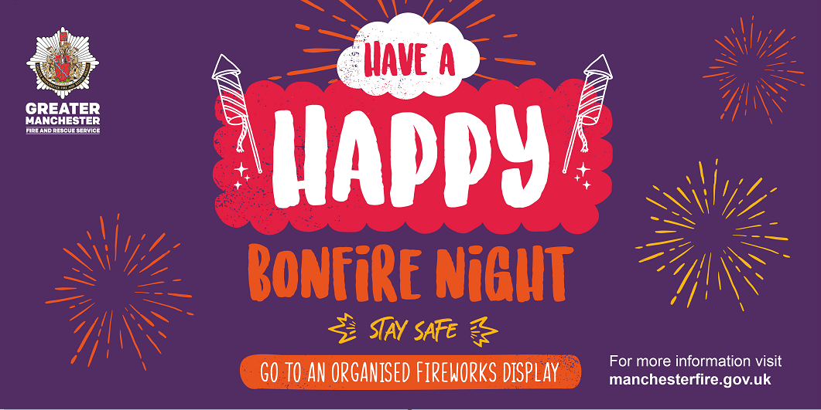
Our advice is not to have fireworks and bonfires at home, but it you are going to celebrate at home, please stay safe by following the Fireworks Code.
Visit manchesterfire.gov.uk
#BonfireNight

In addition to the above, the Greater Manchester Health and Social Care Partnership has also developed the below messages and graphics in relation to Trick or Treating and COVID. The graphics are available to download on the GMFRS website.

Suggested post | Graphic
Let's stay safe and spooky.  Halloween means mixing more.  Keep your family Covid safe and respect those who don't want trick or treaters to call.  CovidsStillHere.org  #CovidsStillHere | 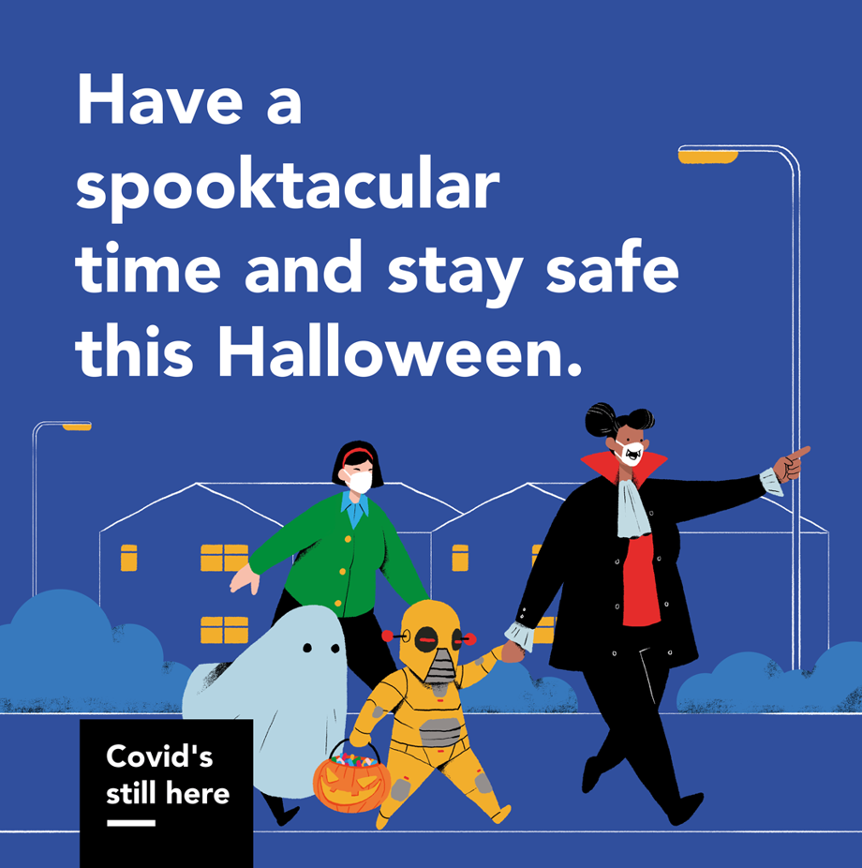
Don’t get a bigger fright than you bargained for.
Trick or treat is back, but Covid's still here.

Protect yourself and your kids. Keep on with your actions to keep Covid away.
CovidsStillHere.org

#CovidsStillHere
Give Halloween a miss if you're self-isolating.

Anyone in your family feel unwell, tested Covid positive, or told to self-isolate?

Stay home and keep trick or treaters away.

CovidsStillHere.org/#FeelUnwell

#CovidsStillHere
Covid isn't a trick or treat.
Have a safe Halloween.

Keep a distance from other trick or treaters, cover your nose and mouth, regularly clean your hands.

CovidsStillHere.org/#EveryAction

#CovidsStillHere

