Lesson Plan – Bonfire, Firework and Anti-Social Behaviour Education for Secondary School (Assembly Purposes)

Session Summary
To introduce the audience to key messages which include advice on staying safe around bonfire night, firework events and Halloween.
Objectives
- To be able to highlight the dangers of fireworks and bonfires
- To know & understand how to stay safe when out and about during the bonfire and Halloween period
- To know the consequences of anti-social behaviour
- To know what to do if clothing catches fire
Delivery Guide
The “Bonfire Safety” video is a drama based on an actual incident that occurred over the bonfire and Halloween period. The aim of the video is to demonstrate numerous dangers during this period and promote areas of concern. It also covers key safety message and areas of best practice.

It should be emphasised to the audience prior to the video being played that this is a drama, no persons are actually hurt and that special effects and make up are used to replicate burns.

The storyline shows two separate groups of youths, one aged around 14 and the older group are around 16 years of age.

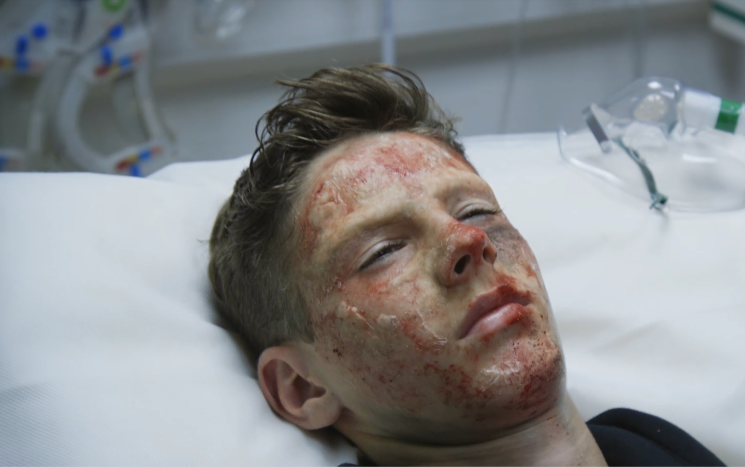

Lesson Plan

Presentation sections | Guidance notes
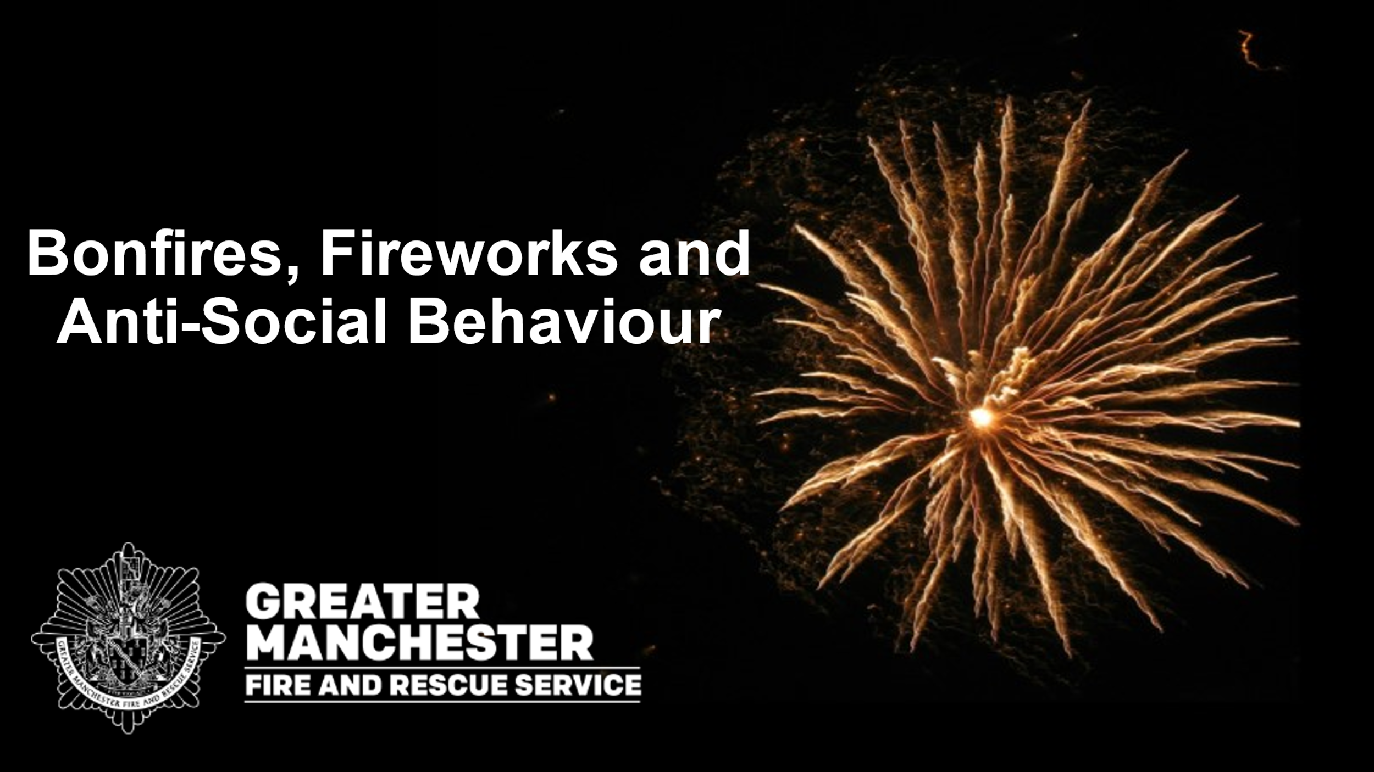  Slide 1  30 seconds | This section is to provide the audience with an introduction on what will be discussed during the session -  We will talk about:  - The dangers of bonfires and fireworks  - How to stay safe during the bonfire and Halloween period  - Stop, drop and roll in case your clothes catch fire  - What anti-social behaviour is including, deliberate fires, hoax calls and attacks on Firefighters  - The Law and Consequences of anti-social behaviour
Slide 2  6 minutes | Bonfire Safety Video  To play the video: Hover over the black box image and a play bar will appear. Click the play button.  **Prior to starting the video inform the children that they should watch and listen carefully**  The video is a drama based on an actual incident that occurred over the bonfire and Halloween period. The aim of the video is to demonstrate numerous dangers during this period and promote areas of concern.  The storyline shows two separate groups of youths, one aged around 14 and the older group are around 16 years of age.
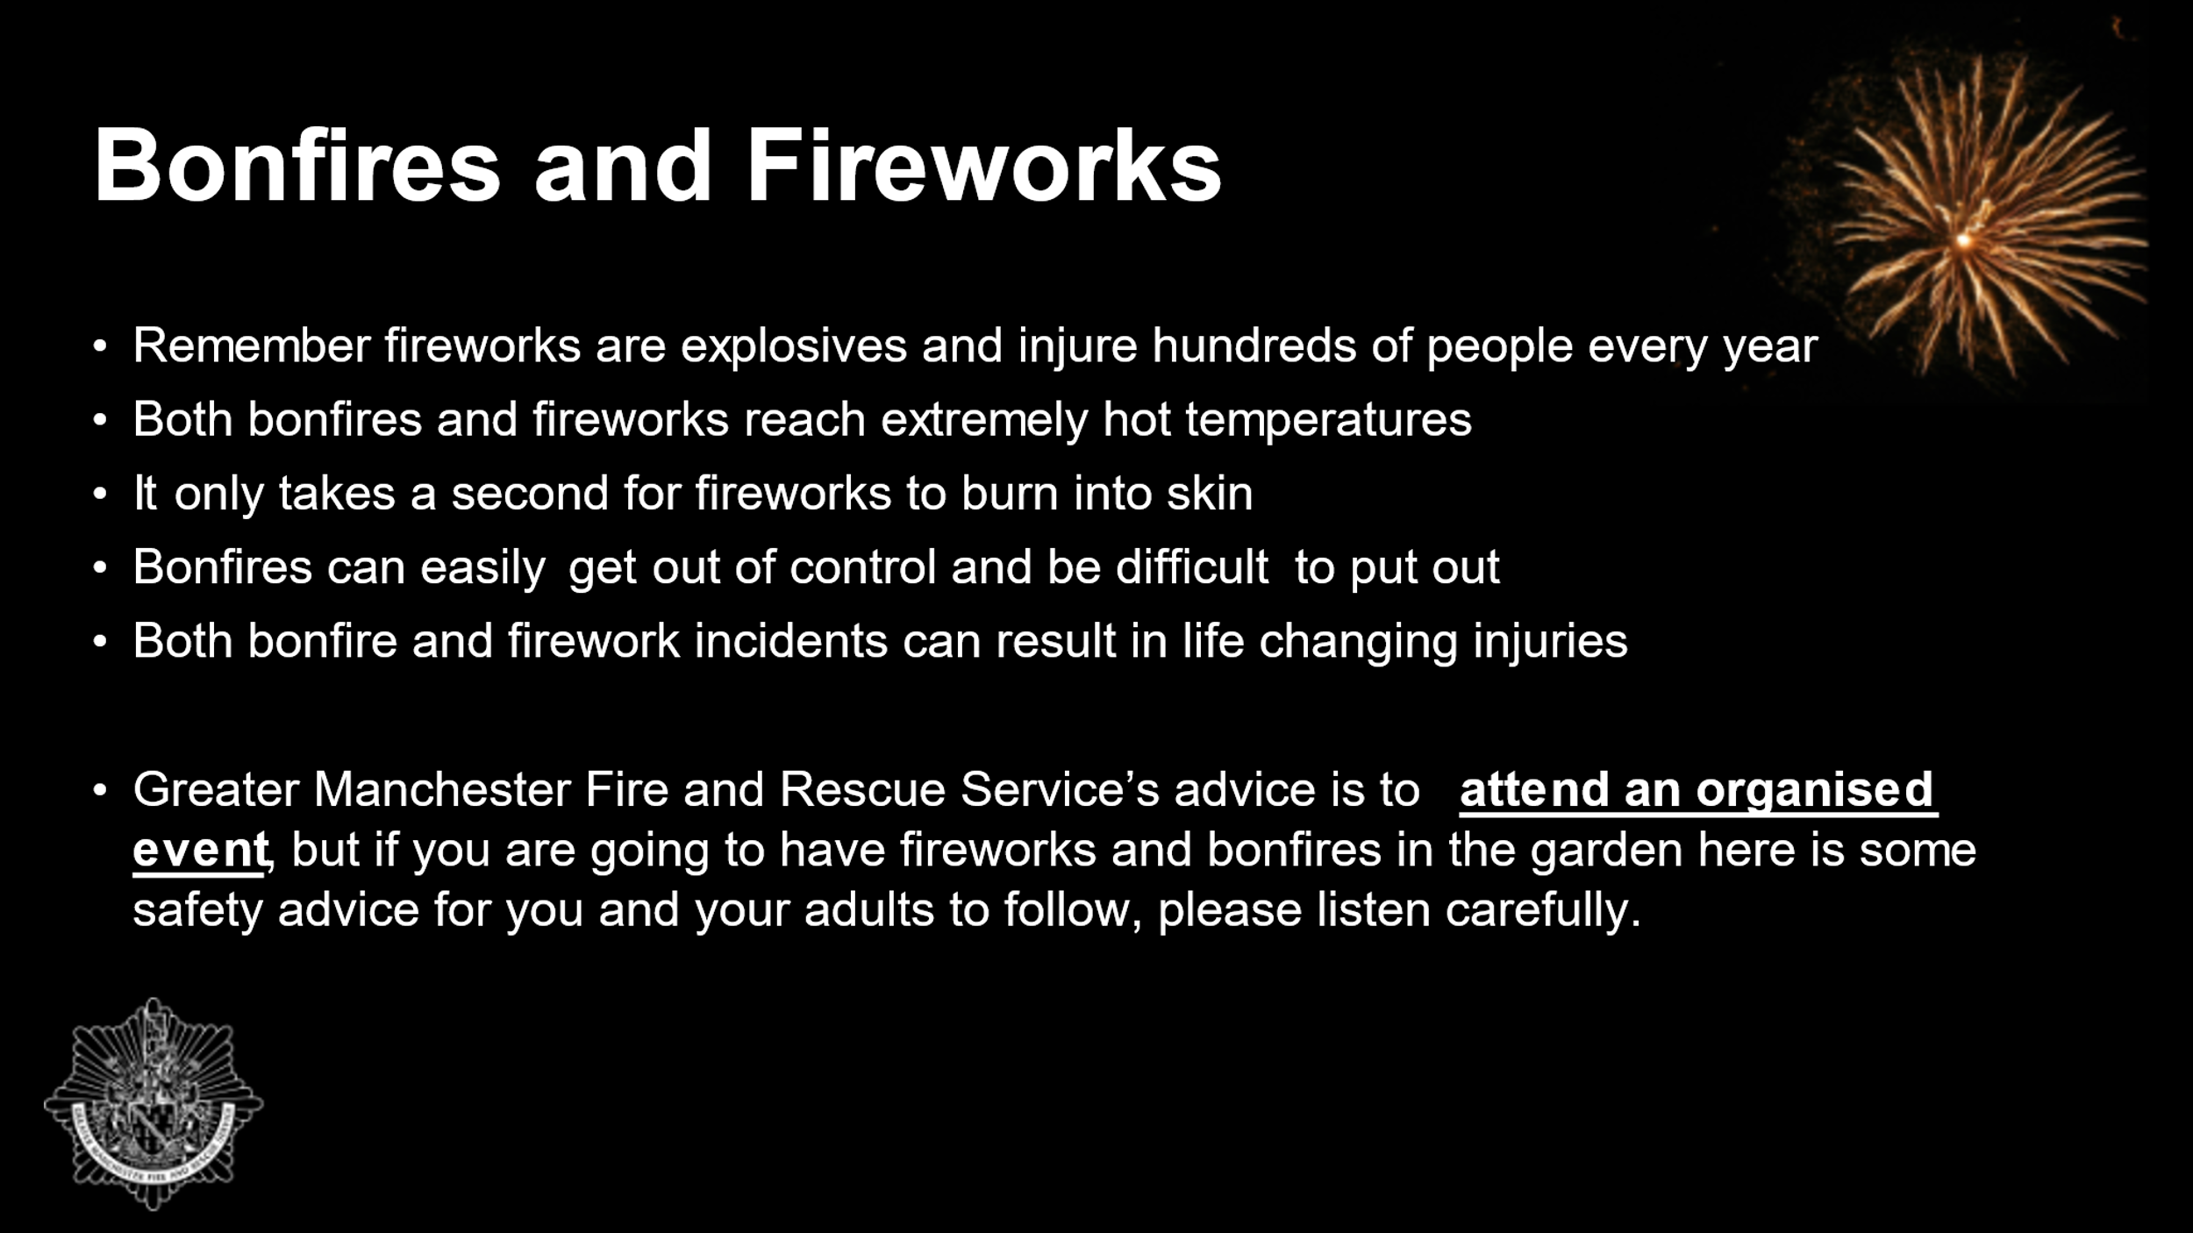  Slide 3  1 minute | Go through the bullet points on the slide:  - Remember fireworks are explosives and injure hundreds of people every year - Lots of people injured by fireworks are children aged 14 years and younger, the same age as you and your friends. Many of the injuries take place at home in gardens  - Both bonfires and fireworks reach extremely hot temperatures (they can burn up to 2,000 degrees, that is 8 times hotter than your ovens at home)  - It only takes a second for fireworks to burn into skin  - Bonfires can easily get out of control and be difficult to put out  - Both bonfire and firework incidents can result in life changing injuries as seen in the video. The injuries Danny sustained can take months and years of hospital treatment. The injuries were on parts of the body that are exposed, such as his face. Serious burns can leave lasting scars. Danny’s type of injury could impact his vision. We don’t want this to be you.  Organised public displays are safer and have more spectacular displays. As shown on the video the youngsters went out on bonfire night rather than going to an organised event and it led to the unfortunate event involving one of the youngsters getting seriously injured.  Greater Manchester Fire and Rescue Service’s advice is to attend an organised event, but if you are going to have fireworks and bonfires in the garden here is some safety advice for you and your adults to follow, please listen carefully.
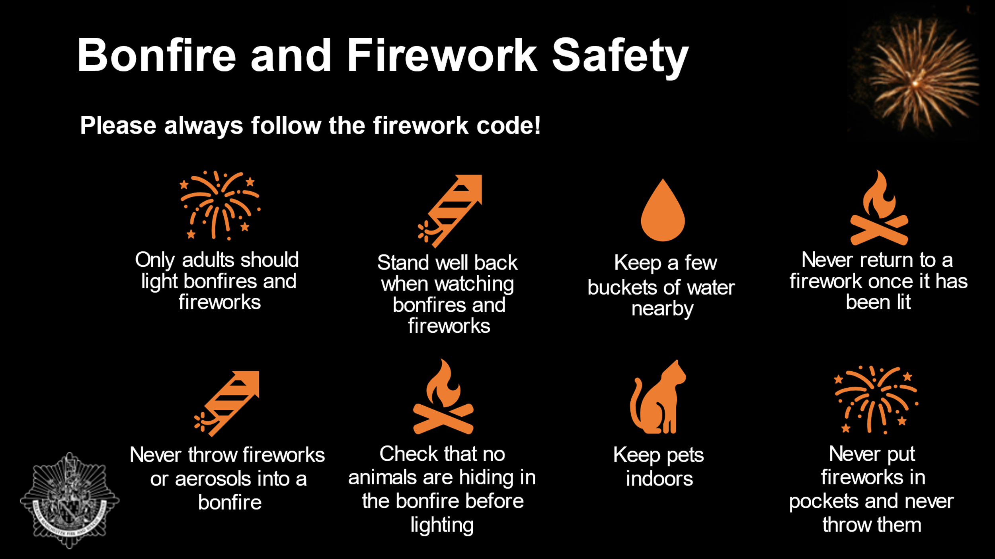  Slide 4  2 minutes | Explain that there are lots of ways to keep safe during the bonfire and Halloween period.  Please always follow the firework code:  - Only adults (18+) should light bonfires and fireworks  - Stand well back when watching bonfires and fireworks (e.g. 5 m - a car’s length away- from bonfires for your own safety and to avoid injuries)  - Always keep a few buckets of water and/or a hose pipe nearby  - Never return to a firework once it has been lit  - Never throw fireworks or aerosols into a bonfire  - Aerosol cans contain liquid made up of different chemicals. If the aerosol comes into contact with a fire then it will heat the liquid in the can, causing it to expand and then in some cases, explode. An exploding aerosol is unpredictable; you won’t know which direction it will go and can travel for some distance, injuring anyone in its path. We are seeing an increase in young people misusing aerosols.  - Check that no animals are hiding in the bonfire before lighting it  - Keep pets indoors (fireworks particularly can be frightening and distressing for animals)  - Never put fireworks in pockets and never throw them  Direct audience to take these messages home to their adults and ask their adults to read and follow the firework code on our website.  Remind audience what to do if their clothes did catch fire:  STOP – stop what you’re doing and stay very still  DROP – drop to the floor.  ROLL – roll backwards and forwards until the flames are out  First aid advice for burns:  COOL – cool the burn with running cold tap water for 20 minutes  COVER - cover with cling film or a sterile, non-fluffy dressing or cloth.  CALL - call for help for any burn larger than a 50p coin: 999 or 111.  Other things to think about:  Never wear Halloween outfits around fireworks, bonfires or other naked flames as the materials might be more likely to catch fire. Only buy Halloween outfits with a CE mark on them as these are safer.  If you are going trick or treating never go alone, only trick or treat at houses that are decorated, cross the roads safely and make sure you are seen by wearing brightly coloured clothing or reflective tape.
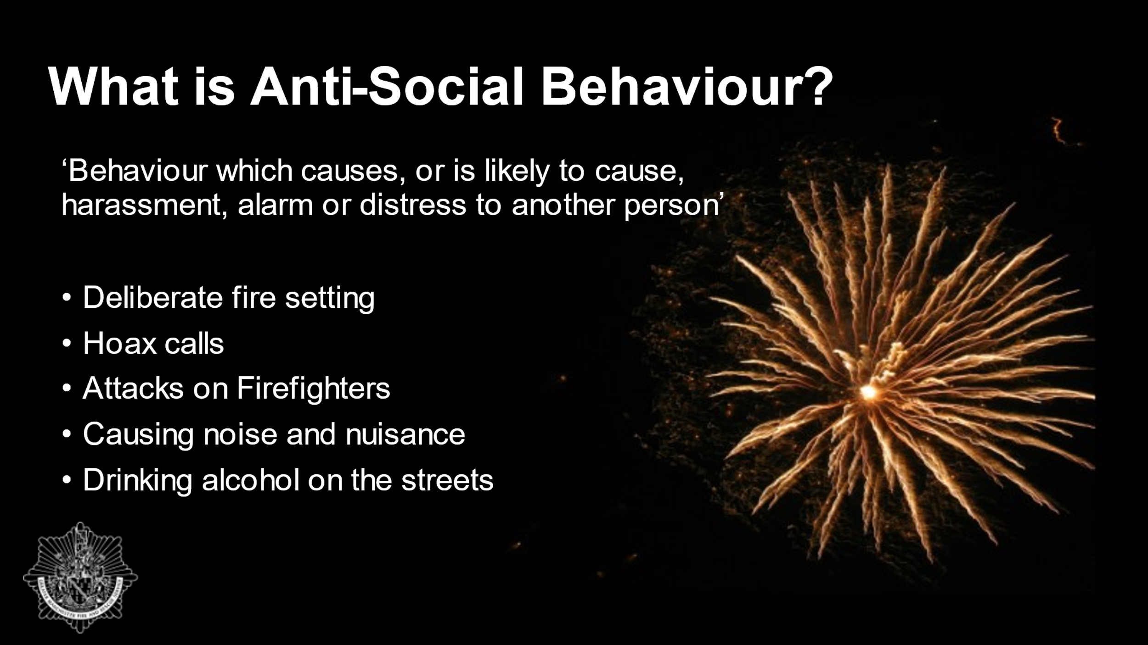  Slide 5  1 minute | Explain to the audience what Anti-Social Behaviour is by going through the slide.  Anti-Social Behaviour is behaviour which causes, or is likely to cause, harassment, alarm or distress to another person’  This can include:  - Deliberate fire setting – such as wheelie bin or skip fires – People have no idea what is already in that bin, it could contain things which are lethal if set alight e.g. chemicals. There are also harmful chemicals in the plastic of the bin itself if set alight, which is bad for the environment. Wheelie bin fires can spread to nearby buildings, which puts people and property as risk.  - Hoax calls – a telephone call made to trick or deceive someone e.g. making a call to the emergency services when it is not a real emergency  - Attacks on Firefighters  - Causing noise and nuisance in a public place  - Drinking alcohol on the streets
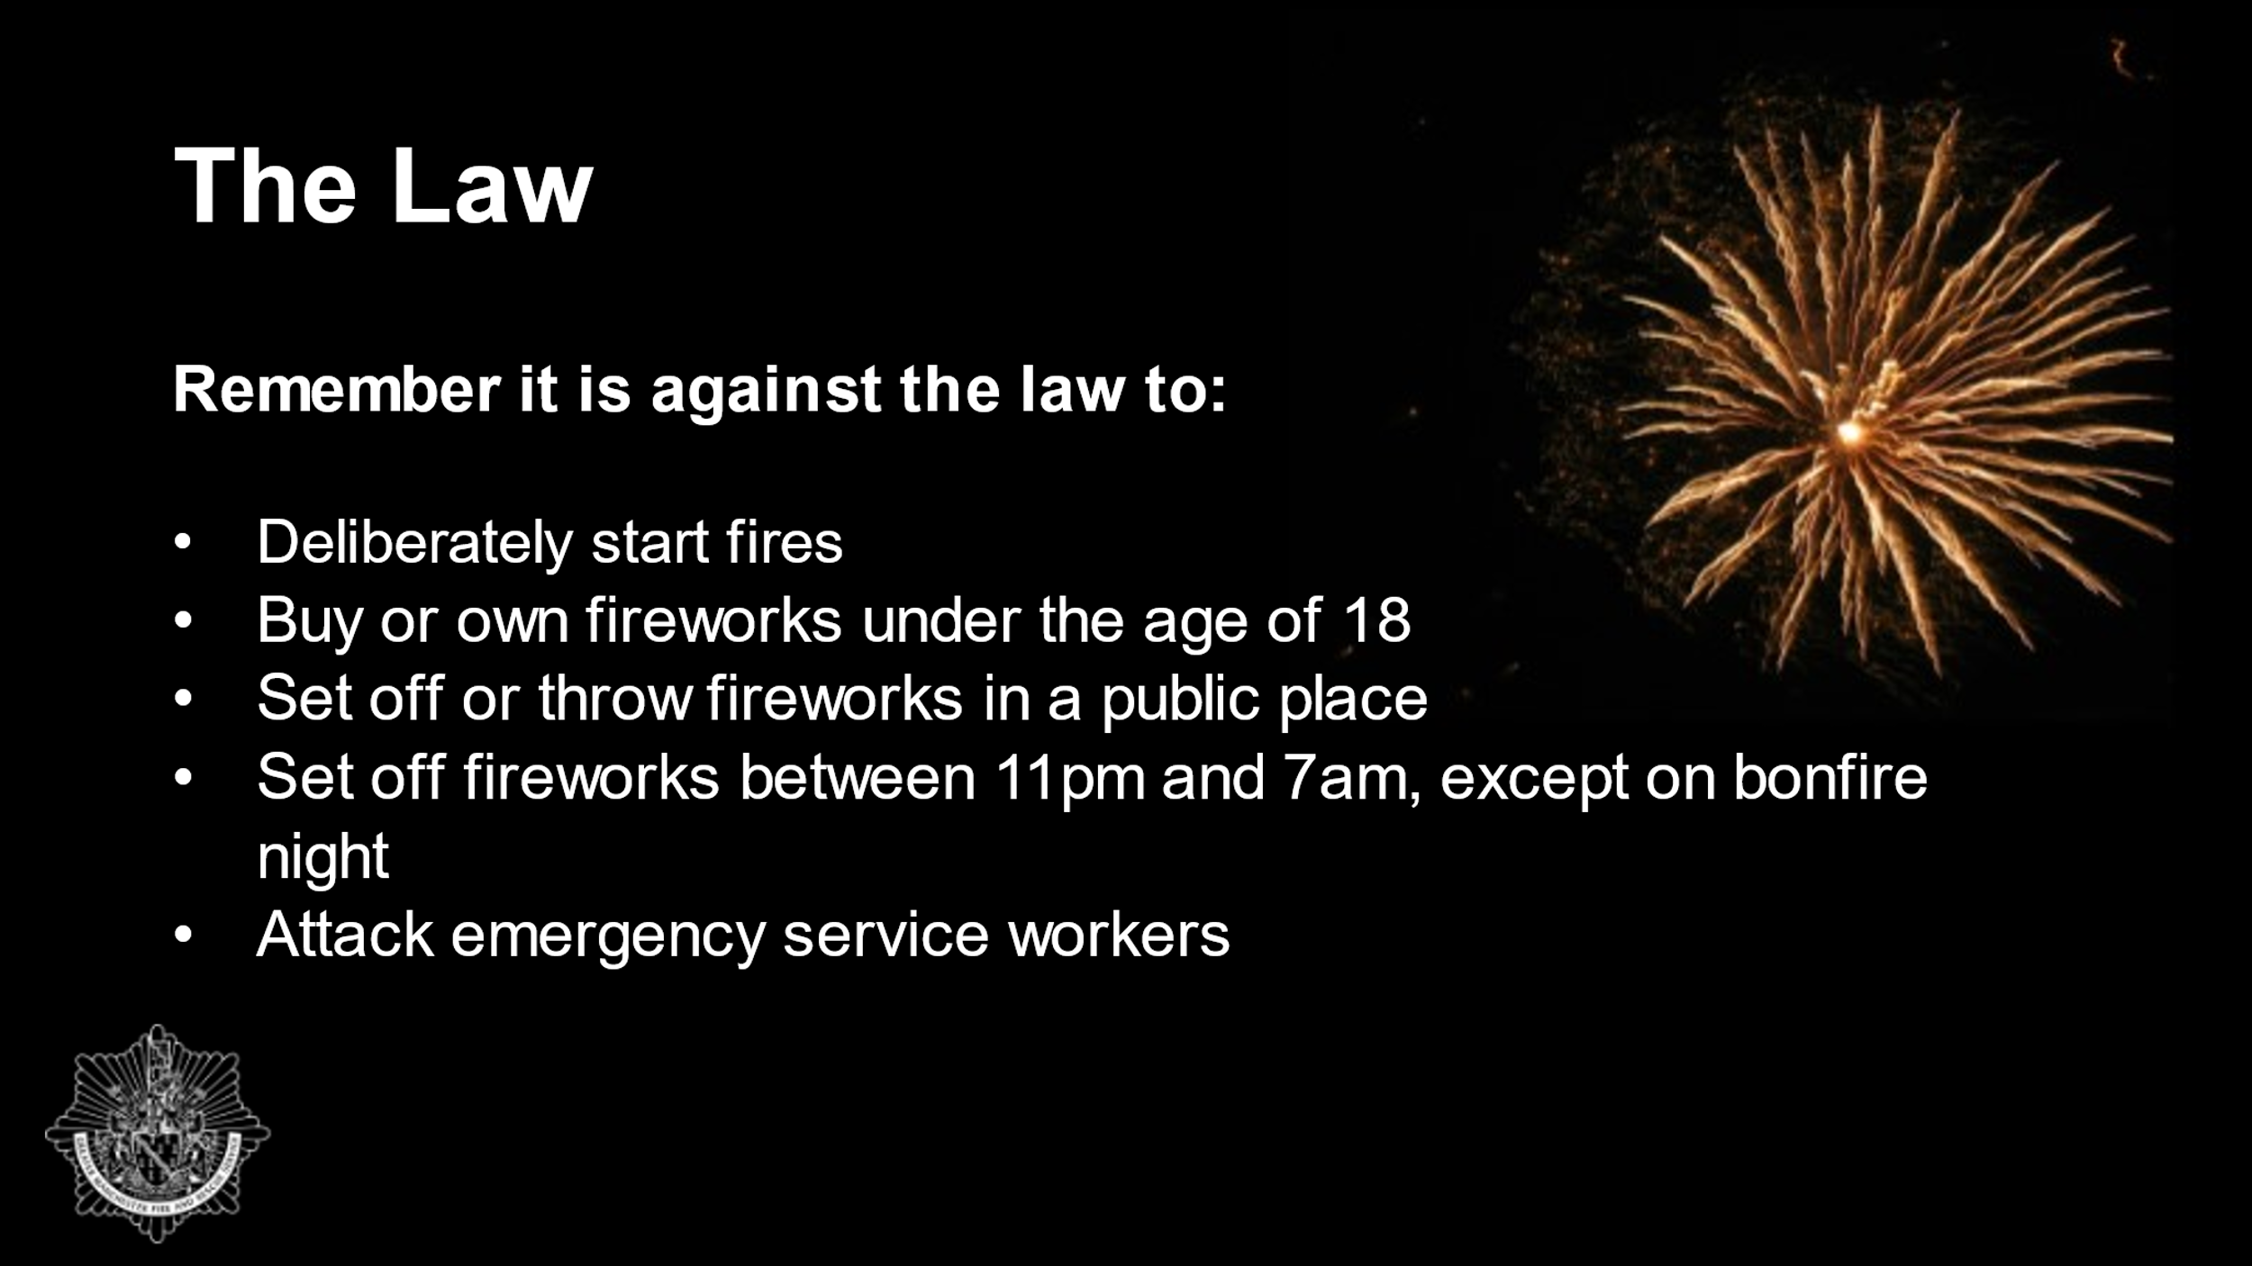  Slide 6  1 minute | Go through the Law slide:  Remember it is against the law to:  - Deliberately start fires  - Buy or own fireworks under the age of 18  - Set off or throw fireworks in a public place  - Set off fireworks between 11pm and 7am, except on Bonfire Night, New Year’s Eve, Diwali and Chinese New Year  - Attack emergency service workers  Danny experiences peer pressure to make him stay with the bonfire when the aerosol is thrown in. Don’t be pressured by others to do anything you are not comfortable with – Walk away and inform an adult.  Explain to the audience that we will shortly being going through the consequences if someone was to take part in anti-social behaviour.
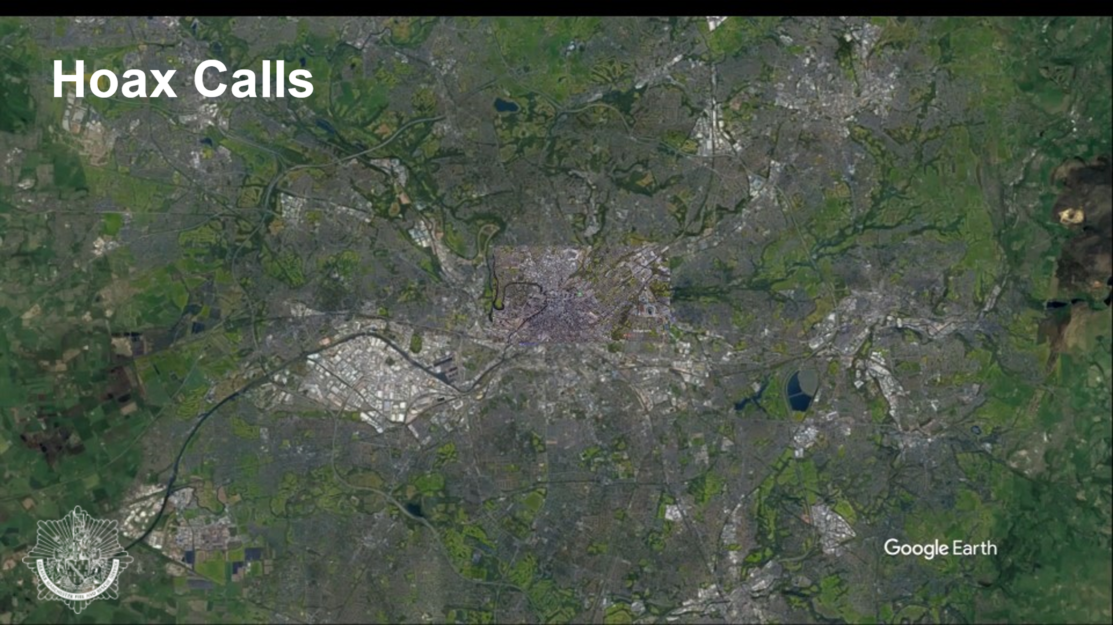  Slide 7  1 minute | Play the google earth video on the slide by hovering over it and clicking the play button. *This is just an example and not based on a real incident.*  While the video is playing, explain to the audience what is happening: Whilst Firefighters are at their station they receive a call out for an incident. It’s actually a hoax call, but they are not aware of this until they arrive and there’s no fire. Whilst attending the hoax call they receive another call to a different address, which is a real fire. This means they have a longer distance to travel to reach the actual fire, which puts people’s lives at risk.  Ultimately we can’t be in 2 places at once. This is the same if anyone makes a hoax call to the emergency services. You may not realise that:  - All 999 hoax calls are traced and recorded – in previous years we have attended 135 hoax calls in the bonfire period alone!  - Hoax call and anti-social behaviour information is given to the police for further action  - Firefighters can risk their lives attending every incident, including hoax calls  - When our firefighters are attending a hoax call, they cannot be at a real emergency – ‘next time it could be your family who need our help’, so think before making a hoax call.
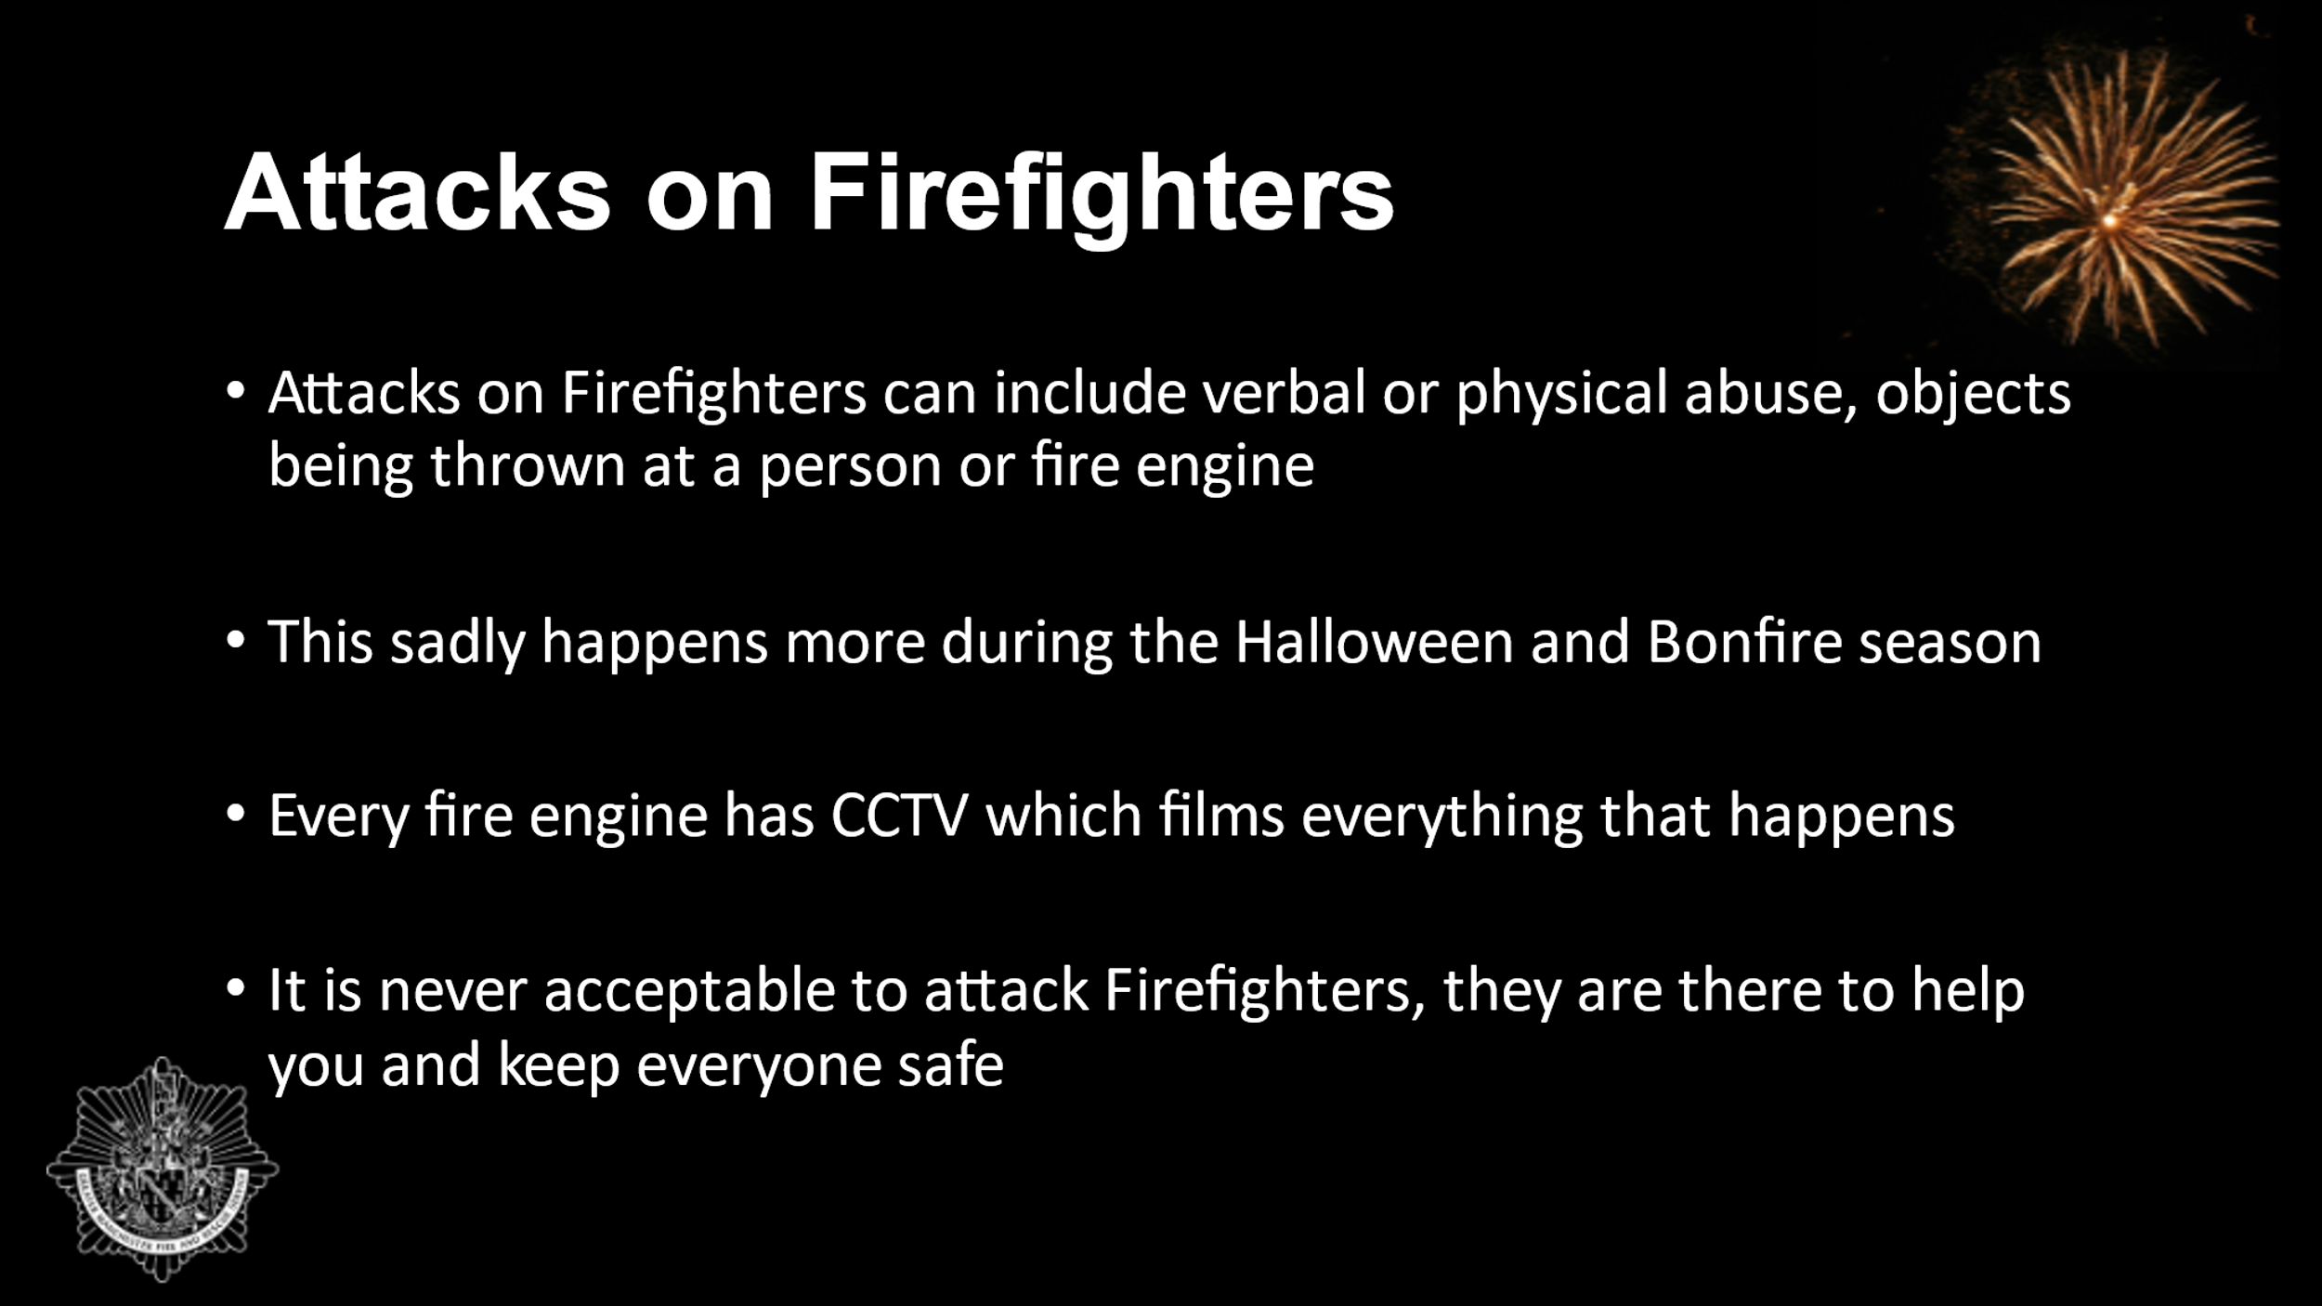  Slide 8  1 minute | Attacks on firefighters and fire appliances (this is a type of anti-social behaviour).  This could include verbal or physical abuse, objects being thrown at a person or fire appliance. The Emergency Services Workers (obstruction) Act 2006, the Crime and Disorder Act and Assaults on Emergency Workers (Offences) Act 2018, all cover offences from hindering emergency workers to causing harm to a worker or criminal damage to equipment i.e. fire engine. This sadly happens more during the Halloween and Bonfire season. Every fire engine has CCTV which films everything that happens.  Fire appliance was hit in the film – means that the fire engine is off the run (no longer in service).  Firefighters could have been hit by an object (attacks on firefighters).  It is never acceptable to attack Firefighters, they are there to help you and keep everyone safe and this is the same for any other emergency service workers.
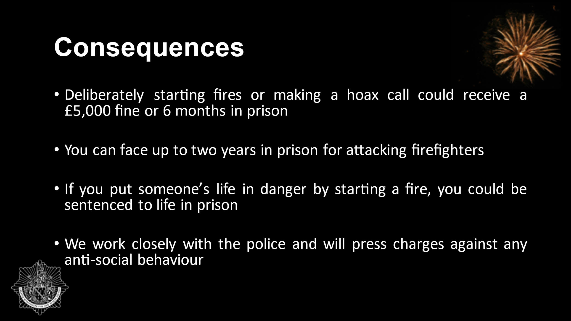  Slide 9  1 minute | Anti-Social Behaviour is serious and could impact your future. If you end up with a criminal record it will limit your career and employment prospects and some countries won’t allow you to visit if you have a criminal record.  The consequences are:  - Deliberately starting fires or making a hoax call could receive a £5,000 fine or 6 months in prison  - You can face up to two years in prison for attacking firefighters  - If you put someone’s life in danger by starting a fire, you could be sentenced to life in prison.  - We work closely with the police and will press charges against any anti-social behaviour  - Our Fire Investigation Team are dedicated to finding those who deliberately start fires  Always think about the consequences of your actions.
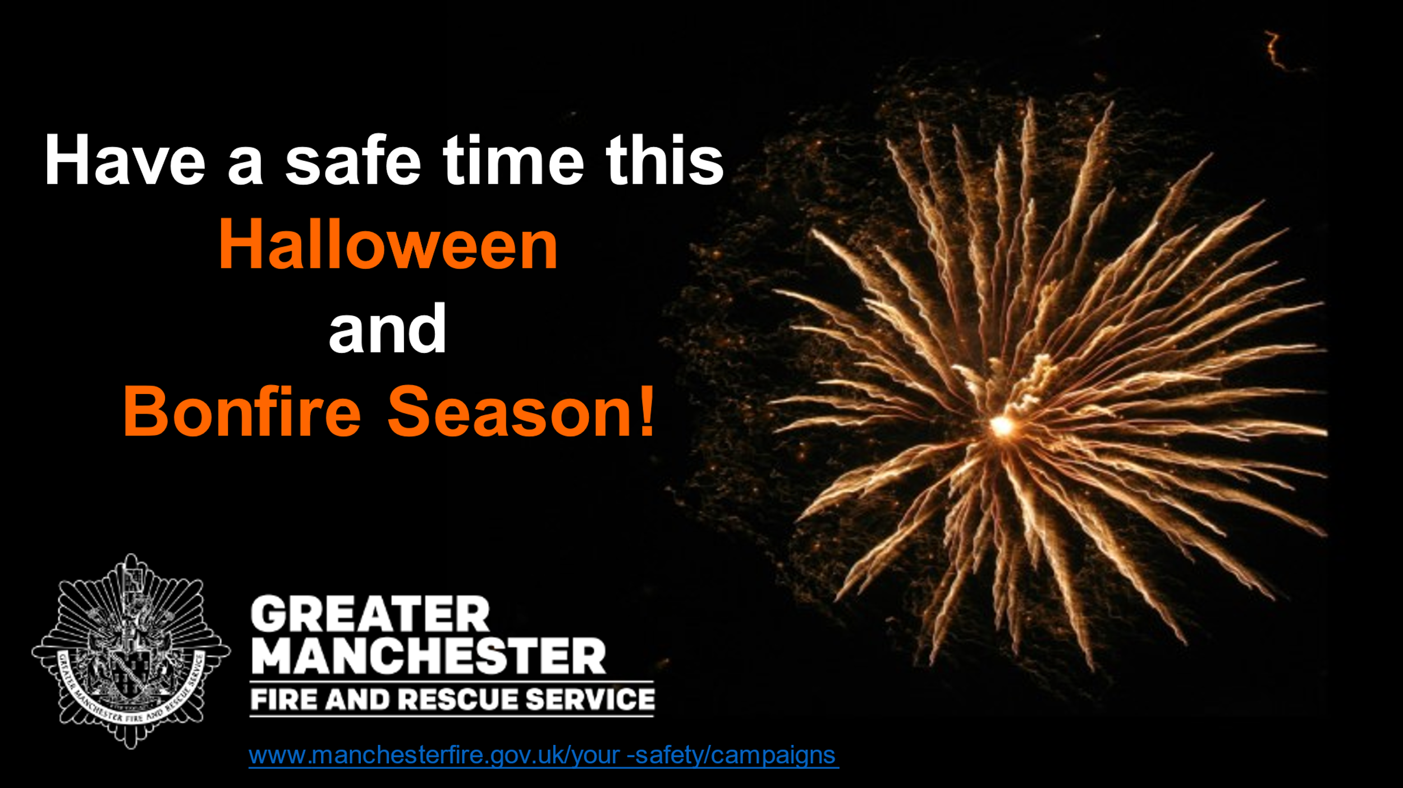  Slide 10  30 seconds | Never put yourselves in situations that may be dangerous. Think about the consequences of what could happen and how you and others may be affected.  Encourage learners to have a safe time during Halloween and Bonfire season.  Please attend an organised event!  Direct the audience to the website more information and where to find their nearest organised event: www.manchesterfire.gov.uk/your-safety/campaigns  Thank the audience for listening.
Total Time: 15 minutes
Presenter to inform teachers of our Bury Safety Centre training site, if they are not already aware. To find out more and to book a visit share the website for Bury Safety Centre: https://safetycentre.manchesterfire.gov.uk/

Programme of Study for PSHE Education:  Managing risk and personal safety and Social influences section. | KS3 | Social influences: R45. about the factors that contribute to young people joining gangs; the social, legal and physical consequences of gang behaviours.
 | KS4 | Managing risk and personal safety: H23. strategies for identifying risky and emergency situations, including online; ways to manage these and get appropriate help, including where there may be legal consequences (e.g. drugs and alcohol, violent crime and gangs).  Social influences: R35. to evaluate ways in which their behaviours may influence their peers, positively and negatively, including online, and in situations involving weapons or gangs.

