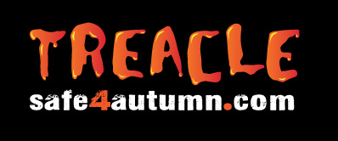
COVID-19 Adapted Lesson Plan – Firework, Bonfire and Halloween safety for secondary schools
Session Summary
To introduce the audience to key Safe4Autumn / Treacle messages which include advice on staying safe around fireworks, bonfire night and the Halloween period.
Objectives
- To be able to highlight the dangers of fireworks and bonfires
- To know & understand how to stay safe during the firework, bonfire, and Halloween period
- To know the consequences of anti-social behaviour
- To know what to do if clothing catches fire
Preparation
Access the resources via the following steps: InsideGMCA > Key Info > Campaigns (then click on Safe4Autumn / Treacle Campaign > School Resources.
Download the entire Treacle Secondary School resources folder onto the desktop on your GETAC tablet (or on a pen drive, though many schools no longer allow this), as this will be used offline and you will not have access to the GMFRS network.
Check the school have the necessary equipment before you arrive (computer, projector and screen or clear wall).
Load the presentation before the children enter the room - **the presentation may take a minute or two to load**
Check whether any of the children or staff who will be in the room having been involved in an incident that relates to the material being delivered – you may need to make adjustments to accommodate this.

Bring with you - The presentation on a suitable storage device such as a tablet or pen drive. Any other resources / equipment you may want to use to accompany the session

Delivery Guide
The “Bonfire Safety” incident case study is an actual incident that occurred over the bonfire and Halloween period. The case study is to demonstrate numerous dangers during this period and promote areas of concern. It also covers key safety message and areas of best practice.

The storyline shows two separate groups of youths, one aged around 14 and the older group are around 16 years of age.

The session is designed to present the dangers of bonfire night whilst providing time for a facilitated conversation with the audience around key topics in the case study.

This method of engagement provides the audience with the opportunity to engage and explore the subject of bonfire and firework safety.

This session can be delivered in two ways dependant on the length of time you have in a school. You can deliver the session in the following timeframes:

- 10-15 minutes for short assemblies – the questions in the presentation can facilitate a ‘hands up’ question and answer style with the audience.

- 30-45 minutes for longer sessions – the questions in the presentation can facilitate a more detailed discussion with the audience.

The guidance on the trainer notes details which information should be provided during a specific timeframe.

The lesson plan is a guideline on how to deliver the session. It contains guidelines on how to facilitate the session and the key information that should be discussed. **Please feel free to use your knowledge and expertise to adapt and include further information, this is just a guidance document*

Lesson Plan

Presentation sections | Guidance notes
Section 1  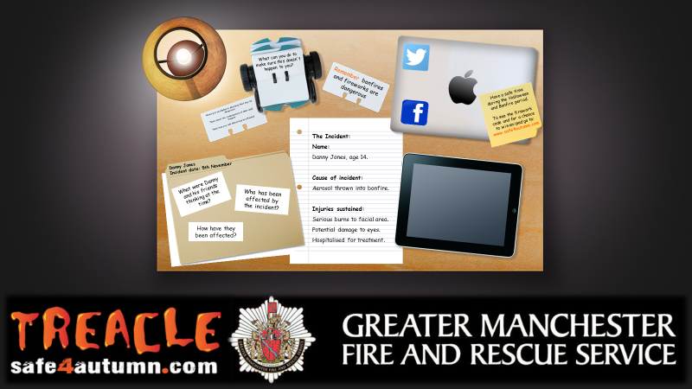  Slide 1 | This section is to provide the audience with an introduction on what will be discussed during the session -  We will talk about:  - The dangers of bonfires and fireworks  - How to stay safe during the bonfire and Halloween period  - Consequences of anti-social behaviour  - Stop, drop and roll in case your clothes catch fire
Section 2  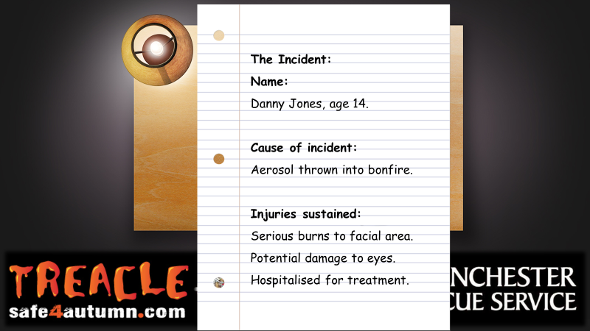  Slide 2 | The “Bonfire Safety” Incident Case Study  Inform the children that you are going to tell them about an actual incident that occurred over the bonfire and Halloween period in Merseyside. They should listen carefully as they will be asked some questions at the end. The slide provides a summary of the incident which is written on the piece of paper.  “On the 5th November Danny Jones aged 14 convinced his mum he was too old to spend the evening with her and his younger sister and wanted to go out with his friends.  Danny left his house to meet up with three of his friends all aged 14. Whilst walking through the local park they came across a bonfire, started by an older group of youths aged 16.  This older group peer pressured Danny into standing close to the bonfire whilst an aerosol cannister was thrown into it. The bonfire exploded and Danny was caught in the flames causing him to become injured. His friends called an ambulance.  When Danny arrived at hospital doctors explained that he had sustained serious burns to his facial area, which could cause potential damage to his eyes. These injuries would take months and years of hospital treatment and may leave lasting scars.  During the same night emergencies services received a large number of hoax calls. Firefighters were responding to incidents one being a wheelie bin fire when they were attacked with the use of fireworks and other items, luckily no firefighters were injured but the appliance had to be taken off the run due to damage”.  Next, explain to the audience that as a group you will now be looking into the incident and the consequences in more detail and you will require their input.  **Advise the audience that you would like some interaction and participation if you feel it is necessary**
Section 3  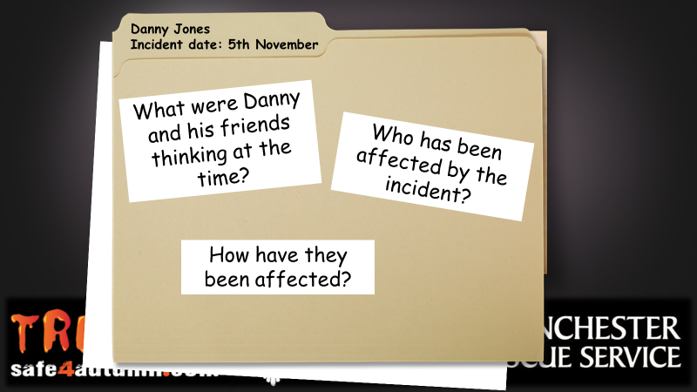  Slide 3 | The facilitated questions…  The purpose of the next 3 questions is to try and draw the key messages from the incident case study out of the audience through engaging in a question and answer session (10 minutes) or a more detailed discussion (30 – 45 minutes).  When asking the questions ask the audience members to raise a hand to provide an answer however….**If the audience do not engage then ask the questions rhetorically and provide the key messages to the audience yourself**  Question 1. What were Danny and his friends thinking at the time?  - Just wanted a good night out together on bonfire night and wants to have fun  - Feels ‘too old’ to be with his mum and sister. Wants to be independent.  - Peer pressure – Danny experiences peer pressure to make him stay with the bonfire when the aerosol is thrown in. Don’t be pressured by others to do anything you are not comfortable with.  - Aerosols – Aerosol cans contain liquid made up of different chemicals. If the aerosol comes into contact with a fire then it will heat the liquid in the can, causing it to expand and then in some cases, explode. An exploding aerosol is unpredictable; you won’t know which direction it will go and can travel for some distance, injuring anyone in its path. We are seeing an increase in young people misusing aerosols.  Question 2. Who has been affected by the incident?  This section provides you with the opportunity to discuss the ripple effect with the audience.  The ripple effect – “A situation in which one event produces effects which spread and produce further effects.” This can relate to Danny’s story by discussing how all the people who surround Danny have been affected due to the incident.  People affected:  - Danny  - His family  - Friends  - Emergency services  - Members for the public / neighbours in local area  - People in need of an emergency service  - The group of young people committing anti-social behaviour  Question 3. How have they been affected?  Following on from the previous question, ask the audience how the people mentioned have been affected by the incident.  Below is information that can be provided to the audience. Please feel free to use your knowledge and experience to add  - Danny – Injuries he sustained can take months and years of hospital treatment. The injuries were on parts of the body that are exposed such as his face. Serious burns can leave burns, lasting scars. Danny’s type of injury could impact his vision.  - His sister – How would you feel if your younger brothers or sisters saw the burns on you? Lots of trips to the hospital for years to come. The emotions and thoughts experienced.  - His mum – The worry, concern, heartache for her son. Taking time off work to be at the hospital, extra care needed due to injuries etc.  - Friends who witnessed the incident – Very traumatic to see. How would you feel if you saw your friends being injured by flames or fireworks? Something they will remember for the rest of their lives.  People in need of emergency services at the same time – Ultimately we can’t be in 2 places at once. This is the same if anyone makes a hoax call to the emergency services. You may not realise that:  - All 999 hoax calls are traced and recorded – last year we attended 135 hoax calls in the bonfire period alone!  - Hoax call and anti-social behaviour information is given to the police for further action  - A convicted hoax caller could face a fine of £5,000 and/or 6 months imprisonment  - Firefighters can risk their lives attending every incident, including hoax calls  - When our firefighters are attending a hoax call, they cannot be at a real emergency – ‘next time it could be your family who need our help’.  - Fire appliance/s hit/damaged – means that then engine is off the run  - Firefighters could have been hit by an object (attacks on firefighters)  **If you have 30-45 minutes, please discuss the information below** -  - Emergency service workers – Who responded to the incident and the NHS dealing with the after care of the injuries. A lot of resources used on an incident which was preventable.  - Neighbours who live nearby – Bonfires near houses, release of chemicals from burning material, particularly plastic and other chemicals i.e. from an aerosol can. Pets frightened by fireworks and families with young children late at night affected by ASB in the area.  - The group of young people committing anti-social behaviour – Their behaviour could impact on their future lives, not just their employment prospects. Anti-social behaviour could result in you facing criminal prosecution and ending up with a criminal record. Some countries won’t allow you to visit if you have a criminal record. Their home may also be at risk if their parents / guardians have actions taken against them as a result of the anti-social behaviour.
Section 4  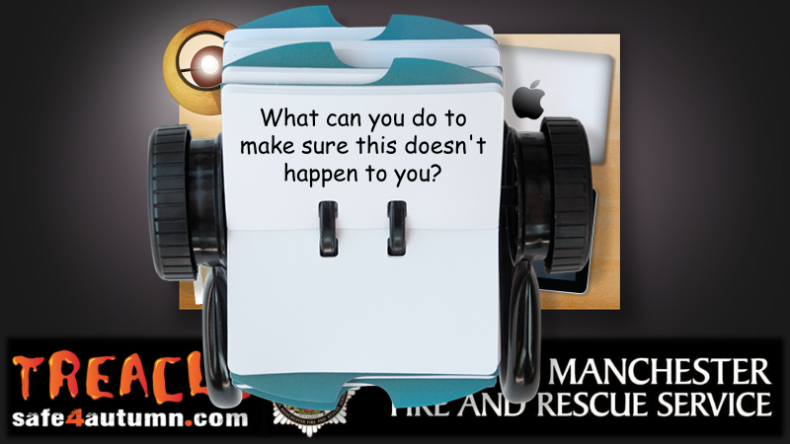  Slide 4 | Further facilitated question: What can you do to make sure this doesn’t happen to you?  - Never do things because of peer pressure and don’t feel embarrassed to say no – if you know it is wrong then don’t do it and be a good friend by not peer pressuring others into doing something that is dangerous.  - Talk through stop, drop and roll if you come into direct contact with a flame  STOP – stop what you’re doing and stay very still.  DROP – drop to the floor.  ROLL – roll backwards and forwards until the flames are out  - Danny and his friends now feel embarrassed, it was pointless for a few minutes of fun, scars may last a lifetime and Danny fears how the injuries sustained will impact his life.
Section 5  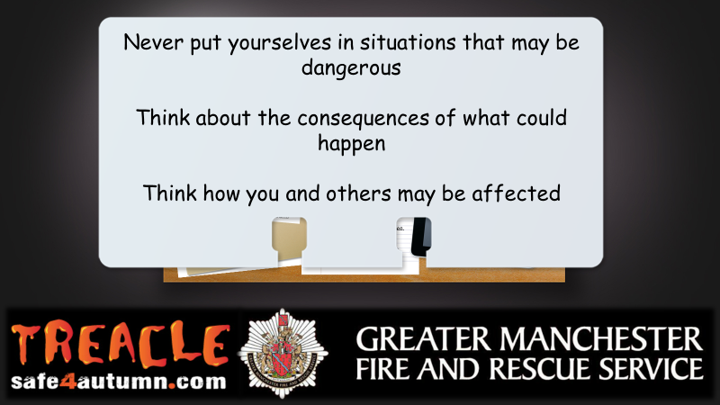  Slide 5 | Summarise the key point on the slide:  Never put yourselves in situations that may be dangerous  Think about the consequences of what could happen  Think how you and others may be affected  **If you have 30-45 minutes, please discuss the information below** -  - Anti-social behaviour – defined as ‘acting in a manner which causes, or is likely to cause, harassment, alarm or distress to any person’. Discuss deliberate fire setting and the consequences of this e.g. could receive a £5,000 fine or 6 months imprisonment. If you endanger life by deliberately setting a fire, you could be sentenced to life imprisonment. Our Fire Investigation Team are dedicated to finding those who deliberately start fires.  - Attacks on firefighters and fire appliances (this is a type of anti-social behaviour). This could include verbal or physical abuse, objects being thrown at a person or fire appliance etc. The Emergency Services Workers (obstruction) Act 2006 and the Crime and Disorder Act both cover offences from hindering emergency workers to causing harm to a worker or criminal damage to equipment i.e. fire engine. Every fire engine has CCTV which films everything that happens. We work closely with the police and will prosecute if you are caught.  - Wheelie bin fire – People have no idea what is already in that bin, it could contain things which are lethal if set alight e.g. chemicals. There are also harmful chemicals in the plastic of the bin itself if set alight. Wheelie bin fires can spread to nearby buildings.
Section 6  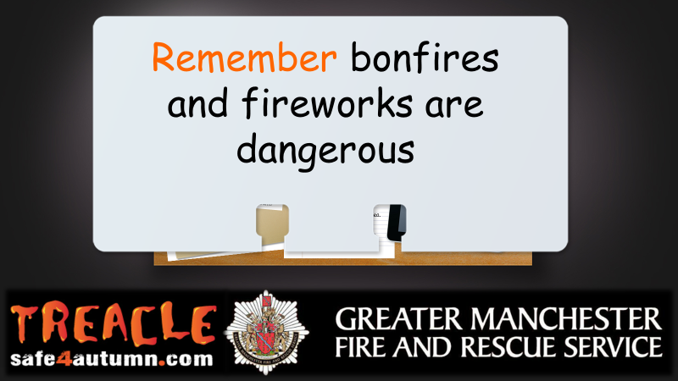  Slide 6 | Summarise key dangers of firework and bonfires:  - Fireworks and bonfires burn at extremely hot temperatures.  - Fireworks and bonfires can cause burns and other injuries.  - Fireworks can cause damage to property, moorlands and start other fires.  - Bonfires can easily get out of control and can be difficult to put out.  - Bonfires are dangerous to the environment.  - Fireworks frighten animals.  Always follow the firework code:  - Only a responsible adult (aged 18 or over) should light them at arm’s length using a taper  - Stand well back  - Never go back to a lit firework  - Never put fireworks in your pocket  - Keep a bucket of water nearby if you are setting off fireworks in your garden  - Never throw fireworks  - Keep pets indoors  Tell adults to also see the firework code.
Section 7  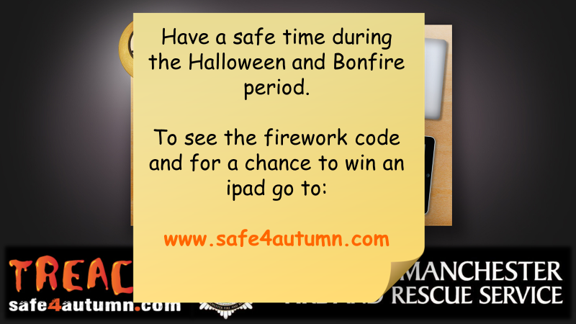  Slide 7 | Encourage learners to have a safe time during Halloween and Bonfire period summarising the key points discussed.  Direct the audience to the website - www.safe4autumn.com for more information on the firework code and further bonfire safety advice.  Promote competition – Win an iPad (Wi-Fi) 32GB by completing a short survey on the website.
Section 8  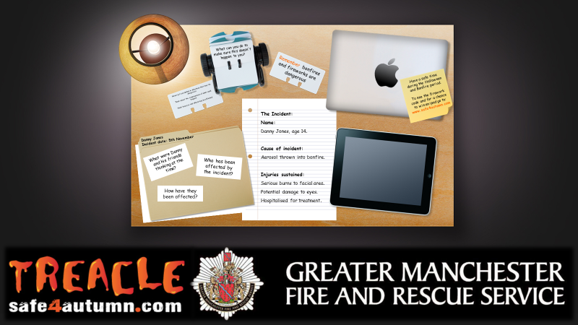  Slide 8 | Any questions?  Discuss any final thoughts with the audience and ask if they have any questions about what has been discussed.
Section 9  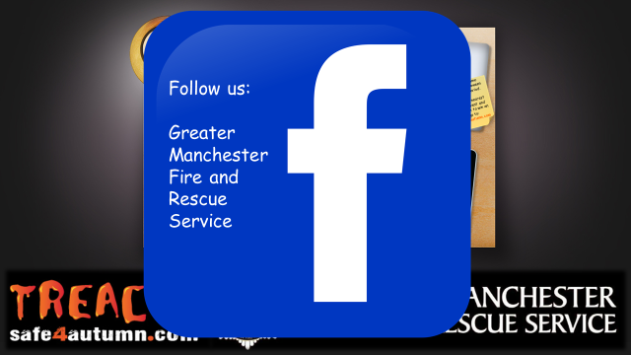  Slide 9  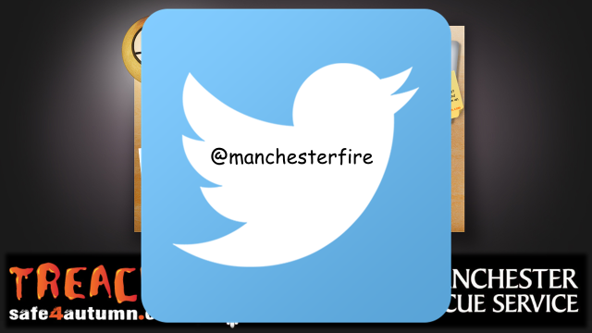  Slide 10 | Refer to audience to both GMFRS social media sites which are the following -  - Facebook – @Greater Manchester Fire and Rescue Service  - Twitter - @manchesterfire
Section 10  Slide 11 | Conclusion to session  Thank the audience for taking part in the session.  *Presenter to inform teachers of our Bury Safety Centre training site, if they are not already aware. To find out more and to book a visit share the website for Bury Safety Centre: https://safetycentre.manchesterfire.gov.uk/  *Please note Bury Safety Centre are not currently taking school visits due to COVID-19 but please still pass on the information for teachers and schools to consider a visit in the hopeful near future*

