c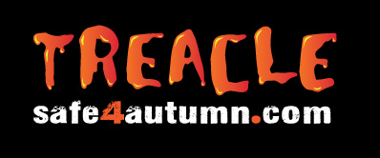
COVID-19 Adapted Lesson Plan – Firework, Bonfire and Halloween safety for primary school

Session Summary
To introduce the children to key Safe4Autumn/Treacle messages which include advice on staying safe around fireworks, bonfire night and Halloween.

Objectives
- To be able to highlight the dangers of fireworks and bonfires
- To know & understand how to stay safe during the bonfire and Halloween period
- To identify safe clothing during the Halloween and bonfire period
- To know what to do if clothing catches fire

Preparation
Access the resources via the following steps: InsideGMCA > Key Info > Campaigns (then click on Safe4Autumn / Treacle Campaign > School Resources
Download the entire Treacle Primary School resources folder onto the desktop on your GETAC tablet (or on a pen drive, though many schools no longer allow this), as this will be used offline and you will not have access to the GMFRS network.
Check the school have the necessary equipment before you arrive (computer, projector and screen or clear wall).
Load the PowerPoint presentation before the children enter the room - **the presentation may take a minute or two to load**
**How to use PowerPoint – All you need to do is click the space bar, arrow keys or remote clicker to move from one slide to the next.

Check whether any of the children or staff who will be in the room having been involved in an incident that relates to the material being delivered – you may need to make adjustments to accommodate this.

Bring with you – The entire Treacle Primary School resources folder on a suitable storage device such as a GETAC tablet (or pen drive), plus your HDMI lead. Any other resources / equipment.

N.B. Please be aware that this is a short presentation, which can be included as part of your usual delivery of key fire/community safety messages to primary school children during the autumn season.

Delivery Guide

This session can be delivered in two ways dependant on the length of time you have in a school. You can deliver the session in the following timeframes:

- 10-15 minutes for short assemblies – the questions in the presentation can facilitate a ‘hands up’ question and answer style with the audience.

- 30-45 minutes for longer sessions – the questions in the presentation can facilitate a more detailed discussion with the audience.

This lesson plan is a guideline on how to deliver the session. It contains guidelines on how to facilitate the session and the key information that should be discussed. **Please feel free to use your knowledge and expertise to adapt and include further information, this is just a guidance document**

Lesson Plan

Presentation | Guidance notes
Section 1: Introduction  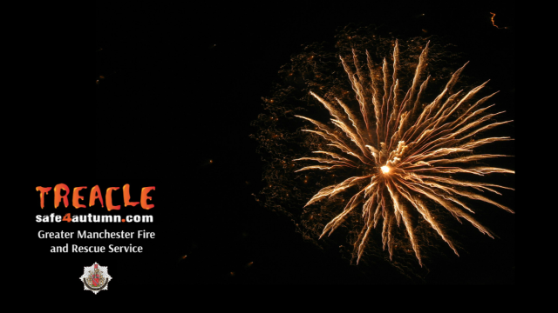  Slide 1 | This section is to provide the audience with an introduction on what will be discussed during the session -  We will talk about:  - The dangers of bonfires and fireworks  - How to stay safe during the bonfire and Halloween period  - Stop, drop and roll in case your clothes catch fire
Section 2: Fireworks and bonfires are dangerous  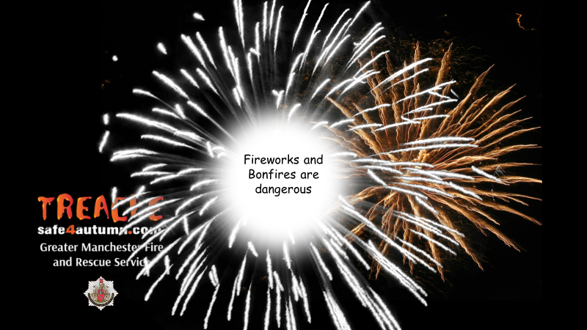  Slide 2 | Hold a discussion with the children based on the following statement that ‘fireworks and bonfires are dangerous’ ask the children why they are dangerous?  Allow the children to think about this question and to come up with some answers. Ask the children to put their hands up and feedback the answers to you.  Some possible answers to discuss:  - Fireworks, sparklers and bonfires are very hot.  - Fireworks, bonfires and sparklers can cause burns and other injuries, if you are too close or not wearing the correct clothing.  - Fireworks can cause damage to property, moorlands and start other fires.  - Fireworks scare animals - they have more sensitive hearing to humans, so the loud noise can frighten them causing them to run and possibly injury themselves.  - Bonfires can easily get out of control and can be difficult to put out.  - Bonfires are dangerous to the environment.  Next ask the children ‘how they can keep themselves and others safe during the bonfire, firework and Halloween period?’  Again allow the children to think about this question and to come up with some answers. Ask the children to put their hands up and feedback the answers to you.  Remember to praise children for their answers.  The key messages are on the next 4 slides.
Section 3: Key Messages  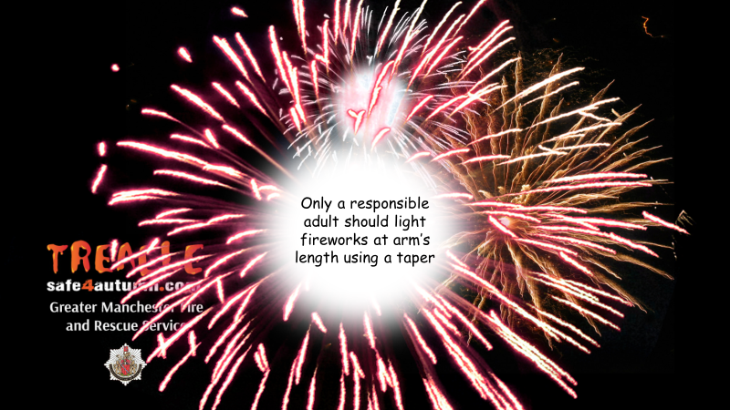  Slide 3  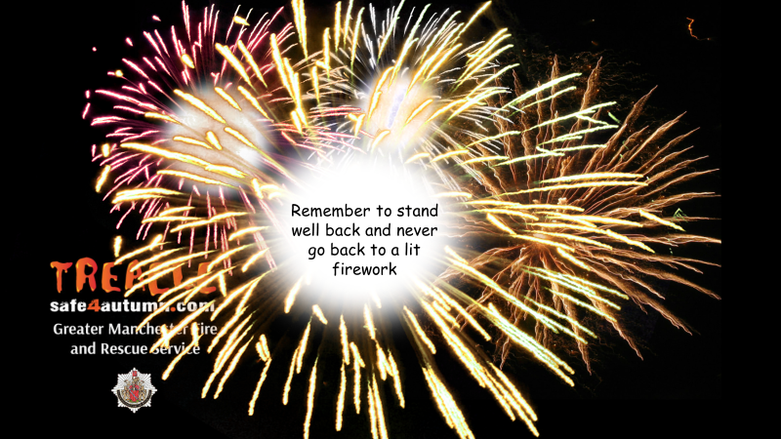  Slide 4  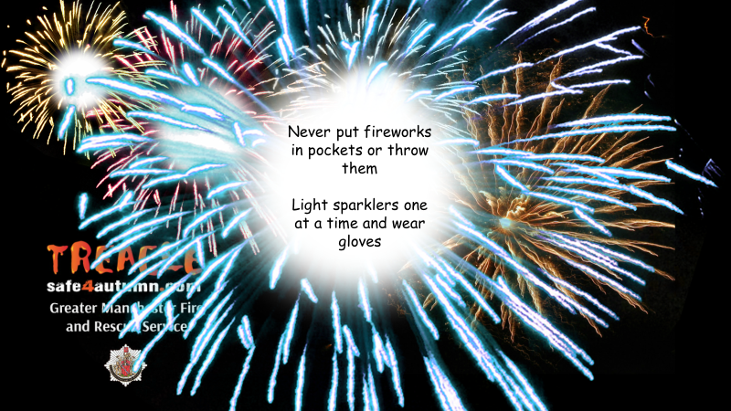  Slide 5  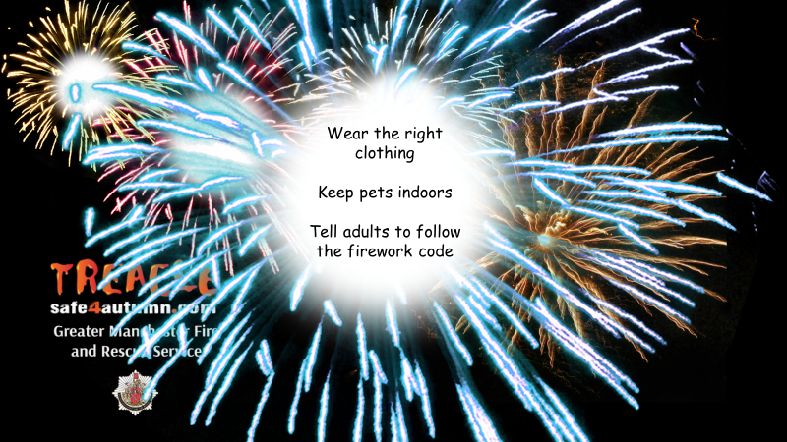  Slide 6 | Children should never light fireworks - Only a responsible adult should light fireworks at arm’s length using a taper – you may need to explain what a taper is to children and why we recommend an adult uses it.  Remember to stand well back and never go back to a lit firework.  Never put fireworks in pockets or throw them.  Light sparklers one at a time and wear gloves – children under 5 should not be given sparklers.  Wear the right clothing  Keep pets indoors  Tell adults to follow the firework code
Section 4: Stop, drop & roll – GMFRS cracker video  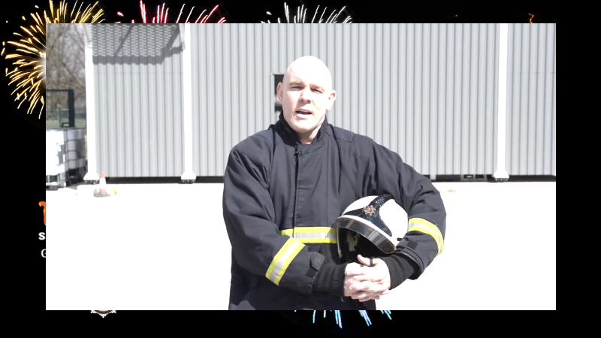  Slide 7 | This section describes what to do should your clothing catch fire.  To play the video: Hover over the image and a play bar will appear. Click the play button.  You may also want to demonstrate to the group yourself, choose someone from the audience or perform as an entire group – please adhere to social distancing rules here.  If demonstrated you might need a gym mat on the floor.  *Take care, no injuries please!*  STOP – stop what you’re doing and stay very still.  DROP – drop to the floor.  ROLL – roll backwards and forwards until the flames are out.  If time is short, the three point message is all learners need to remember.
Section 5: Be Safe!  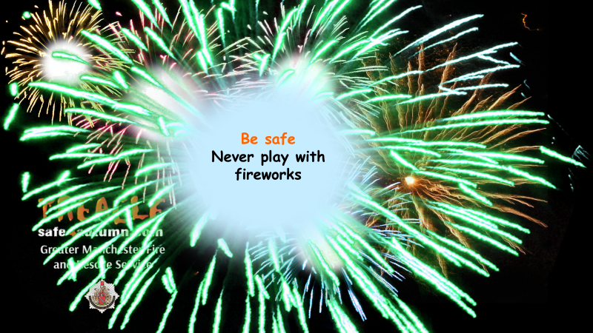  Slide 8 | This section is key bonfire / firework and Halloween messages that should be provided to the children.  Below is some additional information that can be provided. Feel free to use your experience and knowledge to expand on the points as required.  - Fireworks and bonfires are dangerous no matter what age you are. Lots of people injured by fireworks are children aged 14 years and younger, the same age as you and your friends. Many of the injuries take place at home in gardens.  - Hoax calls to emergency services: you may not realise that:  - All 999 hoax calls are traced and recorded – last year we attended 135 hoax calls during the bonfire period  - Hoax call information is given to the police for further action  - A convicted hoax caller could face a fine of £5,000 and/or 6 months imprisonment  - Firefighters can risk their lives attending every incident, including hoax calls  - When our firefighters are attending a hoax call, they cannot be at a real emergency.  - Ask the learners what clothes they will be wearing during the Halloween, bonfire and firework period. Confirm that they should wear warm and bright clothing. Also, Halloween costumes can easily catch fire. They need to keep well away from fireworks, bonfires and any other naked flames.
Section 6: Website info  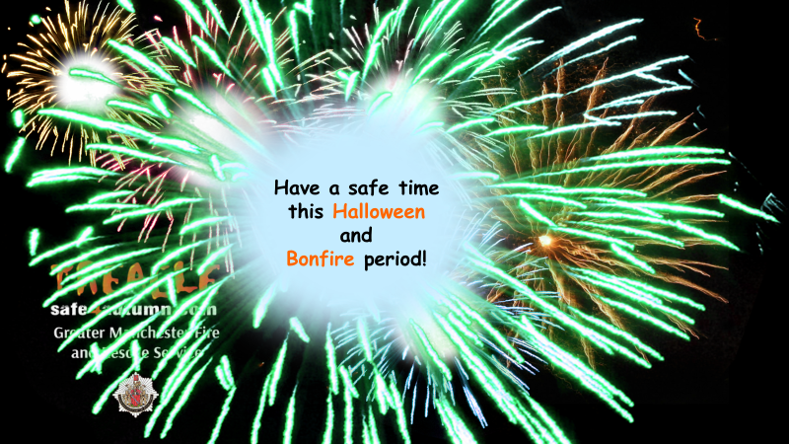  Slide 9  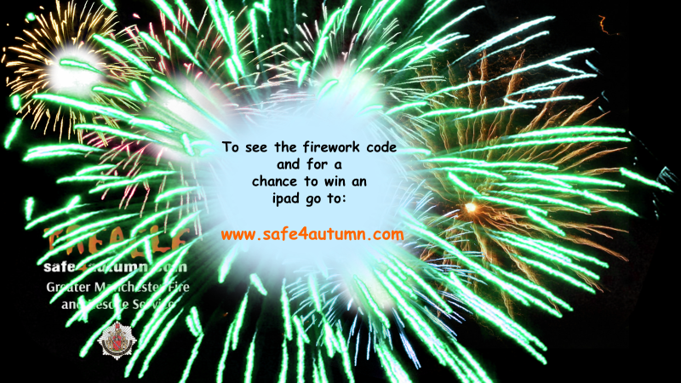  Slide 9 | Encourage learners to have a safe time during Halloween and Bonfire period summarising the key points discussed.  Direct the audience to the website - www.safe4autumn.com for more information and where to find the firework code as well as further bonfire safety advice.  Promote competition – Win an iPad (Wi-Fi) 32GB by asking parents/guardians to complete a short survey on the website.
Section 7: Questions  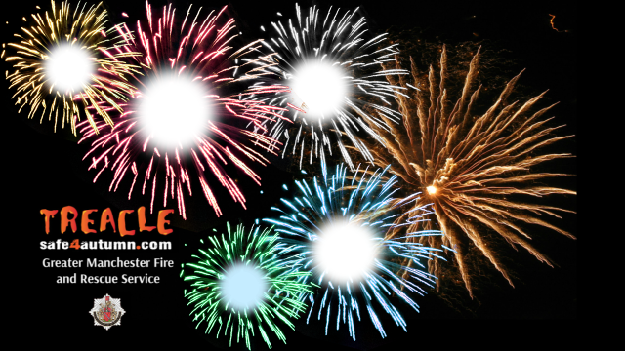  Slide 10 | Any questions?  Discuss any final thoughts with the audience and ask if they have any questions about what has been discussed.  Thank the children for taking part in the session.

Presenter to inform teachers of our Bury Safety Centre training site, if they are not already aware. To find out more and to book a visit share the website for Bury Safety Centre: https://safetycentre.manchesterfire.gov.uk/
*Please note Bury Safety Centre are not currently taking school visits due to COVID-19 but please still pass on the information for teachers and schools to consider a visit in the hopeful near future*

