Working in Partnership

Preventing Fires and Improving Health and Wellbeing

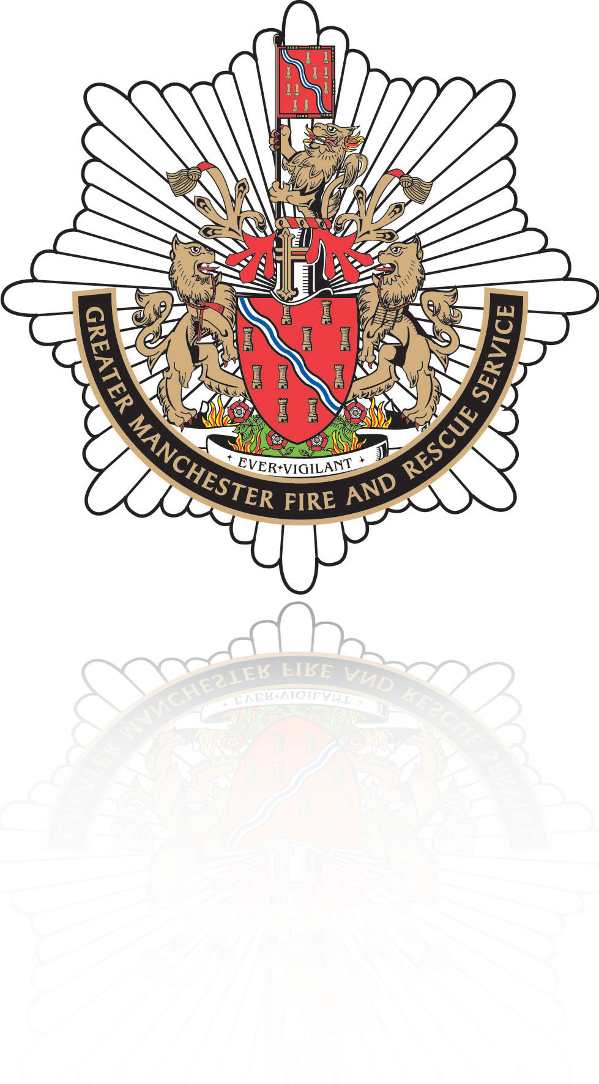

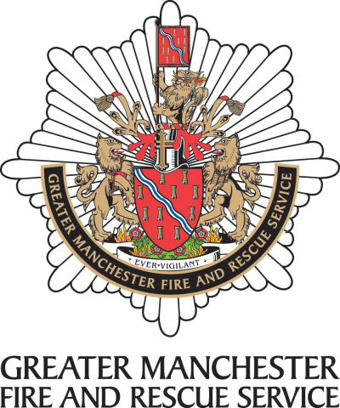

Introduction
The Greater Manchester Strategy 2013, ‘Stronger Together’, provides a vision for public service reform alongside a continued drive for growth and prosperity across the region. The strategy aims to make Greater Manchester a ‘fairer, healthier, safer and more inclusive place to live, known for excellent, efficient, value for money services and transport choices’.
In February 2015 the local authorities and NHS organisations in Greater Manchester (GM) signed a landmark devolution agreement with government on the transformation of health and social care. At the heart of the agreement is a vision to deliver the fastest and greatest possible improvement in the health and wellbeing of the 2.8million people living across Greater Manchester. The GM Strategic Plan: Taking Charge of Health and Social Care in Greater Manchester, was endorsed by all of the organisations in the devolution partnership and sets out this ambition and the priorities for transformation now that control over the £6billion health and social care budget has been devolved. The GM plan is underpinned by Locality Plans in each of the ten GM districts. The plan sets out an ambition to improve outcomes for the residents of GM, increasing independence and reducing demand on public services.
Greater Manchester Fire and Rescue Service (GMFRS) is committed to preventing fires and other emergencies across the county but our core purpose is wider than this. We aim to, ‘save, protect and improve the lives of people in Greater Manchester’. To support this vision and the aims of Stronger Together and the GM Strategic plan, we are reforming our service and working with our partners to meet the needs of the communities we serve and provide added value for money.
Many factors that result in poor health outcomes and place major stress on health and social care services and other partners are also factors that contribute to fire risk. Frailty, poor physical and mental health, obesity, smoking, alcohol and substance abuse are all areas of concern for fire and rescue services because they can increase an individual’s risk of having a fire or becoming a casualty in a fire (or other emergencies). It makes sense then for us to work with our partners to deliver collaborative approaches to improving outcomes for our communities.
This document offers a framework for GMFRS and its partners to work together to prevent fires and improve health and wellbeing for those who are most at risk.

People at Increased Risk of Fire
It is difficult to categorically define the factors that increase an individual’s risk of having a fire, or being injured or killed in a fire, because fire risk can only be truly assessed on a case-by-case basis. However, it is important for us to try and describe this group so that our staff, and partners who refer people to us, understand our target group for the fire prevention activities we deliver. We often refer to this target group as ‘people at increased risk of fire.’
In the introduction we described some of the factors which can increase an individual’s risk of having a fire or becoming a casualty in a fire. Evidence for this can be found in the GMFRS annual report, ‘Learning from Accidental and Non-Accidental Fatal Fire Incidents’.
The latest report, published in 2016, found that that mental illness, physical disability, alcohol, drugs, smoking, prescribed medication and living alone were all contributory factors in fire deaths. The report also found that 40% of people who died in fires were known to Social Services. Also 50% were over the age of 60, which is disproportionate when compared to the Greater Manchester population in which only 20.4% are over 60. The table below summarises some of the common factors observed in fatal fire incidents.
Person | Occupations/routines | Environment
Mental illness | Smoking | Inadequate smoke detection
Physical disability | Alcohol use | Clutter/Hoarding
Aged over 60 | Prescribed or over the counter medication | Blocked escape routes
Known to social care | Drug use | Living alone/isolation
Memory impairment | Poor fire safety routines | Inadequate care or support
Frailty/falling

Using this information, we can describe people at increased risk of fire as; People whose risk of having a fire, being injured in a fire, or dying in a fire, is increased by one or more of the following; their physical or mental health or social care needs, their lifestyle or occupations/routines, the physical and social environment in which they live.

Working in Partnership
There are a number of different ways to approach partnership working to prevent fires and improve the health and wellbeing of those most at risk. One way is through the development and implementation of written partnership agreements between GMFRS and its partners. Written partnership agreements should be underpinned by a number of principles;
- agreements should be developed in situations where working together is mutually beneficial and provides better service and value to the public than working alone
- agreements should include the agreed aims and objectives of the partnership
- agreements should document tasks to be undertaken, timescales and the respective responsibilities of each partner
- agreements should provide a benchmark against which the outputs and outcomes of the partnership can be measured and evaluated
- Partners should be willing and able to commit time to implement and maintain the agreement and it should be acknowledged that a lack of success once a partnership has been reviewed may result in termination of that agreement.
GMFRS has written partnership agreements with a variety of partners including Mental Health Trusts, drug and alcohol treatment services and housing associations. However, we recognise that as a result of continued public service reform, devolution and substantial changes to the health and social care landscape, new and innovative structures and models of delivery are being developed across Greater Manchester. These include Public Service Reform (PSR) hubs, Locality Care Organisations (LCOs), Place Based Integration Early Adopter sites and others. These developing multi-agency models perhaps lend themselves to partnership arrangements with GMFRS that differ to the written partnership agreement approach described above and so we will adopt a flexible approach to working with our partners to achieve shared goals.
As an organisation we commit to supporting new ways of working in the most appropriate way in each instance. This could mean integration into multi-agency teams, sharing of assets and buildings or being part of a wider public service response to local need.

Safe and Well Visits
A good starting point for developing partnerships that aim to prevent fires and improve health and wellbeing is to explore the role that GMFRS’s Safe and Well visits can play.
GMFRS has delivered over 620,000 home visits (previously called Home Safety Checks) across Greater Manchester, between 2005 and 2016. Delivery of the visits has contributed to a 43% reduction in dwelling fires, illustrating their preventative value.
Traditionally, the visits focussed on testing and fitting smoke detection, developing escape plans and providing fire safety advice to address common causes of fire such as cooking, candles and electrics. More recently, our understanding of who is at increased risk of fire has helped us to build on this; visits now include questions to establish if and how physical and mental health, mobility, substance misuse, smoking, social isolation and fuel poverty impact on the householder’s fire risk. Understanding this enables us to tailor our fire safety advice to meet the needs of the individual or household, making our interventions more effective for those who are most at risk.
Talking to people about the underlying risk factors provides GMFRS with an opportunity to deliver or signpost people to advice on health, wellbeing and crime prevention, whilst passing on referrals where a more specialist approach is needed. To reflect this we have changed the name of our visits from Home Safety Checks to Safe and Well visits. To maximise the value of Safe and Well visits, it is essential that we agree inward and outward referral pathways. Furthermore, GMFRS requires the expertise of partners to inform the wellbeing advice that our staff deliver during the visits.

Other Opportunities
There are many other opportunities for collaborating to prevent fires and improve health and wellbeing. We have 41 community fire stations and other venues, as well as community vehicles which can be used by our partners and community groups. We have volunteers who can support joint initiatives. We deliver seasonal and topical campaigns which can be co-developed where appropriate. We also offer a variety of other services to the public, such as youth engagement programmes, Moss Side Boxing club, Irlam climbing wall, school visits and Heartstart training. Further details about these offers are provided in our Community Safety Resources Brochure.
By working together with partners we hope to provide a more integrated service to people who live and work in Greater Manchester, sharing our assets and adding public value through a collaborative approach.

Making it Happen
GMFRS has developed a suite of resources to support the development and implementation of partnerships. These are;
- Partnership Agreement template - Preventing Fires and Improving Wellbeing
- Safe and Well Referral form - for partner referrals
- Safe and Well Referral form – for self-referrals
- GMFRS Community Resources Brochure
- Fire Safety Leaflets
- Safe and Well promotional film (4.5mins)
- Training webinar for partners (60mins)
To access the resources, or discuss working together, contact your local GMFRS Community Safety Manager;
Manchester: Clare Platt plattp@manchesterfire.gov.uk 0161 608 5312 / 07790 337829
Salford/Trafford: Andy Pownall pownallp@manchesterfire.gov.uk 0161 609 0212 / 07977 410605
Wigan/Bolton: Derek Dempster dempsterd@manchesterfire.gov.uk 01204 902112 / 07734 275762
Bury/Oldham/Rochdale: Jax Effiong effiongj@manchesterfire.gov.uk 0161 909 8634 / 07976 027920
Stockport/Tameside: Martin Barber barberm@manchesterfire.gov.uk 07734 275712 /07734 275712
Greater Manchester: Email our central Prevention team at safeandwell@manchesterfire.gov.uk or visit our website www.manchesterfire.gov.uk

A Final Word - The Marmot Review
During an independent review of health inequalities, Professor Sir Michael Marmot identified that Fire and Rescue Services are in the perfect position to deliver interventions and work in partnership with other agencies to reduce health inequalities.
‘I visited various interventions and programmes aimed at improving health and reducing inequalities. I was so impressed with the work of the Fire Services! Back then I was completely unaware of the relevance of their day to day work to reducing health inequalities. I realised that the agendas of preventing ill-health and preventing fires were closely linked: fires and ill-health occur in the more deprived areas, to people at the bottom of the socio-economic gradient, to those in poor housing, and to those whose circumstances have lead them to take up unhealthy lifestyles. The Fire Services do what every stakeholder involved in reducing health inequalities should do: engage directly with the community, work to provide them with the opportunities they need to live healthy life and focus on prevention.’
(Professor Sir Michael Marmot, Fair Society, Healthy Lives: The Marmot Review. Strategic Review of Health Inequalities in England post-2010. HM Government)

