Smoking and fire safety campaign 2024 – partner communications pack
Our smoking and fire safety campaign is aimed at smokers in Greater Manchester. Elements of the campaign will target smokers that live alone, smokers that misuse drugs or alcohol, smokers aged 50+, males and communities in Greater Manchester with a higher smoking prevalence.
Smoking is one of the top causes of accidental fires in the home, and the top cause of accidental fire deaths in the home in Greater Manchester. The campaign aims to reduce smoking-related fires, injuries and deaths by tackling risks such as not putting cigarettes out properly and falling asleep with a cigarette still burning.
The 2024 campaign will launch 26 April and will run for two months.
The campaign’s key messages are:
- The best way to prevent a smoking related fire at home is to stop smoking. For help and support to quit visit makesmokinghistory.co.uk
- To prevent a fire in your home, take your cigarette outside.
- Ensure your smoking materials are extinguished properly, in a sturdy ashtray (put it out, right out).
- Never smoke in bed or when you’re tired. It’s easy to fall asleep with a cigarette burning and set furniture, clothes or bedding alight.
- Don’t smoke if you’ve taken drugs or alcohol that make you tired or drowsy.
- Don’t leave a lit cigarette, cigar or pipe lying around. They can easily fall over and start a fire.
- Fit a working smoke alarm on every floor of your home and in rooms where you usually smoke.
- Test your smoke alarms regularly – they could save your life if a burning cigarette starts a fire.
- Complete an Online Home Fire Safety Check for smoking fire safety advice and to find out if you’re eligible for a Home Fire Safety Assessment.
Facebook, X and Instagram: @manchesterfire. Hashtag: #SmokingFireSafetyGM used in social posts.
Social media assets, and other resources, can be downloaded from: manchesterfire.gov.uk/your-safety/campaigns/smoking-and-fire-safety/
Key activities
- Sharing messaging on social media
- Smoking and fire safety leaflets and posters available for GMFRS staff and partners to distribute
- Targeted online display and printed newspaper advertising, using the same artwork as the social media assets
- Smoking and fire safety webpages: manchesterfire.gov.uk/your-safety/fire-safety/house-maisonette-or-bungalow/smoking/
- Smoking and fire safety campaign webpage for partners: manchesterfire.gov.uk/your-safety/campaigns/smoking-and-fire-safety/
Campaign assets are available from the campaign webpage for partners. If you have any issues downloading any assets, please contact hendersonz@manchesterfire.gov.uk.
Partners are encouraged to share content from the digital toolkit as widely as possible across all social channels, as well as linking to our webpage: manchesterfire.gov.uk/your-safety/fire-safety/house-maisonette-or-bungalow/smoking/ when possible.

Suggested social media posts
Facebook and X
Copy | Image/Alt Text
Smoking is the top cause of accidental fire deaths in the home .  To prevent a smoking-related fire in your home:  ❌ Never smoke in bed.  💤 Take extra care if you smoke when you’re tired.  💊 Don’t smoke if you’ve taken medication that makes you tired or drowsy.  #SmokingFireSafetyGM | 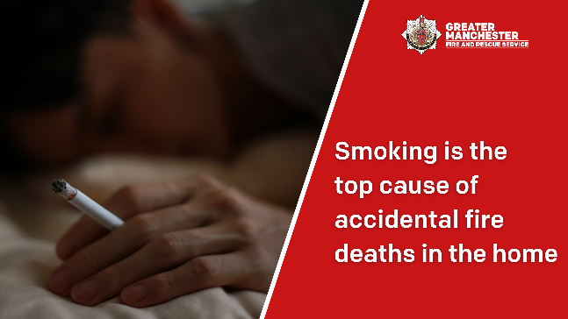  A hand holding a lit cigarette in bed. ‘Smoking is the top cause of accidental fire deaths in the home’.
The best way to prevent a smoking related fire at home is to stop smoking.  For help and support to quit visit makesmokinghistory.co.uk  #SmokingFireSafetyGM | 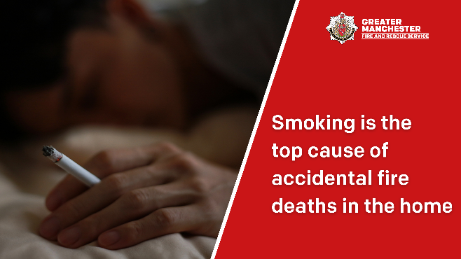  A hand holding a lit cigarette in bed. ‘Smoking is the top cause of accidental fire deaths in the home.’
To prevent a fire in your property, take your cigarette outside and enjoy a smokefree home.  📈 Smoking is the top cause of accidental fire deaths in the home.  #SmokingFireSafetyGM | 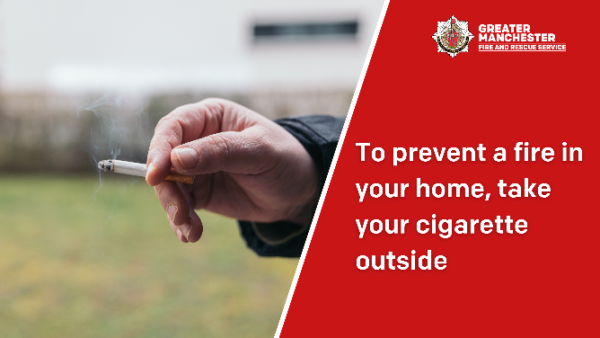  A hand holding a lit cigarette outside. ‘To prevent a fire in your home, take your cigarette outside.’
Put your cigarettes out properly, in a sturdy ashtray that won’t tip over.  #SmokingFireSafetyGM | 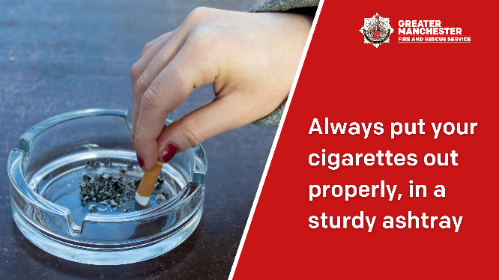  A hand stubbing out a cigarette in a thick glass ashtray. ‘Always put your cigarettes out properly, in a sturdy ashtray.’
❌ Never smoke in bed or when you’re tired .  It’s easy to fall asleep with a cigarette burning and set furniture, clothes or bedding alight.  #SmokingFireSafetyGM | 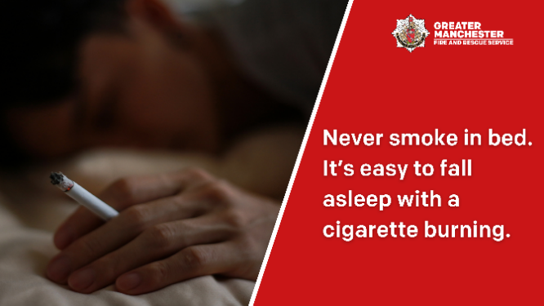  A hand holding a lit cigarette in bed. ‘Never smoke in bed. It’s easy to fall asleep with a cigarette burning.’
❌ Don’t smoke if you’ve taken drugs or alcohol that make you tired or drowsy.  It’s easy to fall asleep with a cigarette burning and set furniture, clothes or bedding alight.  #SmokingFireSafetyGM | A hand holding a lit cigarette in bed. ‘Smoking is the top cause of accidental fire deaths in the home.’
❌ Don’t leave a lit cigarette, cigar or pipe lying around. They can easily fall over and start a fire.  Smoking 🚬 is the top cause of accidental fire deaths in the home.  #SmokingFireSafetyGM | A hand holding a lit cigarette in bed. ‘Smoking is the top cause of accidental fire deaths in the home.’
❗ Fit a working smoke alarm on every floor of your home and in rooms where you usually smoke. Remember to test them regularly.  #SmokingFireSafetyGM | 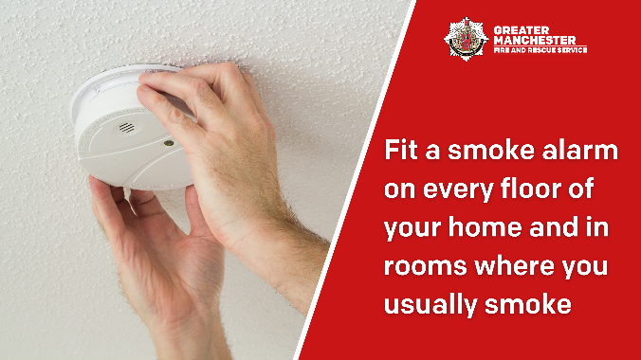  Person fitting a smoke alarm on the ceiling. ‘Fit a smoke alarm on every floor of your home and in rooms where you usually smoke.’
❗ Test your smoke alarms regularly – they could save your life if a burning cigarette starts a fire.  ✅ Fit a smoke alarm on every floor of your home and in rooms where you usually smoke.  #SmokingFireSafetyGM | Person fitting a smoke alarm on the ceiling. ‘Fit a smoke alarm on every floor of your home and in rooms where you usually smoke.’
❗ Fit a working smoke alarm on every floor of your home and in rooms where you usually smoke.  ✅ Complete an Online Home Fire Safety Check for smoking fire safety advice and to find out if you’re eligible for a free Home Fire Safety Assessment: https://www.manchesterfire.gov.uk/your-safety/hfsa/  #SmokingFireSafetyGM | Person fitting a smoke alarm on the ceiling. ‘Fit a smoke alarm on every floor of your home and in rooms where you usually smoke.’

Instagram
Copy | Image/Alt Text
Smoking is the top cause of accidental fire deaths in the home .  To prevent a smoking-related fire in your home:  ❌ Never smoke in bed.  💤 Take extra care if you smoke when you’re tired.  💊 Don’t smoke if you’ve taken medication that makes you tired or drowsy.  Search ‘smoking’ on @manchesterfire website for more information.  #SmokingFireSafetyGM | 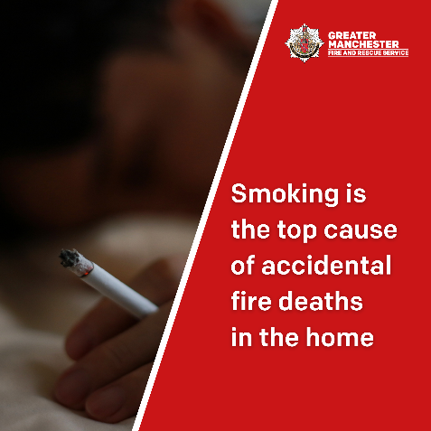  A hand holding a lit cigarette in bed. ‘Smoking is the top cause of accidental fire deaths in the home.’
The best way to prevent a smoking related fire at home is to stop smoking.  For help and support to quit search ‘Make Smoking History GM’.  #SmokingFireSafetyGM | A hand holding a lit cigarette in bed. ‘Smoking is the top cause of accidental fire deaths in the home.’
To prevent a fire in your property, take your cigarette outside and enjoy a smokefree home.  📈 Smoking is the top cause of accidental fire deaths in the home.  #SmokingFireSafetyGM | 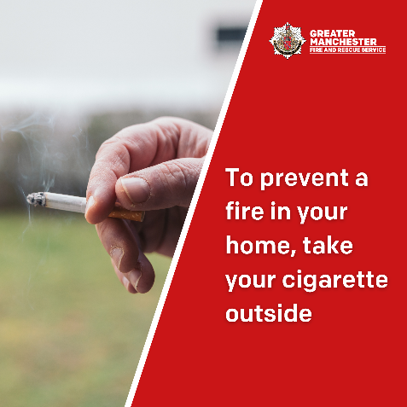  A hand holding a lit cigarette outside. ‘To prevent a fire in your home, take your cigarette outside.’
Put your cigarettes out properly, in a sturdy ashtray that won’t tip over.  #SmokingFireSafetyGM | 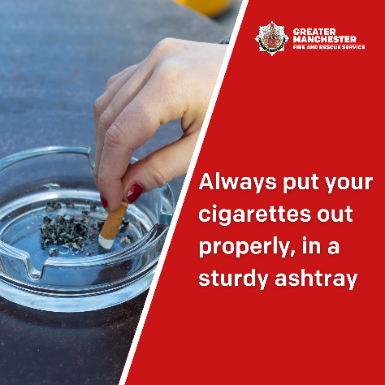  A hand stubbing out a cigarette in a thick glass ashtray. ‘Always put your cigarettes out properly, in a sturdy ashtray.’
❌ Never smoke in bed or when you’re tired.  It’s easy to fall asleep with a cigarette burning and set furniture, clothes or bedding alight.  #SmokingFireSafetyGM | 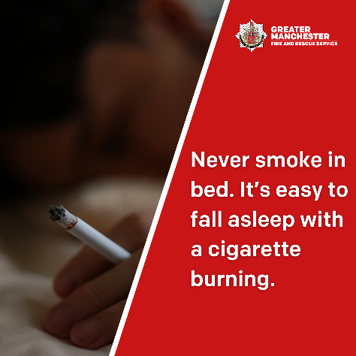  A hand holding a lit cigarette in bed. ‘Never smoke in bed. It’s easy to fall asleep with a cigarette burning.’
❌ Don’t smoke if you’ve taken drugs or alcohol that make you tired or drowsy.  It’s easy to fall asleep with a cigarette burning and set furniture, clothes or bedding alight.  #SmokingFireSafetyGM | A hand holding a lit cigarette in bed. ‘Smoking is the top cause of accidental fire deaths in the home.’
❌ Don’t leave a lit cigarette, cigar or pipe lying around. They can easily fall over and start a fire.  📈 Smoking is the top cause of accidental fire deaths in the home.  #SmokingFireSafetyGM | A hand holding a lit cigarette in bed. ‘Smoking is the top cause of accidental fire deaths in the home.’
❗ Fit a working smoke alarm on every floor of your home and in rooms where you usually smoke. Remember to test them regularly.  📈 Smoking is the top cause of accidental fire deaths in the home.  #SmokingFireSafetyGM | 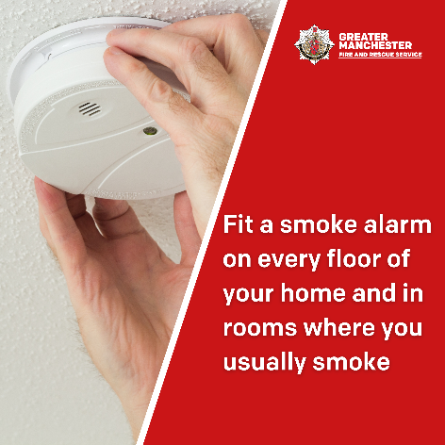  Person fitting a smoke alarm on the ceiling. ‘Fit a smoke alarm on every floor of your home and in rooms where you usually smoke.’
❗ Test your smoke alarms regularly – they could save your life if a burning cigarette starts a fire.  ✅ Fit a smoke alarm on every floor of your home and in rooms where you usually smoke.  #SmokingFireSafetyGM | Person fitting a smoke alarm on the ceiling. ‘Fit a smoke alarm on every floor of your home and in rooms where you usually smoke.’
❗ Fit a working smoke alarm on every floor of your home and in rooms where you usually smoke.  ✅ Complete an Online Home Fire Safety Check for smoking fire safety advice and to find out if you’re eligible for a free Home Fire Safety Assessment.  Search ‘HFSA’ on the @manchesterfire website  #SmokingFireSafetyGM | 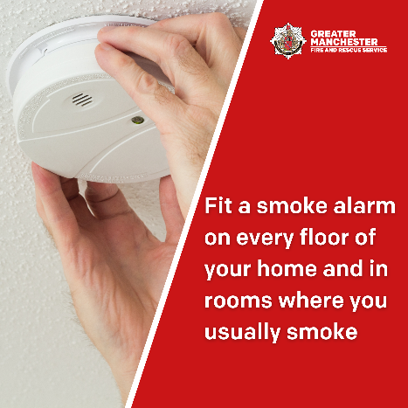  Person fitting a smoke alarm on the ceiling. ‘Fit a smoke alarm on every floor of your home and in rooms where you usually smoke.’

