Road Safety
Fatal 4 Fact Sheet

The following information contains facts and information on the Fatal 4.
The Fatal 4 Presentations that are available on our GMFRS Website and are aimed at 16+ due to the content and videos used.
There is also a Lesson Plan for each of the topics, to help support your delivery.
Please use your discretion on who and how you deliver this information to.
Fatal 4 Fact Sheets
Speeding | Page 2
Distraction | Page 7
Drink & Drug Driving | Page 13
Seatbelts | Page 17

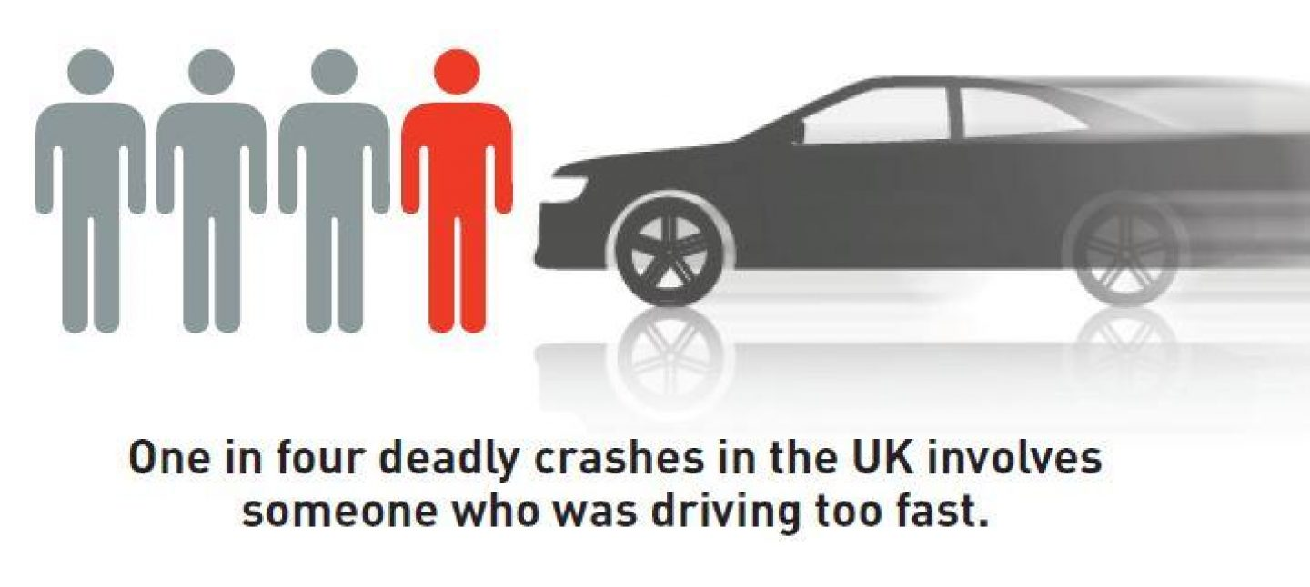

To access GMFRS Road Safety Pages visit www.manchesterfire.gov.uk

Speeding
Speed Limits Are Not Targets
Speed limits are limits, not targets. They are set as the top speed for any road, and should never be exceeded, a safe speed is often far below the posted limit.
- When a car crashes, it’s the amount of kinetic energy that the car has which determines the force of impact. Kinetic energy is the energy of motion. Small increases in speed lead to much higher increases in kinetic energy.
- When you’re driving, it’s hard to perceive that a slight increase in speed is so damaging. It’s easy to let speed creep up. But a crash at 30mph involves twice as much energy and destructive potential as a crash at 20mph.
Crashes at higher speeds cause more severe injuries and deaths.
‘Rural Roads Are Not Racetracks’
Narrow, bendy roads often lack pavements or cycle paths and are unsuited to high speeds.
- Rural roads pose high risks, accounting for well over half of all fatal crashes. Cyclists, motorcyclists, and car drivers are more than three times as likely to be killed per mile travelled on a rural road than an urban road.

- Speed is often a major factor in rural road crashes. A study of single-carriageway rural roads estimated that a 10% increase in average speed results in a 30% increase in fatal and serious crashes.

- The most common crash types on rural roads are collisions at intersections, head-on collisions and running off the road.

Stopping Distances
A vehicle travelling at 20mph would stop in time to avoid a child running out three car-lengths in front. The same vehicle travelling at 25mph would not be able to stop in time and would hit the child at 18mph. This is roughly the same impact as a child falling from an upstairs window.
Driving is unpredictable and if something unexpected happens on the road ahead, such as a child stepping out from between parked cars, it is a driver’s speed that will determine whether they can stop in time and, if they can’t stop, how hard they will hit.
In adverse weather, such as icy roads stopping distance increases by up to 10 times.
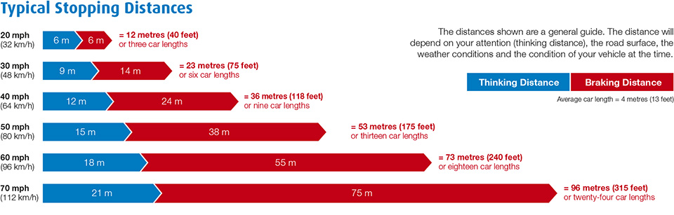
Two second rule
The two-second rule is a rule of thumb by which a driver may maintain a safe trailing distance at any speed. The rule is that a driver should ideally stay at least two seconds behind any vehicle that is directly in front of his or her vehicle.
- Allow at least a two-second gap between you and the vehicle in front on roads carrying faster-moving traffic and in tunnels where visibility is reduced.

- The gap should be at least doubled on wet roads and increased still further on icy roads.

Driving at safe speeds saves lives
Driving at a safe speed reduce the risk of road death and injury and enables more people to make safe and healthy journeys on foot and by bike.
- A pedestrian hit at 30mph has a 1 in 5 chance of being killed.

- Every day, road crashes cause devastation to individuals, families and communities across the UK and the globe. Vehicle speed is always a factor in the severity of the incident.
- With someone injured on a UK road every four minutes, and vehicle speed playing a part in every crash, it’s time to come together to say that there is no need to speed.

Research has found that many young men who have been driving for a while are overconfident in their driving ability and believe they can safely take risks when at the wheel. This includes driving too fast, especially when in a hurry or on roads they think they know well and being more likely to use a handheld mobile at the wheel.

Clarify why slower driving is safer

The faster a vehicle is travelling, the longer it takes to stop. At higher speeds, a driver has less time to react and stop in time in an emergency.
- The faster we drive, the greater our risk of crashing, and the harder we hit if we crash. A crash at 30mph has twice the energy and destructive potential of a crash at 20mph.
- The greater the impact speed, the greater the chance of death. A pedestrian hit at 30mph has a very significant (one in five) chance of being killed. This rises significantly to a one in three chance if they are hit at 35mph. Even small increases in speed can lead to an increase in impact severity.
- Where traffic is slow, more people choose to walk or cycle. 20mph is an appropriate maximum speed in places where people live.
- Fast moving traffic also creates unpleasant noise and air pollution, making our communities less safe and deterring people from walking and cycling.

Speeding Drivers and why they should expect to be caught
Safe road users comply with road rules and share responsibility for the safety of everyone who uses roads.
- Most road deaths and injuries are caused by unsafe driver behaviour, often because drivers are going too fast for road conditions.

- Investment in roads policing and a comprehensive speed enforcement programme is essential to catch speeding drivers and deter people from speeding.

Speeding Penalties
- The minimum penalty for speeding is a £100 fine and 3 penalty points added to your licence.

- You could be disqualified from driving if you build up 12 or more penalty points within a period of 3 years.

- New drivers, still within 2 years of passing their driving test, will have their diving licence revoked (withdrawn) if they build up 6 or more penalty points

Speeding penalties - GOV.UK (www.gov.uk)

Distractions

Young males aged 17-24 are four times more likely to be killed or seriously injured compared with car drivers aged 25 or over.

- Young male drivers are more likely to crash with passengers in the car.
- Tell them that you are going to play a film called ‘Party Car’. This Campaign’, created by (THINK! – Road safety). Is aimed at tackling driving distractions among this high-risk group.
- The campaign encourages passengers to ‘let a mate concentrate’.
- The films show how certain behaviours which may seem minor, can be distracting to the driver.

Describe different types of driving distractions, visual, manual and cognitive.

Physical distractions, such as texting or making a phone call, setting a sat nav, or eating. Remember it's illegal to use a hand-held phone whilst driving, as well as being potentially dangerous.
Mental distractions, such as worries, a conversation in the car or on a hands-free phone, or not paying attention to familiar roads.
Visual and audio distractions, such as loud music, looking at things happening outside your car, or trying to read a sat nav.

There are simple things you can do to make sure there's nothing to distract you and that your full attention is on the road.
- Prepare yourself and your car before starting your journey.
- Clear out clutter - cans and soft drink bottles rolling around under your seat are clearly a distraction and could even roll under the pedals and stop you from being able to use them properly.
- If you need to use your sat nav, make sure it's fully charged up (or plugged into your car's charging port), and that you've already programmed the correct postcode and address.
- Pre-set the radio to your favourite stations, and if you want to listen to playlists, make sure they're set up on your device before you leave.
- Send any texts or make calls, then pop your phone in the glove box.

Mobile Phones
Talk through the facts and possible consequences of using a mobile phone handheld or hands free whilst driving.

- Much less aware of what’s happening on the road around them.
- Fail to see road signs.
- Fail to maintain proper lane position and steady speed.
- Are more likely to ‘tailgate’ the vehicle in front.
- React more slowly, take longer to brake and longer to stop.
- Are more likely to enter unsafe gaps in traffic.
- Feel more stressed and frustrated.

The current penalties for using a mobile phone whilst driving
- The current penalties for using a mobile phone whilst driving are

- A fixed-penalty notice – a £200 fine and six penalty points for using a handheld phone when driving
- New drivers who have passed their test in the past two years will automatically lose their licence. If taken to court, you could face disqualification and a fine of up to £1,000 (£2,500 if you’re driving a lorry or a bus).

Say to the group… Ask yourself… Could you live with the guilt if you caused injuries or death by using a phone, sat nav, tablet, or any device that can send or receive data, whilst driving or riding a motorcycle?

How to stay clear-headed whilst on the road
- It's not easy to put all of your worries and thoughts to one side, but you need to be as calm and focused as possible.
- If you have something on your mind, try to deal with it as much as possible before getting behind the wheel.
- Try not to drive if you're feeling overwhelmed, stressed, or you think you won't be able to give driving your full attention.
- If you need to make a call or send a text, wait until you've pulled over safely to use your phone.
- Even if you're feeling stressed, resist the urge to smoke, vape or eat while you're driving.
Staying focused whilst having passengers in the car

- Passengers of all ages can be a distraction - from teething toddlers to overexcited friends.
- Kids squabbling or arguing in the back is another big distraction for drivers too!
- Make sure children are securely strapped into car seats and booster seats.
- If you're driving with one young child, it can be less distracting for the child to ride in the front seat (in a suitable restraint) because casual eye contact is easier.
- If there are two adults in the car, one can look after any children while the other concentrates on driving.
- Ask passengers to keep the music at a level where you can hear the sat nav and other drivers around you.
- If you're finding the drive difficult, ask your passengers to keep conversations to a minimum.
- Keep political discussions and any other heated topics strictly off-limits

How to drive safely with Pets in the car

- There are ways of keeping your pet safe in the car, but if your pet is playing up during the drive, how can you stay calm and collected?

- Secure your pet properly, never let your pet travel loose in the car, even if you're worried the drive is stressing it out. Besides being a serious distraction, if they're free to jump about inside the car, they're more likely to be injured or injure you if you are involved in a collision.

- Don't attempt to reach out and calm your pet until you've pulled over and parked safely. Ensure there's plenty of fresh air and make regular stops for walks and toilet breaks, they'll benefit both of you.

The importance of being attentive whilst driving

The key to driving is to ensure you’re always alert and attentive to what’s going on around you. As such, distractions can hamper your ability on the road. If an incident occurs ahead and you’re too busy changing the radio station, you might not be able to avoid a collision. Therefore, you need to make sure every second on the road is spent being fully attentive.

The importance of being mindful whist driving

Some motorists have tunnel vision, only watching what’s going on directly in front of them. This isn’t ideal though because hazards can be present everywhere. Make sure to pay attention to the whole road and be better prepared to avoid hazards when driving.

Remember the two second gap rule
When driving, particularly on motorways and at high speeds, ensure to leave a lengthy gap between you and the car in front. This should be around two seconds (or two chevrons if they’re painted onto the road). In wet or icy conditions, you’ll need to leave a longer distance.
D Distraction is a killer
I It’s your responsibility to drive safely and for the safety of others
S Stay Safe
T Take your time
R Ring before you leave
A Always, let a mate concentrate
C Could you live with your conscience?
T Text then pop your phone in the glove box
I If your passengers are distracting you, pull over, stop the car
O Observe others using the roads inside and outside of the vehicle
N Never drive when eating, drinking or reading

Drink & Drug Driving

Over 200 people are killed and more than 1,100 seriously injured in drink drive crashes each year.
- Often it is an innocent person who suffers, not the driver who is over the drink drive limit. Pedestrians, motorcyclists, pedal cyclists, and vehicle passengers are killed or seriously injured by drink drivers each year, as are around 40 children.
- The legal drink drive limit is 80mg of alcohol per 100ml of blood.
- Every year the police breath test over half a million drivers or riders, and over 60,000 (c12% of those tested) fail or refuse to take the test. They then face a driving ban of at least 12 months, a large fine and possible imprisonment.
- However, the risk of crashing increases well below the legal limit. Drivers with a blood alcohol level between 20 mg/100 ml and 50 mg/100 ml are three times more likely to be killed in a crash than those who have no alcohol in their blood.

Alcohol impairs judgement, making drivers over-confident and more likely to take risks.
- It slows their reactions, increases stopping distances, affects judgement of speed and distance, and reduces the field of vision. Even a small amount, well below the legal limit, seriously affects the ability to drive safely.
- Alcohol is absorbed into the bloodstream very quickly, but it takes about an hour for 1 unit to be removed by a healthy liver.
- Drinkers cannot be sure how much alcohol they are consuming because the alcoholic strength of drinks varies enormously, as does the size of measures.

- Never rely on trying to calculate accurately how much alcohol is in your body, and whether you are above or below the drink drive limit.

- Remember, you may still be over the limit the next morning after drinking the night before!

Drink-driving penalties and that It’s an offence to drive, attempt to drive, or be in charge of a motor vehicle on a road or public place if the level of alcohol in your breath, blood or urine exceeds the prescribed limit.
You could be imprisoned, banned from driving and face a fine if you’re found guilty of drink-driving.
The actual penalty you get is up to the magistrates who hears your case and depends on your offence.
In addition to these penalties are the everyday consequences of being caught drink driving which can include:
- Increase in car insurance costs.
- Job loss.
- Trouble getting into countries like the USA.
- The shame of having a criminal record.
Loss of independence and those who depend on you.

Almost 100 people are killed each year in accidents involving drivers who were impaired by illegal drugs or medicines), over 400 are seriously injured and around 1,100 slightly injured.

A new drug drive law came into force in England and Wales in March 2015 and made it an offence to drive, attempt to drive, or be in charge of a motor vehicle with certain drugs in the body above a specified limit. This applies to illegal drugs, prescribed medicines and over-the-counter medicines.

The law sets very low limits for eight illegal drugs, such as cannabis, cocaine, ecstasy, and ketamine, so taking even a very small amount could put a person over the limit.

Explain the effects of illegal drugs for individuals.
Slower reactions - Panic attacks or paranoia –Tremors.
Poor concentration – Aggression.
Confused thinking - Erratic behaviour - Dizziness – Cramps.
Distorted perception - Blurred vision.
Over confidence, resulting in taking unnecessary risks.
Poor co-ordination - Severe fatigue the following day.

Illegal drugs and zero tolerance for people taking illegal drugs and driving.

The Police only need to obtain a blood sample and show that any of the specified drugs are present above the limit specified.
They can also use a roadside 'drugalyser' to test for cannabis and cocaine.
Prescribed or otherwise. If you’re taking any of the specified 'medicinal' drugs don't stop taking your medicines.
- If you're not sure if you’re safe to drive, check with your pharmacist or doctor.
- Follow the advice of a healthcare professional and read the accompanying leaflet.

Drink-driving penalties - GOV.UK (www.gov.uk)

Seatbelts
The laws for seat belt wearing
You must wear a seat belt if one is fitted in the seat you’re using and there are only a few exceptions.
You’re also only allowed one person in each seat fitted with a seat belt.
You can be fined up to £500 if you don’t wear a seat belt when you’re supposed to.
Tell the audience the main reason to wear a seat belt is that it’s a safety precaution that prevents you from…
- Getting killed by the force of the airbag opening.
- Hitting the dashboard with your head during an accident.
- Tumbling with your vehicle in case it flips over and starts rolling.
- Being ejected out of your vehicle in a crash.
Tell the group, children must
Be in the correct car seat for their height or weight until they reach 135 centimetres tall or their 12th birthday, whichever is first.
Wearing a seat belt if they’re 12 or 13 years old, or younger and over 135cm tall.

You can be fined up to £500 if a child under 14 isn’t in the correct car seat or wearing a seat belt while you’re driving.

Talk about children and teenagers wearing seat belts.
- Children and teenagers think that seat belts are uncomfortable and awkward.
- They believe that they would be depriving themselves of comfort and style by wearing seat belts.
- They also believe that they are invincible and will never be involved in an accident.
Talk through reasons when you don’t need to wear a seat belt if the group want to discuss this. We always recommend that you always wear a seat belt where fitted, unless there is medical exception, however these some of the legal exemptions.

- A driver who is reversing or supervising a learner driver who is reversing.
- In a vehicle being used for police, fire, and rescue services.
- A passenger in a trade vehicle and you’re investigating a fault.
- Driving a goods vehicle on deliveries that is travelling no more than 50 metres between stops.
- A licensed taxi driver who is ‘plying for hire’ or carrying passengers.
- Your doctor may say you don’t have to wear a seat belt for a medical reason.

Clarify the law - If your vehicle does not have seat belts

- If your vehicle doesn’t have seat belts, for example it’s a classic car, you aren’t allowed to carry any children under 3 years old in it.
- Children over 3 are only allowed to sit in the back seats.
- These rules only apply if your vehicle was originally made without seat belts.
- You must wear a seat belt if you’re pregnant, unless your doctor says you don’t have to for medical reasons.
- You must wear a seat belt if you’re a disabled driver or passenger unless you don’t have to for medical reasons. You may need to adapt your vehicle.
- Animals must be suitably restrained.

Seat belts: the law: Overview - GOV.UK (www.gov.uk)

