Firefighter Fitness & Selection Test Guidance
Greater Manchester Fire and Rescue Service

September 2021
Version 2

Contents

Introduction 2
Practical Test Day: 4
- Bleep test (20 metre Multi-Stage Fitness Test (MFST)) 4
- National Firefighter Selection Tests 5-7
Get Fire Fit! 8
- Training Suggestions 9
- Training & COVID-19 10
- Specific Needs Analysis 10
- Monitoring Your Exercise Intensity 13

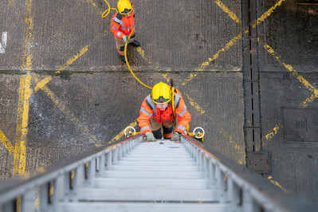

Greater Manchester Fire and Rescue Service believe in an ethos that investing in and looking after employees will help to promote a happy, healthy workforce. Commitment to create an environment whereby employees are encouraged to engage in a healthy active lifestyle is embedded in the organisations core values, evidenced in our Wellbeing Strategy. Wholetime operational Firefighters are allocated dedicated physical training time whilst on shift. Comprehensive gym facilities are provided on all stations and at Headquarters, with all employees having access to regular classes.

Introduction
It is well known that the occupational tasks of a firefighter are arduous; often involving operating and carrying heavy equipment whilst working for long periods of time in challenging conditions. These tasks demand a myriad of essential physical attributes to ensure they can be performed effectively, whilst reducing the likelihood of injury.
A successful fitness programme should focus on a combination of components including strength, power, aerobic training, muscular endurance and flexibility. In addition, training that develops neuromuscular movement patterns is crucial to promote reaction time and reduce risk of injury to a firefighter when faced with environmentally challenging tasks, so training should also incorporate modes of agility, balance and proprioception development.
Preparing to meet the physical requirements for the recruitment process can be challenging, particularly due to Covid-19 placing restrictions on access to gym facilities. If you have a determined attitude, and are ready to commit to your training, the timetable provided within this booklet gives you an easy to follow 12-week fitness programme, offering creative ways you can train from home with just a small selection of equipment. Guiding you throughout your training journey, the sessions are designed to support you with all aspects of fitness highlighted, helping you to prepare for the physical challenges ahead, through recruitment and life as a firefighter.

Before you begin
If you have any doubts about your health or physical ability to exercise, you should consult a doctor before commencing any physical training programme. This is especially important if you are (or think you might be) pregnant, if your health status has recently changed, if you are recovering from a recent illness or injury, or if you are new to exercise.

Key tips:
If you answer yes to any of the questions below or if you have any concerns regarding a medical issue, further guidance should be sought from a medical professional prior to participation to ensure your safety:
- Has your doctor ever said that you have a heart condition OR high blood pressure?
- Do you feel pain in your chest at rest, during daily activities of living OR when you engage in physical activity?
- Do you lose balance because of dizziness OR have you lost consciousness in the last 12 months?
- Have you ever been diagnosed with another chronic medical condition (other than heart disease or high blood pressure)?
- Are you currently taking prescribed medications for a chronic medical condition?
- Do you currently have (or have had within the past 12 months) a bone, joint or soft tissue (muscle, ligament or tendon) problem that could be made worse by becoming more physically active?
- Are you currently taking any medication which causes drowsiness or any other side effects which may affect your ability to carry out physical activities?
- Are you currently under investigation/monitored for any medical condition? Answer NO if you had a problem in the past, but it does not limit your current ability to be physically active.
- Are you currently under investigation/monitored for any medical condition?

- Make sure you wear suitable clothing during your training sessions, particularly appropriate footwear.
- Remain hydrated throughout periods of exercise.
- Fitness improvements take time and it is important that you listen to your body. Training too hard too quickly can easily lead to injury, so progress gradually and ensure sufficient rest and recovery time is taken.
- If you are unsure about any aspect of the guidance or you would like additional support with your training, it is recommended that you seek the advice of a suitably qualified fitness professional.

Practical Test Day:
As part of the recruitment process, you will be required to attend a Practical Test Day where you will begin by completing a physical activity readiness questionnaire and attend a full briefing of what to expect delivered by the Talent and Resourcing Team.
Following this you will complete an aerobic fitness test.

Bleep test (20 metre Multi-Stage Fitness Test (MFST))
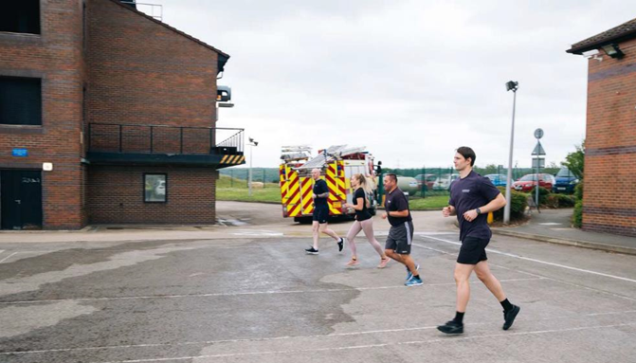
The bleep test (or MSFT) is designed to measure aerobic fitness. The test involves continuous running between two lines 20 metres apart, in time to a recorded bleep.
The test is progressive, with the bleep and pace getting quicker at each level. You will be required to keep up with the bleep, turning when signalled by the bleep. You will need to get a foot on or over the line in time with the bleep, if you reach the line before the bleep, wait for the bleep before continuing. Your final score is recorded at the level you stop, or if 3 misses are recorded, your final score will be the last bleep you successfully reached.
The required standard to pass the Bleep test is Level 8.8.
You can test your cardio fitness against this level by:
- Practicing the bleep test at home (Bleep test tracks can be found on music streaming services such as Spotify)
- Running 1.5 miles (2.4 kilometres) continuously in 12 minutes or less
- Running on a treadmill at 7.5 mph (12 km/h) for 12 minutes

National Firefighter Selection Tests
If you are successful at completing the Bleep Test, you will then move on to complete a series of physical tests. You will be required to complete the following job-related tests: 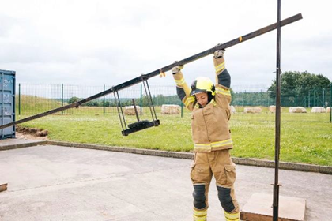

Simulated ladder Lift – 30kg
This is a test of your upper body strength, and your ability to lift a ladder – something that you will regularly do as a Firefighter. You will be expected to wear full fire kit and raise a bar that is already 75cm off the ground, past the marker identified to 182cm and back down again without bending your legs.
Training tips (Upper Body strength)
- Single rope pull 28 kg of static weight 23 times without rest from a seated position.
- Single rope pull 60 kg of static weight once from a seated position.
- Lat Pulldown – aim for the standards above and then increase
- Carrying 30kg in one hand comfortably across 20-40m. The grip required is small and thin (rope/ladder handle).
- Confident in either hand.
- Grip Strength – can you hold awkward shapes in one hand.
- Ensure you can comfortably shoulder press 30kg. Aim for 3 x 6 reps at 30kg and increase.
  - Include large body movements such as cleans/snatches, and above head exercises.
  - Aim for 3 x 6 reps at 30kg and increase.
  - Train this area 2 times a week with rest days in between.

Equipment Carry Test (Rural)
This tests your cardiovascular fitness, stamina and muscular strength and involves carrying a range of fire and rescue service equipment around a course. This must be done within a certain time.
Candidates are required to:
- Pick up the hose reel and run one length of 25 metres, then run back.
- Pick up and carry two 70mm lengths of hose 100 metres (4 lengths of the course).
- Carry one roll of hose at chest height for 25 metres, and then jog 75 metres.
- Pick up and carry a 2.4-metre-long hard suction hose and basket strainer for 100 metres, then jog 100 metres.
- Pick up and carry a 30kg barbell for 100 metres.
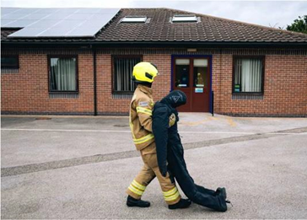
‘Dummy drag’
Candidates are required to: Drag a 55kg 'dummy' around a 30metre course, backwards.
Training tips (Functional Fitness)
The best type of fitness training is one that includes all aspects of fitness. High intensity exercise such as HIIT, circuit training, crossfit, boxing or team sport will improve the necessary areas of fitness.
- Ensure you are comfortable carrying and walking with at least 30kg weights of various shapes and sizes
- Alternate weight baring walking with free shuttle runs
- Include this type of training 2-3 days a week
- Core stability is needed to protect your posture during awkward or uneven movements.

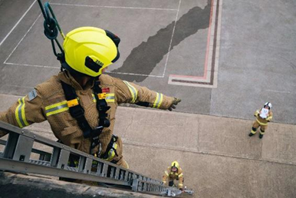 Ladder climb
This is a test of your confidence whilst working at height. With the guidance of an instructor, you are required to demonstrate a correct 'leg lock' at ground level before ascending a fully extended 13.5m ladder. You must climb this ladder to approximately second storey height before performing another 'leg lock'. You will then be asked to lean back with your arms outstretched and describe a symbol shown on the floor.
During this test you will be wearing full fire kit (personal protective equipment), a helmet and a harness.

Enclosed Space / BA Crawl
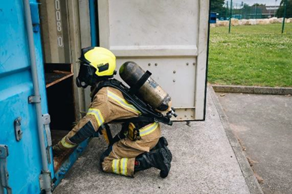
This tests your confidence and agility when working within an enclosed space. You will be required to wear full fire kit and a breathing apparatus mask whilst crawling through a series of tunnels in darkness. This simulates some of the conditions that firefighters may face when dealing with compartment fires.

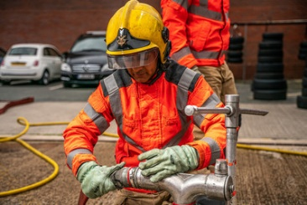

Manual Dexterity
This tests your manual dexterity. You will be required to assemble a number of fire service couplings securely, within a set time whilst wearing fire gear.
Training tips (technical tests; Ladder climb, BA crawl, Manual Dexterity)
These assessments are more complicated to train for. However, any fear of heights or claustrophobia may hinder your ability to progress. You can make yourself familiar with various practical actions such as climbing and crawling, and manual skills such as using tools and fittings.

Get Fire Fit!
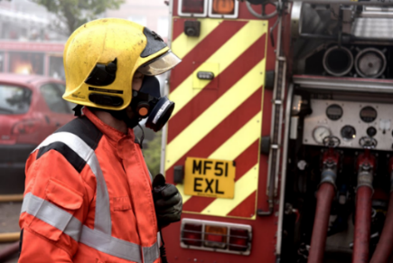
“Having a high level of physical fitness allows me to be ready for anything the job throws at us, whether it's carrying equipment, rescuing casualties or wearing breathing apparatus. It allows me to focus on getting the job done without worrying about my physical capabilities”. FF Vickers, GMFRS
“Having a good level of fitness allows me to perform in difficult and challenging conditions” FF Hartley, GMFRS
Flexibility
- Firefighters need to be able to manoeuvre their body through challenging or tight confined space, requiring a good level of flexibility.
- A lack of flexibility will limit the range of motion, placing stress on joints, which can then potentially result in injury such as muscle strains or ligament damage.
Core stability
- Working in dark conditions with debris underfoot is not uncommon for a firefighter.
- The body’s ability to react quickly to a slip or trip depends on the neurological pathway from our joint to our brain to initiate a reaction.
Cardiovascular Endurance
- The tasks that a firefighter undertake whilst wearing PPE are demanding, and require a good level of cardiovascular fitness.
- All Greater Manchester Fire and Rescue operational firefighters are required to undertake an annual fitness test to the national standard VO2 of 42.3 ml/kg/min. This is the equivalent to 8.8 on the Bleep. This should be the minimum level of fitness that a firefighter should maintain.
Muscular strength & endurance
- Lifting and carrying heavy equipment demands a level of physical strength, so tasks can be completed comfortably, with the stamina to continue.
- These include handling ladders, hose running, carrying equipment and using the cutting equipment.

The fitness levels you achieved for the Selection tests are the bare minimum that you will need in your role
- You will need to maintain the fitness standards for the rest of your career. That may well be until you are over 60 years old. If you start out fitter, it will be easier to maintain.
- The Recruits Course is very physically and mentally demanding. You will be working physically hard for large portions of the day.
- If you have a higher fitness level, that gives you more time to work on the skills, learning and technical elements of the course

Further training Suggestions
You should be aiming to train 3-4 days a week with a variety of training styles:

- High Intensity Interval Training
- Circuit Training
- Cross Fit
- Running/jogging
- Boxing
- High intensity sports

Additional training such as Yoga or Pilates will improve your core stability and flexibility & mobility. These can be crucial for preventing injury.
Make all your workouts functional, working large muscle groups, developing Cardiovascular (CV) fitness and always include elements of core stability and flexibility development.

5 Firefighter fitness fundamentals:

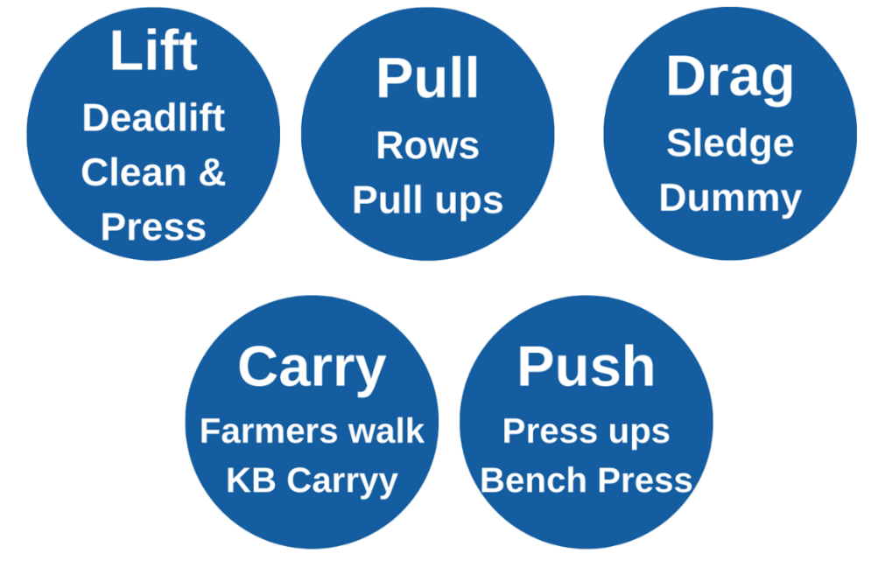

Training & COVID-19
Due to Covid-19 restrictions, you may be faced with the challenge of training without access to a gym... So, it is time to get creative!
If you are training at home, you do not need to have access to a multi gym with expensive equipment. Throughout the programme, look out for the light bulb which offers tips for using equipment you may have at home to add some resistance.
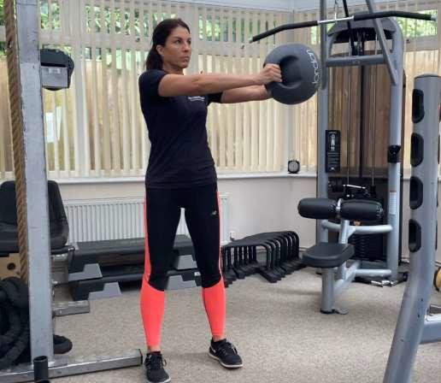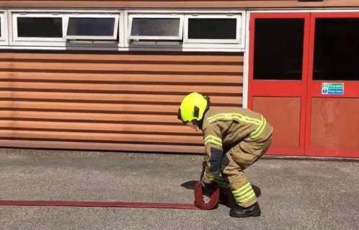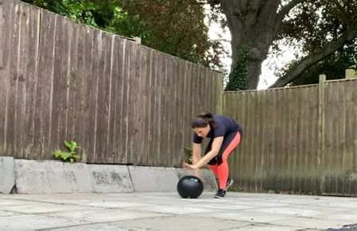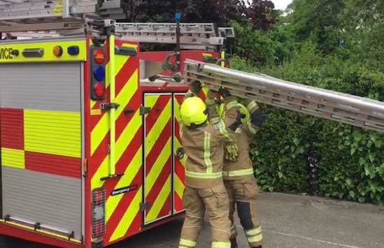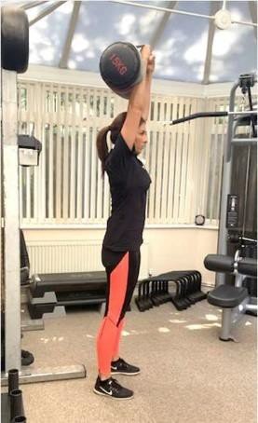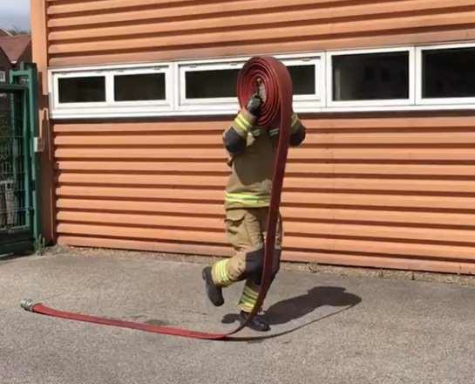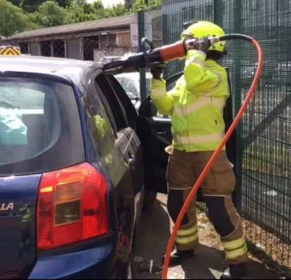

Specific Needs Analysis

Identify any gaps
Throughout your training, you can establish and monitor your own training status in relation to the demands of the role outlined. From this, you are encouraged to complete a Needs Analysis based on the recommended physical attributes and ability. The Needs Analysis encourages you to explore your training history, what has your training previously involved, how often, what modes, what you like, dislike, barriers, injuries or weaknesses. It may be that you stick to following a specific training regime that you most enjoy, such as predominately cardio or weights, which is common. However, this can come at a risk of neglecting other essential components that are essential for a firefighter to possess.
Taking some time to think about your training history will also help you to establish your current baseline whilst identifying any gaps in your training. You can then ensure these are factored into your programme, helping you to achieve your goals.

Set Your Goals
Planning what you are aiming to achieve will help you to ensure you get the best out of your training sessions.
Setting SMART: Specific Measurable Achievable Realistic Timebound goals and following a specific programme will help you to stay on track and monitor your progression.

How to plan your needs analysis:

To ensure you are getting the best out of your exercise sessions it is essential that you listen to your body and monitor the exercise intensity. To improve fitness, you need to be working at a high enough intensity to overload and progress.

Monitoring Your Exercise Intensity
There are various validated tools you can use to monitor intensity. It would be advisable to use a variety of these rather than relying on one method to measure your exertion:

Method 1) Rate of perceived exertion – RPE
The rate of perceived exertion scale is a tool (below) which enables you to assess your exercise intensity, whilst correlating to your given effort and how it makes you feel. The Borg Rating of Perceived Exertion scale is 6 – 20, however you may prefer the 1 -10 category ratio scale, both of which are displayed in the table below.
Borg scale 6 – 20 | Perceived Exertion | Category Ratio 1 – 10 | % Effort
6 | No exertion at all | 0 | 20%
7 | Extremely light |  | 30%
8 |  | 1 | 40%
9 | Very light |  | 50%
10 |  |  | 55%
11 | Light |  | 60%
12 |  | 3 | 65%
13 | Somewhat hard |  | 70%
14 |  | 5 | 75%
15 | Hard (heavy) |  | 80%
16 |  | 7 | 85%
17 | Very hard |  | 90%
18 |  |  | 95%
19 | Extremely hard | 10 | 100%
20 | Maximal exertion |  | Exhaustion

Method 2) How does it feel? Can you Talk?
It is good practice throughout your exercise session to ask yourself how the intensity feels.
Are you working hard enough to improve your fitness?
Moderate intensity would be measured around 5 out of 10 using the 1-10 scale. You generally should still be able to talk, you will feel warmer and slightly sweaty, but it is not uncomfortable.
Vigorous intensity would be measured above 6 out of 10, using the 1 – 10 scale. You will not be able to hold a conversation and may be feeling uncomfortable during this high intensity zone.

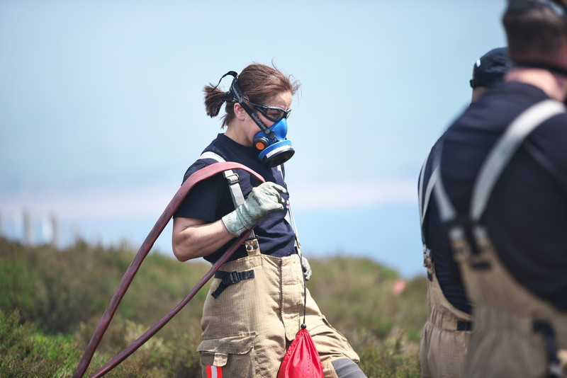

For more fitness training tips, including suggested training plans and calendars, see our “Training Plan” guide.

