# START SAFE



## Fire Safety Education Session

### Factsheet – Year 2

Today Firefighters from Greater Manchester Fire and Rescue Service have visited your school and delivered an education session to your child’s class. This fact sheet tells you about some of the things from that lesson. Please read it and talk about it as a family.

## What is START SAFE?

START SAFE is an educational package that has been designed to help children and their families to stay safe from fire in several ways.

### About the Year 2 session

**It increases the children’s knowledge about the risk that fire presents**. The dangers that matches and lighters can pose was particularly stressed.

**We talked about the actions that should be taken in the event of a fire.**



This included:

* The importance of having a correctly fitted and working smoke alarm
* in your home
* What to do if the smoke alarm sounds, particularly during the night-time
* What someone should do if their clothes caught fire

#### The importance of START SAFE and what you can do to help

Whilst the issues covered in these sessions can be sensitive to some children they are of great importance. We know from experience that giving children this knowledge in school in the past has had very positive effects in terms of major injuries being avoided to the children and members of their families.

All we ask is for your support and help with regards to the work we do with young people by talking to your child about the lesson and further reinforcing the messages at home.

If you are worried that someone in your family has an unhealthy interest in fire you can contact us to discuss our FIRESMART Programme.

##### There are some Top Tips linked to what your child learnt in the session on the back of this sheet. Why not display the other side of this handout on the kitchen notice board, or another suitable place, where everyone can see it?

# Fire Safety Tips



### Smoke alarms

* A smoke alarm could save your life.
* Fit smoke alarms on each level of your home - it's the simplest, single step you can take to cut the risk of dying from fire in your home
* Fit a heat alarm in your kit
* Test the batteries in your smoke alarm every week - never remove them
* A smoke alarm will wake you up and give you vital extra time needed to escape

### Have a Bedtime Routine

You are more at risk from a fire when asleep. So, it's a good idea to check your home before you go to bed. Use this quick check list to keep your home safer from fire:

* Close inside doors at night to stop a fire from spreading
* 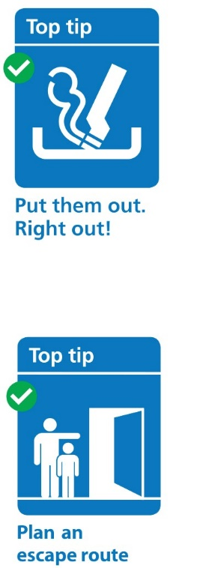Turn off and unplug electrical appliances unless they are designed to be left on – like your freezer
* Check your cooker is turned off
* Don't leave the washing machine on
* Turn heaters off and put up fireguards
* Put candles and cigarettes out properly
* Make sure exits are kept clear
* Keep door and window keys where everyone can find them

### Have an Escape Action Plan

* You need to be prepared and have an escape plan - one day it could just save your life! Make sure you and those you live with know how to escape in the event of a fire.
* It's important that everyone in your home (including children and the elderly) is involved in putting together the escape plan
* Everyone should know where the window and door keys are
* Your normal way out of the house is your best escape route so always keep it clear of clutter - think of the difficulties you'll have using this route in pitch darkness or smoke
* Walk your escape route with the rest of your family or housemates and make sure everyone can open windows and doors easily
* Always choose a second escape route, in case the first one is blocked
* Review your escape route regularly to take into account any changes in your home

Did you know ... If you are a Greater Manchester resident and are concerned that your physical or mental health, home environment or daily activities might increase your fire risk or reduce your chances of escape, you may be eligible for a **Home Fire Safety Assessment.**

**Scan me**



We offer fire safety advice and provide and fit free smoke alarms where they are needed. For general fire safety advice or to see if you are eligible for a visit to your home by one of our Firefighters or Prevention Advisors, please visit our website at manchesterfire.gov.uk or scan the QR code. If you do not have access to the internet, call 0800 555 815